25th January, 2017

Dear Member
January newsletter already! It does not seem long since we were preparing to celebrate the turning on of the Christmas lights and now we are looking forward to Summer and our Field Visits. But before I get to that I wonder if anyone has noticed that we have updated the Mercury News Shop’s smaller window?
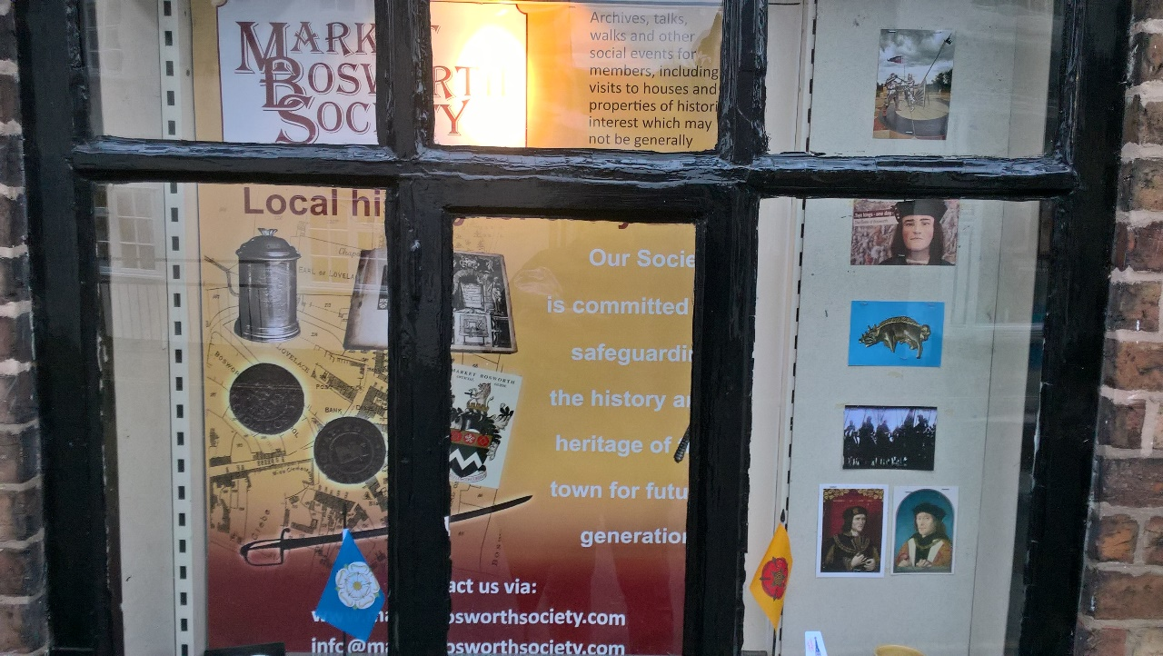
Sadly my photography really does not do it justice, it is much better in real life. I would like to thank Brian Oakley; who was balancing in the window attaching the posters for long enough for two shoppers to ask if he was for sale. I must also say thank you to Glynis Oakley, Beth Dawes and Ingrid Davison for their research, another splendid job. Thanks as well to Clive and the ever patient Claire, from Mercury News, who allowed us to dismantle their counter, remove everything on several shelves and get under their feet, without so much as a murmur. I would add that Dean and Nicky at The Graphic, did a great job in laying out and printing the final poster, at very competitive terms, thanks to you both. Why not pop by and have a look at the window you will not be disappointed.
On Thursday, 19th January, we were addressed by one of our fellow members, Derek Jerram, delivering his lecture, entitled “Dam and Blast” Derek both informed and entertained. If like me you think a reservoir to be a hole in the ground into which water pours only to be blocked at the other end, until needed, then you would, like me be wrong, Derek started off with the details of a disaster which took place in the Dolomite Mountains in 1961. The dam was some 900’ high and one night part of a mountain, a massive 2 kilometres by 1.6 kilometres by 150 meters high, slipped or fell into the reservoir. The dam held but some water washed over the top and down the valley destroying all in its path. A local priest who lived on a mountainside saw the whole thing illuminated by the flashes of the arcing electricity as the water destroyed the power station below. The height of the water over the dam was estimated at between 100 meters to 200 meters. Sadly over 2000 people died due to drowning and buildings collapsing, as you would expect but many also died because of the enormous air pressure generated which rendered them unable to breath. The engineers and geologists were held responsible, receiving prison sentences. The son of the geologist, who had also begun a career as a geologist was banned from working on dams, The sins of the father…Derek went on to explain about other disasters, some much smaller in scale, acid rain falling on limestone and causing a sump to fill with carbon dioxide suffocating four workers, for example. It of course was not all doom, Derek explained how dams were built and one of the jobs, now done by bulldozers was once done by hundreds of men trampling clay to make the dam watertight. Many men started and finished their working lives trampling down clay to make dams. Derek is clearly a man who knows his subject well and I for one discovered a lot more about reservoirs and dams. Thank you for your lecture Derek.
Here are a few dates for your diary. I have some more suggestions and ideas for lectures and will be adding them as we go forward. Thank you for your ideas, please keep them coming.
Forthcoming Lectures and Field Trips
2017 Lecture/Field Visit Lecturer
February 16th | Stuart Leicestershire Civil War and Dissent | Peter Liddle MBE
March 16th | AGM & Sparkenhoe Farm Cheeses | David (or Jo) Clarke
April 20th | Bob and Bill | Dereck Chatterton
May 18th | My Story | Jürgen Schwiening
June 15th | Community Led Archaeology Digs - The story so far | Professor Carenza Lewis
July 20th | Field Trip | Beaumanor Hall
August 17th | Field Trip | Bosworth Battlefield Centre
September 21st | Memories of a Bosworth Panel | Robert Leake Narrator
October 19th | The Story of the Gurkhas | Margaret Cross
November 16th | Bending The Beams | Terry Sheppard
November. TBA | Christmas Lights Switch On | Open Evening TBA
December | No Meeting this month

Annual General Meeting, will take place on the 16th March at 7.00 pm. An agenda will follow in February (don’t forget the SGM immediately prior to the February meeting). It would appear that we will lose at least two long standing members of the committee and I would ask that you give serious consideration to joining the committee. A lot of work is done behind the scenes and if shared the tasks are easier to perform. You do not have to jump in at the deep end but could join as a general committee member making valuable contributions and supporting other committee members, such as the Secretary or Treasurer for example. It is a fantastic way to learn how to be a team player and how committees work. If you would like to know more, know someone who would be interested (friends, relatives, neighbours) or if you would like to step forward then please contact me, by email: nigel_palmer.MBS@btinternet.com or by telephone: 07930149408. You may recall that I became chairman only last March, with little experience of the role. A fact a number of you have noticed, I have no doubt. In some aspects the learning curve has been quite steep but I have always been able to rely upon the support of our committee and of course our previous chairman.. Come and have a go, there is no reason not to take part.
I look forward to welcoming you to our meeting on the 16th February, as Peter Liddle MBE makes a welcome return. Peter will be telling us about what a lot of people refer to as the second Battle of Bosworth “Stuart Leicestershire, Civil War and Dissent! I dare say that, if asked, he will also tell us something of a recent and very exciting discovery in the centre of Leicester. Mathew Morris has done it again! Mathew as I am sure you know was the archaeologist who discovered the body of Ricard III. Mathew has now discovered the largest Roman mosaic seen for some considerable time in Leicester. We have asked Peter to bring along some photographs to share with us in February. As usual the meeting will be in The Free Church and will commence at 7.30 pm

At the moment the hope is that the funding applications will be successful, as the Bosworth Links Committee really see this as a wonderful way to demonstrate, yet again, what we can achieve as a community. It will be a lot of fun and we will find out more about our predecessors, whoever they may be. I would, however like to send an appeal to any Chairmen/women or Secretaries of Clubs and Societies. We would dearly love to come and tell your members what our project is about and why we think it is so special. If you are reading this then do please get in touch with me, (details above). If you are the member of a society please consider drawing this to the attention of that society’s committee. The Market Bosworth Society website (www.marketbosworthgsociety.com) has been updated and if you click on the Bosworth Links logo you can read all about the project (and share with friends and family all over the world) plus you can register an interest in volunteering to take part in the project. All we are waiting for now is the green light from our funding requests.
Best Wishes
Nigel Palmer
Chairman

