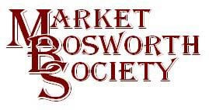February 2017
Dear Member
Let me start with an explanation, if I may? I have been using a BT account to send and receive emails on behalf of the Society and will likely continue to do so. BT though will only allow 50 emails to be sent at any one time, I therefore send out batches of emails to overcome this. The Society’s domain has no such restrictions and so you may see emails from info@marketbosworthsoiety.com in which case you need not be alarmed. If you are not technically minded stop reading this bit now……there was a problem. Before switching to the info email I test sent several emails and found that non-were being received by any BT account. It turned out that our domain did not automatically include a Sender Policy Framework (SPF) Record in the email header. It appears that BT did previously allow emails without the code but now reject them as spam. Problem is they do what they refer to as a “Hard Reject” which means that they do not appear in the spam folder nor are they bounced back. They appear to enter into a black hole. But after several emails (including one to Gavin Patterson) and several telephone calls it is all now resolved.
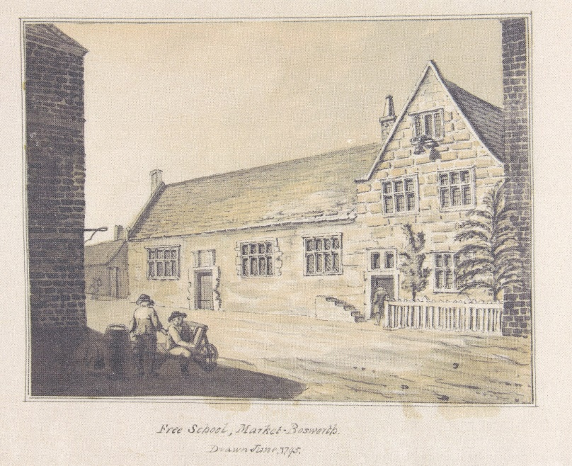
Now to a much more interesting mystery, one I suspect will be just as quickly resolved. In this image, “Free School, Market Bosworth” drawn June 1795 a building is shown which fulfilled the purpose of a school. The mystery being, where was it? I do not recognise the building at all and so I guess it has been demolished, but what now stands on that site. I see that just to the left of the children (school was out when the drawing was made) is a bracket for a sign. So anyone who knows please let me know, nigel_palmer.MBS@btinternet.com or Info@marketbosworthsocity.com If you happen to know why there appears to be a set of steps leading nowhere you might add that (but I, at least, know that answer).
Those members present at the February meeting enjoyed another thoroughly excellent Lecture from Peter Liddle MBE, Peter was making a very welcome return to tell us all about Stuart Civil War in Leicestershire and Dissent. Peter explained the history of the Civil War in the 17th Century with accuracy and with humour. He brought the events in Leicestershire (with Leicester changing hands twice) to life. He has an encyclopaedic knowledge and talked for over an hour without notes, prompted only by the projected illustrations. Peter’s talk next year will not be one to be missed. I do sometimes find it odd that history repeats itself and strange events, some call them coincidences occur. A battle, or more accurately a skirmish took place in 1644 in exactly the same spot as The Battle of Bosworth in 1485. Careful archaeological research has confirmed this. Cannon balls from 1485 have been discovered with musket balls from 1644. Not just nearby but in, around and on top of each other. The Skirmish in 1644 between the Royalists and Parliamentarians would have been by cavalry. The musket balls found are from pistols, which, for a rider are really a use once weapons, before reaching for a sword. I would imagine it to be extremely difficult to reload a musket on horseback, no matter how proficient a rider the musketeer happened to be!

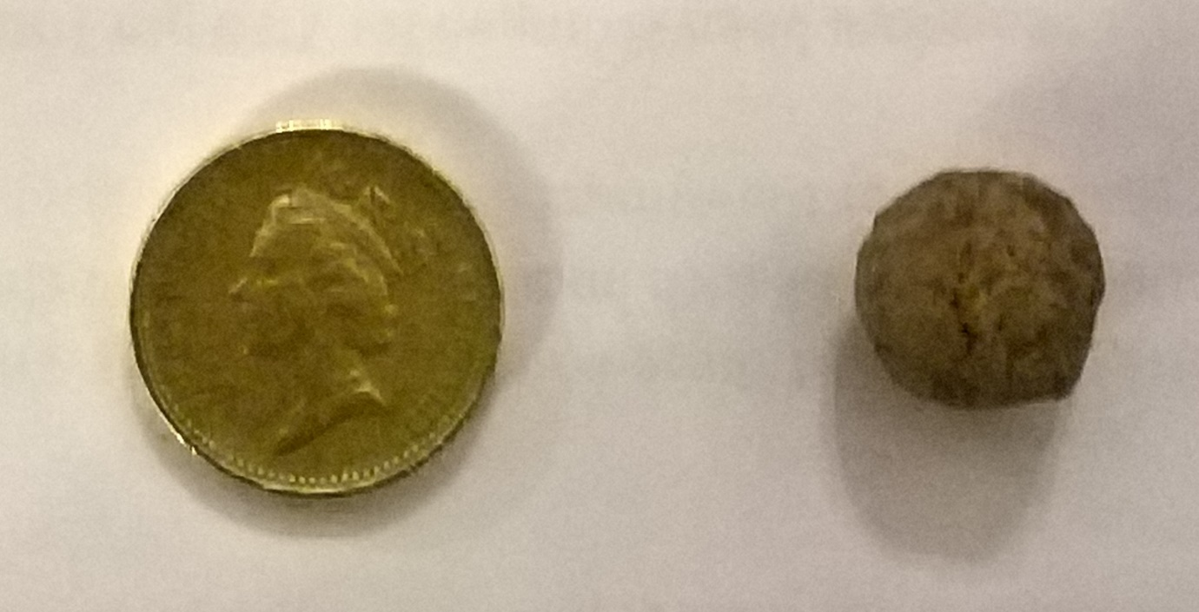
On the very day of the Lecture Peter Loseby received a musket ball (no not like that) found from that self-same field where the Battle of 1485 and the skirmish of 1644 took place! And here it is next to a £1 coin for scale. So, two battles in the same field 159 years apart and a musket ball found over 372 years later, on the day of the lecture about the Civil War! I must admit that I became so engrossed in the Peter’s narrative of the events that I took only a few notes, so this article is a little light. What is certain, to me at least, is that history has some fascinating twists and turns and The Civil War like all conflicts is riddled with ifs and buts. We are all very excited to see what secrets Bosworth Links will reveal, one should look at recent finds in Leicester by Mathew Morris to realise the potential archaeology has for revealing our histories.
Prior to Peter’s lecture we held the Special General Meeting (SGM) as had been advertised. You may recall it was to strengthen and clarify the Society’s constitution. I am delighted to confirm that this was indeed the outcome. You will find a copy of the SGM Minutes and the Updated Constitution attached to the email carrying this News Letter. I would like to thank those members present for supporting the amendments unanimously.
Next month we will be holding our Annual General Meeting at 7.00 pm, 16th March 2017. The meeting will take place at The Free Church, Barton Road, Market Bosworth. You will be provided with reports from the Chairman and Secretary together with Audited Accounts seeking approval. You will then be asked to elect a committee for the next 12 months. Anyone can stand for nomination to the committee provided that they are fully paid up members of the Market Bosworth Society. Nominations for the election of Officers should be made in writing to the Honorary Secretary one week in advance of the AGM, from a paid-up member of the Society; who has obtained the consent of the proposed nominee. The address and email address is on our website, or you may contact me. nigel_palmer.MBS@btinternet.com. Please do your best to attend the AGM and help us to elect a committee for the next year. I have also attached an Agenda in case you missed the last one. Copies of last year’s minutes will be available at the meeting, should you want one earlier then please let me know. I will be happy to send one out but did not want to include too many documents with this newsletter.
We will be sorry to see Eric Colley and Diane Coleman leave the committee at the AGM, as they have decided to stand down. I would like to publicly thank Eric and Diane for their long-standing support of the Society. The vacant seats will not be easy to fill. Although, I would be surprised if there is not someone reading this who would like to get involved, particularly as we have some exciting times ahead with Bosworth Links. Serving on a committee, which meets just once per month, is an excellent way to meet people and to take part in community events. We will aim to recruit two new committee members. If you would like to spend a little time in a highly worthwhile way, whilst making friends, learning new skills, and helping to ensure the future of the Society then contact me by email (above) or by telephone, should you prefer, 07930149408 or 01455290160. I am happy to have a chat and answer any questions you may have about committee work.
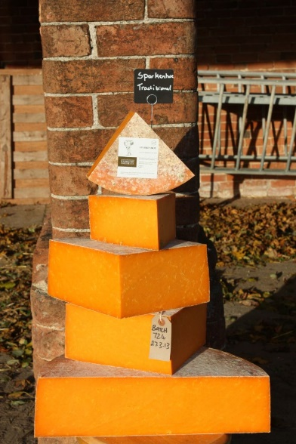
Following the AGM, we have a mouth-watering Lecture by Jo and David Clarke from Leicestershire Cheese based at Sparkenhoe Farm, Upton. Jo has kindly agreed a special rate just for the Society and so I would like to see a good turnout. We will hear about the history of cheese making and more specifically the history of Sparkenhoe Farm Cheeses. I understand that there will be tastings available and the opportunity to buy some of the excellent cheeses at the end of the meeting (reminiscent of Alf and his sausages). Don’t forget your pocket money, would be my advice Lynne and I are huge fans, the Red Leicester tastes just as it did when I was a boy! This lecture will, as usual begin at 7:30 pm, on the 16th March 2017 (following the AGM) at the Free Church, Barton Road. All are welcome, non-members are always welcome, subject to availability and will be asked to pay just £3.00 upon entry. Jo and David also organise walks over their scenic farmland and I shall be looking to see if we can accommodate a walk as one of our field visits, as long as the walk coincides with the opening hours of the Cream Tea facility!
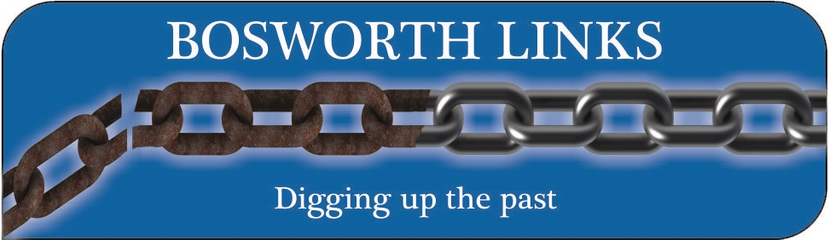
Following the articles in Aspect and The Graphic last month we have been out and about telling groups Pabout our Bosworth Links project. I must say that we have been warmly received and have enjoyed a very positive response. If you missed the articles, do not worry just go over to www.marketbosworthsociety.com/bosworthlinks and the details are all there. There is a link to register your interest as a volunteer. We have had quite a response from people wishing to volunteer and are beginning to compile a healthy list from the on-line forms and telephone calls. You don’t have to register on-line, give me or Peter Loseby a call.
There is plenty of opportunity and we really do want to hear from you if you are interested in taking part. It will be good fun and an opportunity to learn a few things. Why not register as a volunteer now? This will enable us to keep you informed of progress and important dates, together with the outcomes of our funding request, essential to our success. We are inching ever closer to the decision time for the funding groups, so please keep your fingers crossed for us. There is also a link to a video about The Rothley Big Dig which we are aiming to emulate. It is a really happy video showing how everyone of all ages and abilities took part. We do want everyone to be involved and therefore if you are a member of a Club or Society and want us to come and tell you all about Bosworth Links, then use the telephone numbers or email address above to let me know. We have a few presentations lined up throughout March but I am sure we can squeeze a few more in. Be a shame to miss out.
The Market Bosworth Society have also been invited by the Parish Council to attend the King Richard III artwork dedication on the 19th March (events start from mid-day and the actual dedication is timed for 3.30 pm).
The Parish Council have supported the Society in progressing Bosworth Links and it will be a great opportunity for you to come and have a look at what we plan to do and register your interest. Be lovely to see a good crowd at the dedication and at the other events.
Please also look at www.marketbosworthsociety.com/what’son page. We have completed our lectures and visits diary up to March 2018. If what we have planned appeals to you then why not come along to the meetings as a visitor or join as a member and attend the Field Trips as well? Membership is just £9.00 for a single annual membership and £14.00 for a joint annual membership (although that may change at the AGM). The “What’s on” information is in the form of a list and as a calendar. To turn it to a pin board double click any event on the calendar. I am trying out a calendar provided entirely free by Tockify.com (there are subscription versions available as well). The calendar is simple and easy to use and loaded up without problem using a Wordpress plug-in provided. I hope to see you at some (why not all?) of our future meetings and Field Trips. In the meantime, all the very best to you.
Nigel Palmer
Chairman

