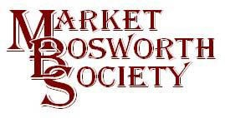September 2017
Dear Member
Memories In Bosworth
Our last Lecture Meeting on the 21st of September was another of the truly popular interactive meeting. audience shared may interesting recollections with the instigating panel comprised of, Audrey Boston, David Fitt and John Smith. Robert Leake’s well researched and witty introductions set the scene nicely and had the audience chuckling. Audrey got us underway and told us a lovely story of her life. Audrey is a natural communicator and some of her reminiscences were very, very funny. The story about her canal boat and cutting it in half to get it home brought some of the biggest laughs. She was backed up by John Smith who took us on his rounds as a delivery boy and man with Bamfords. The names of people I knew growing up in Bosworth tripped off his tongue and his antics whilst delivering Paraffin were equally as funny as Audrey. David Fitt maintained the standard and shared with us some delightful and entertaining anecdotes and stories about the Bosworth Carnival, again names chimed with me, Philip Jenkins, Miss Cash, Richard Mapp, Ted Scott, Phil Tebbutt, Eddy Keats and so many more. It was brilliant. David’s telling of the time he was “kidnapped” by four Arabs had me and the rest of the audience in stitches. These events are always very popular and we hope to run more of them in the coming years. If you have a story to tell or would like to take part do please get in touch, 01455290160/07930149408
. There were some sad moments as we reflected on some no longer with us but we were grateful for the memories they left for us.
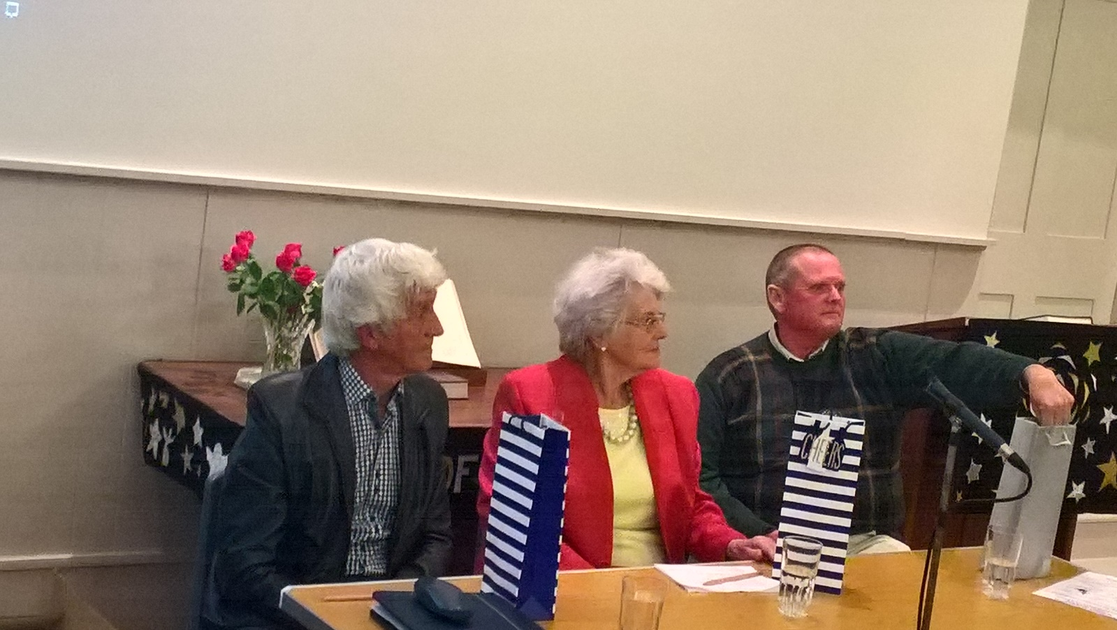
The panel with their Market Bosworth Society pencils……..
What was particularly sad was that when David left the High School, the whole inventory of photographs, 17 years’ worth of photographs of the Bosworth Carnival, were destroyed. Just think how much they would be worth to researchers and residents of Bosworth now. In winding up the evening, after presenting the panel with a well-earned Market Bosworth Society pencil, Robert made an appeal. The Society plans to run a film night as part of our programme of events next year and would love to hear from anyone with videos or even DVDs of Bosworth that we could show on our film night. It does not have to be professional and could be just a few seconds worth, no matter. We will put videos, DVDs and clips together. It would be a tragedy to lose these films. Do please look them out and contact me or any committee member. It would be a tragedy not to preserve this history for future generations. One of the Societies functions is to maintain an archive and we are happy to accept items for the benefit of future generations. Please, please do not let us lose these wonderful records and insights.
Next Month’s Meeting: Margaret Cross “The Story of the Gurkhas”
Our next Society meeting will be on the 19th October and will take place in the Free Church, Barton Road, Market Bosworth. The meeting will commence at 7:30 pm. Margaret Cross will be making a very welcome return to Market Bosworth and the subject of her lecture is “The Story of the Gurkhas” Those who have heard Margaret talk before will know what an excellent evening we have in store. Whilst primarily for Society members we do (subject to availability) welcome guests and ask that a small fee be paid to help defray costs, current £3.00. Remember that Society membership is only £9.00 per year and £14.00 for a joint membership. This also means you will be able to attend other lectures, Field and Summer visits and will receive a monthly News Letter packed with interesting news and information.
Hinckley & Bosworth Borough Council, Local Heritage Asset List
You will have seen that the Paul Grundy, Conservation Officer for Hinckley and Bosworth Borough Council, is working to develop a Hinckley and Bosworth Borough Council Local Heritage Asset list. This was announced in the Borough Bulletin recently and added to our Facebook page and website. I have recently spoken with Paul and he reports that the process is on schedule, I will keep you informed of developments and where we may be seeking help in the future. Watch this space, as they say.
What lies below?
You may recall that the Community Archaeology Project, Bosworth Links, we ran in July turned up some interesting archaeological features. One in particular, the remains of a wall or possibly a stone plinth in the Parish Field has fuelled a good deal of speculation as to its origin. In his book “The Book of Bosworth School 1320 – 1950” the author S. Hopewell M.A. offers some evidence that there was at one time a monastery in Market Bosworth. He cites several sources for his evidence, which is not proof but worthy of further investigation. There was mention of some older foundations at the current Dixie Grammar School building and I decided to base some of our research there. I was delighted when Kevin Smith, Facilities Manager confirmed that he had arranged for Gemma Tallis and I to visit the cellars. Gemma is a true Arachnophobe, but she managed not to scream hardly at all. We visited the cellars on the 19th, September. We had a very good look round and share some of the photographs here for you to see. We have yet to analyse the photographs but some do support our knowledge that there have been buildings on that site previously. Also some of the stone appears to have been recycled. A massive thank you to Kev for arranging this for us.
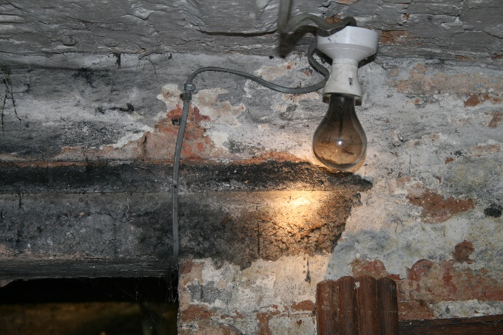
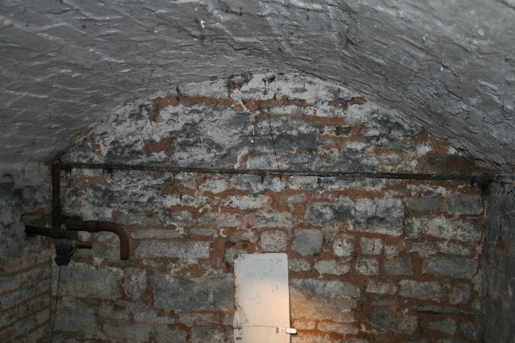

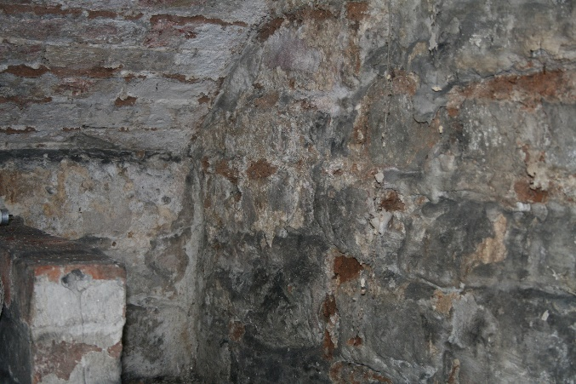
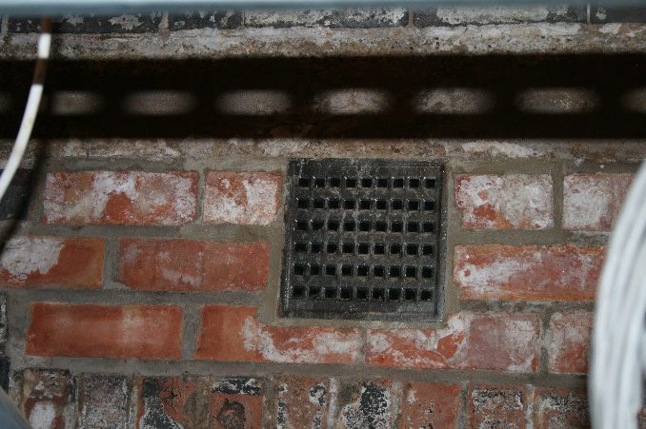

The last picture was taken in the newer cellar beneath the Dixie School Hall. And is a mystery? Does anyone know why the cellar doors have been bricked up? As can be seen an air vent was installed but it is impossible to see into the bricked up part. If anyone knows then please contact me, info@marketbosworthsociety.com or by telephone 07930149408/01455290160 or by posting on our Facebook page. We are very lucky as the Dixie Grammar School and the Dixie Educational Foundation have been very supportive of both the Society and Bosworth Links. I will keep you apprised of any information our research turns up. Please do not hesitate to share anything you know. It might be the missing piece of the jigsaw! I would encourage anyone who is able to get on-line (that’s everyone as the Community Library have access to the internet and people available to help) to have a look at our Facebook page. I know Facebook has a poor reputation in some quarters but ours, managed impeccably by George Lees, and is a very useful source of information. We do not allow pseudonyms, aliases or bad behaviour and react quickly to inappropriate comments and posts. We are currently helping two people with family research via our Facebook page, you too may be able to help. All we ask is that, as a closed group when you ask to join you answer one simple question. We see this as a door to gain entry rather than a barrier and you do not have to be a Society member to join. Our Facebook members are very knowledgeable on a wide variety of subjects.
Castle Hill Archaeological Excavations
Mathew Morris, our project leader is currently working on another project, Castle Hill Country Park at Beaumont Leys. This is also funded by the Heritage Lottery Fund, our major sponsors and the project is managed by Leicestershire County Council with of course Mathew and his team from The University of Leicester Archaeological Services. I went over recently to see how they were getting on. The site is believed to be the remains of a medieval manorial site linked with the Knights Hospitallers. The Knights Hospitallers, or The Order of Knights of the Hospital of St John of Jerusalem to use its full name, was a medieval Catholic military order founded in the late 11th or early 12th century to protect the Holy Land and provide care for sick, poor and injured pilgrims travelling there. They held several properties in Leicestershire from the late 12th century onwards, most administered from their Preceptory at Old Dalby. In England, the Order was suppressed and their property passed to the Crown in 1540, during the English Reformation. This is second year of the dig and it is throwing up some interesting archaeologic features and posing a number of questions. A number of people taking part also took part in Bosworth Links and it was nice to say hello to them as we looked around the dig. I took a few pictures to share . Some interesting stone formations can be seen here and here is an overview showing a stone hearth.
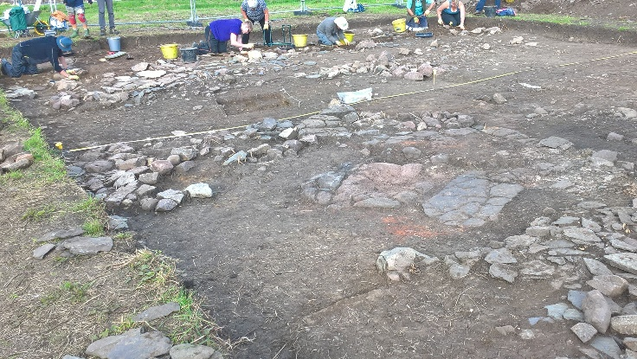
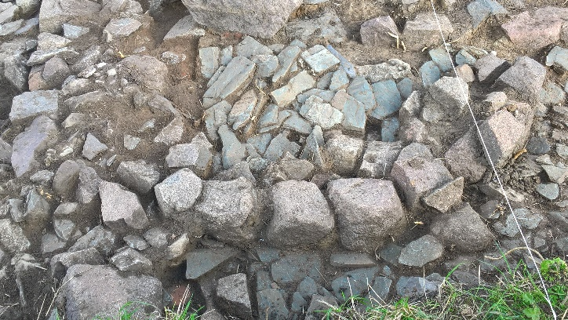

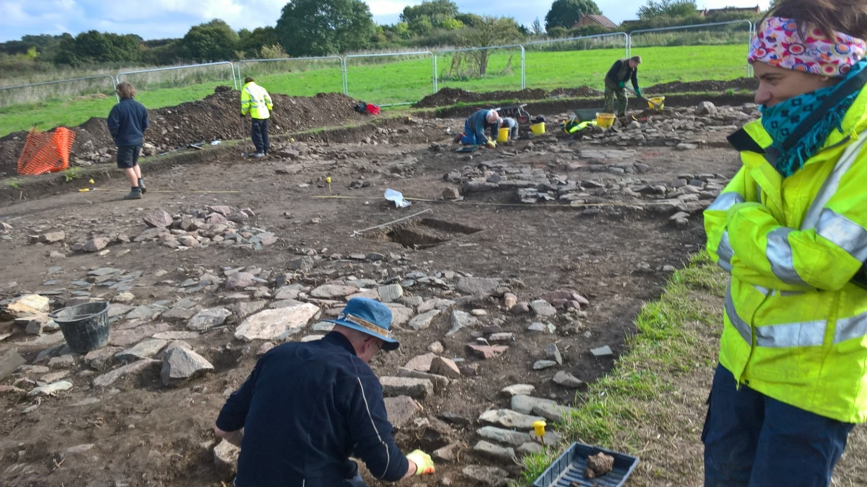
On the right, below is Mireya Gonzales Rodriguez, one of the Bosworth Links Supervisors.

For more information about this dig and the overall project please have a look at https://ulasnews.com/2017/08/29/ulas-archaeologists-return-to-city-park-to-explore-historic-monument-linked-with-the-knights-hospitallers/
Preserving the past for our future
Our Archive room is now ready and we have started to move items into the cabinets and map chest. It will take some time but well worth the effort. We have been offered some unique items and will reveal all later but for now do remember that if you have maps or documents, videos, DVDs diaries, etc. etc. that will be of interest to researchers now and in the future do please contact the Society. We are always happy to discuss how to preserve this information for future generations. it would be a terrible shame for any of these items to be lost to future generations. My telephone number and email address are printed above.

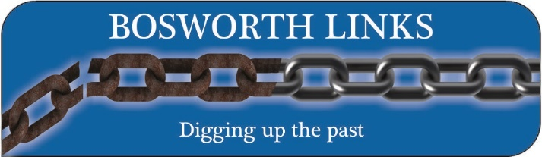
Bosworth Links Update and important dates!
When I saw Mathew recently I took the opportunity to check on progress with the finds from our Community Dig in July. I am delighted to report that the pottery analysis is now complete and the report is ready to be written. The clay pipes, bowls and stems are being examined as we speak and next the flint sherds. Mathew again confirmed that every single pit had produced something of interest, even significance
The Feedback Meeting and World Screening of the Dig video has been confirmed. It will take place in the Dixie Grammar School Hall on the 19th of November and promises to be a very exciting meeting. The exact timings will be announced nearer to the meeting but we hope everyone in Bosworth will come and see the finds and that all of the volunteers will be present when we screen the video. It will be a great opportunity to find out what we can now tell about the development of Bosworth as a settlement.
Funding
We will shortly be submitting our paid receipts to our sponsors in order to secure next year’s funding and we will start again planning for the dig on the 21st and 22nd of July 2018. Do keep an eye on the website www.marketbosworthsociety.com/bosworth-links for more information and also our Facebook page. We will shortly be planning the test pit sites and so if you have already volunteered to host a pit we will be in touch in due course. We will also be knocking on a few doors in locations where we would like to develop our knowledge. If you would like to take part, we are planning 25 pits again next year so there is plenty of room for everyone, please let us know. If you would like to host a pit you can contact us via the website or call 07930149408 01455290160. Volunteers can register on the website by following the link and if you are not a web user don’t worry. Just call us and we will arrange to get a volunteer form to you. We had a brilliant cross section of people taking part last year and hope to do so again. It is very important to me, the Bosworth links Committee and the Market Bosworth Society Committee that we include everyone regardless of age or ability. There is a role for everyone, don’t be shy come and join in the fun. If you doubt me ask anyone who took part in the Summer.
The dates for your diary are:
19th November 2017, Feedback meeting with Mathew Morris and the first screening of the dig video! World Premier!
21st June, 2018 Community Meeting (provisional at St. Peter’s Church)
30th June, 2018 Masterclass with Peter Liddle MBE
21st and 22nd July 2018 Community Archaeological dig in and around Bosworth
Unless stated otherwise the events will take place in the Dixie Grammar School Hall.
See you there!
Nigel Palmer
Chairman

