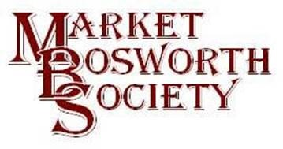September 2016
Dear Member,
Welcome to our September Newsletter, which is a little longer than usual. I hope you will not mind. I would like to start this month with our September lecture, “Memories of Bosworth Panel”. I was unable to attend the meeting personally as Lynne and I were enjoying a short break at the coast. But, I understand from a number of people that it was another successful evening akin to the May lecture. These evenings do appear to be popular and I will be working with your committee to schedule in some for next year. Robert has very kindly provided me with a report which I include here. The report is virtually unedited. I just corrected the spelling mistakes (just joking Robert, there were none).
Our meeting on September 15th drew a good audience for a history of the businesses occupying 9 -11 Main Street, where Elizabeth Ann and Lloyd’s Chemist are now located.
After watching early television advertisements on the screen to welcome the audience and set the 1950s/1960s mood, Robert Leake was the narrator for the story which had been extensively researched by Glynis Oakley, Beth Dawson and Ingrid Davison. Thank you very much ladies, another first class job.
The audience heard about Elliot Hollier, the earliest trader [1828] at number 11, a seedsman and druggist, followed by Henry Thorburn [1849] and then the first in a line of grocers, James Hollier. In 1863. Thomas Drackley came next and then by 1904 Thomas Curtis followed by Arthur Percy Beale, 1912 – 1925.
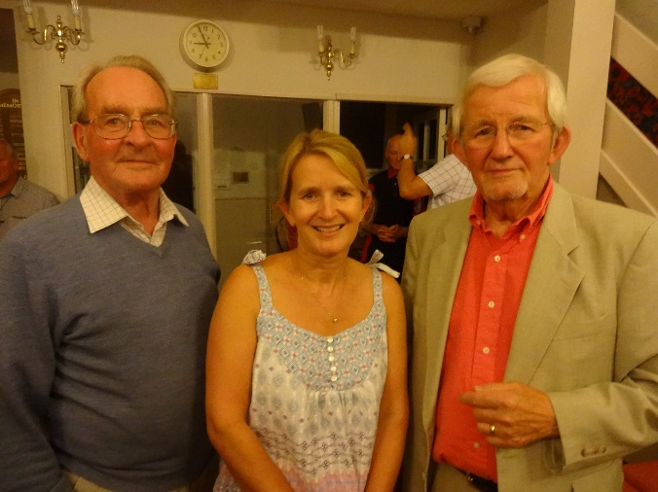
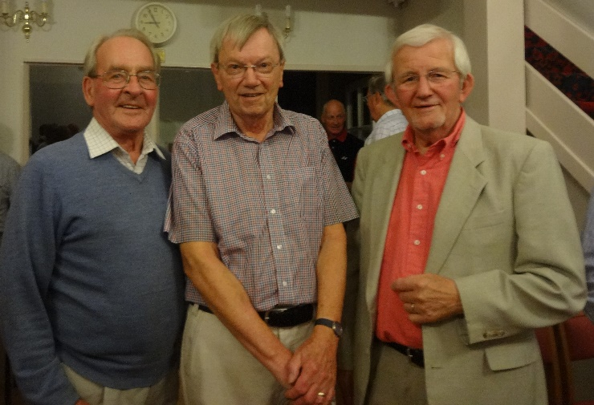
On display were records, advertisements and photographs of the different businesses as the evening progressed. Memories taken from a range of sources were used to describe what these shops were like. Laura Croman had written about Mr Beale being known as ‘Nippy Beale’ because of his way of nipping a raisin in half to give the exact weight! Thoughts of Arkwright’s ‘Open All Hours’ crept in to our minds, encouraged by our narrator...

Phil Tebbutt, Robert Leake (narrator) and Alan Bamford Phil, Alan’s daughter and Alan.

Then the story came into living memory with Bertha and Dennis Quincey taking over the shop.
Kay Palmer [nee Quincey] was able to bring the shop alive in a recording she made for the Society describing her memories. Mary Coleman [nee Quincey] also had memories of the shop which were read out, including the flour which came from the Help Out Mill at Odstone and memories of Eunice Lowe and Betty Pallett who worked in the shop. Roger Loseby had memories too, particularly of the bacon slicer and the Huntley & Palmers glass fronted biscuit display case.
Cliff and Marjorie Tebbutt took over in December 1953 and there were some memories from Phil Tebbutt which were read out. In 1962 the Tebbutts opened a fancy goods shop where Dressini is now based and Ike and Lucy Bamford began their 15 years in Main Street. Their son, Allan, was in the audience with his daughter to hear his reminiscences spoken. From all the descriptions and photographs the audience were able to build a clear picture of shopping at the time, for many bringing back almost forgotten memories. Winifred Pratt, Freda Rollinson, Maureen Mattock and Glynis Parnell were all remembered, while former shop and delivery boy John Smith was present to personally describe some of his memories of life in the shop, anecdotes about delivering and the generosity of the Bamford family. These were the days when the ‘customer was king’. John’s stories were followed by a spontaneous round of applause.
The Bamford story continued with the opening by Pauline and Allan of a craft shop and then a coffee shop in the adjacent front rooms, now number 9 Main Street.
After experiencing the change to decimal currency and the introduction of VAT, always doing their best for the customers, Ike and Lucy decided to retire. Mrs Appleby-Austin from Carlton bought the businesses and it became Crofters [wines and delicatessen], later PF & T. Herbage [high class grocers] and then bought by Carol and Tim Pyatt [delicatessen and coffee shop], taking the story up to the 1980s, when other businesses took over parts of the extensive buildings. These included Hornbrook & Godwin [furnishings], House of Hazel [jewellery], Tout Loisir [leisure wear], Ore Inspired [a cave of unusual treasures], Rivals [antiques] and Pobbs [wine bar] before Elizabeth Ann began at number 11 in 1984, with Lloyds Chemist in the adjacent premises at number 9.
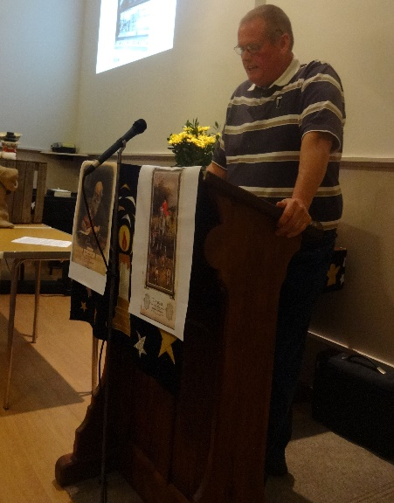
Glynis and Ingrid were thanked not only for their considerable efforts with the research but also Glynis for putting together all the photos and advertisements [from old copies of Church News or Aspect] to make a continuous visual throughout the talk. The audience seemed to enjoy the evening, going home thinking of bacon slicers, biscuit displays and sweet jars, and wondering if they could still ask for ‘tick’ or delivery at their local shops.

John Smith Remembering and sharing his time at “Bamford’s”
As someone once said, there’s more. I have the transcript of John’s speech and after reading it could not resist repeating it here. It invoked so many, forgotten memories for me I thought you too might like to read it (if you were there on the evening forgive me).
John Smith
Bamford’s Shop Boy
I worked at Bamford’s part time, Monday, Tuesday, Thursday and Friday nights and Saturday mornings from 1963 and then full time from 1966 – 1975.The other staff who worked part-time were Winifred Pratt, Maureen Mattock, Freda Rollinson and later Glenis Parnell. I wore a grey overall when I first started and one of my jobs was to whitewash the walls in the store rooms; this was a job that was undertaken once a year.
My job entailed serving the customers, stocking shelves, lifting and carrying, and delivering groceries. Tuesday was the quietest day of the week when I cleaned shelves. I also did weighing up; for example, corn, rabbit pellets, and chicken pellets. Some products were weighed up as customers required them for example; prunes, dried apricots, turmeric, black peppercorns and nutmegs. Cream cheese had to be cut and sold in 4oz portions, it came in a 3lb block and it was very difficult to make the last portion 4oz, so you were left 3 3/4ozs which then had to be sold a bit cheaper.
I remembered the shop had Danish bacon delivered on Mondays, Lovett’s pop on Tuesdays and Hoyes pop on a Thursday. The brewery delivered on a Tuesday or a Thursday and I got the crates ready. There was a 6d deposit on a bottle. Customers bought their ruby wine or sherry from a barrel. Customer service was important and I had to serve promptly. My hours were from 8 am to 12.30 and then 2pm to 6pm. I had one and a half hours for lunch. Sometimes when Lampards were making faggots on a Monday I would buy one and eat it for lunch.
Everything had to be priced and Shaw's Book told you the price of all the goods. There was a white band with squares that you put the prices on. When decimalisation came in, I had to stay late to put all the new prices on. The till was a drawer so I had to add up in my head or write it down. My first ever full time wage packet was £4.19s.6d which I collected on a Saturday and when I left in 1975 it was £19.00.
Mr Bamford's Vauxhall car used for deliveries
Mr Bamford let me drive the van up and down farmers drives for practice before I got my licence. Jim Sippett from Cadeby taught me to drive. I made the deliveries on my own after I passed my test. I loaded the van between 4 pm and 4.30 pm and was back home by 6.30 pm (sometimes later if the farmer’s wife made me a drink). When out in the van I had a money float. Some of the farmers had a monthly account. Deliveries included such villages as Shackerstone, Congerstone, Carlton, Wellsborough, Bosworth, Bull in the Oak, Cadeby, Sutton Cheney, Coton, Shenton and Vero’s at Stapleton. These deliveries, usually in boxes, were made on Mondays, Thursdays, Fridays and Saturday mornings. I mostly delivered to the same people each week.
On Wednesdays we went to Leicester to pick up groceries and sweets from the wholesalers. I collected eggs from Clarke’s farm in Shenton and goats’ milk from Wollaston’s also in Shenton. Occasionally I took Guinness in a barrel to the Guinness family who lived at Osbaston Hall. Sir Wolston Dixie, who at that time lived at The Inn on the Park, (now demolished), also had deliveries. Mr Davis, who lived in Sutton Lane, left his order on a wooden pedestal just inside the door, which I collected on Mondays.
When the gas pipeline was being constructed, the welders on the pipeline were French and they would send someone to the shop daily to purchase Brie and Camembert cheese and a dozen or two crates of Marston's bitter.
Mr and Mrs Bamford were keen on dancing and another couple came over on Fridays. Soda flakes were sprinkled on the floor to make it easier to dance.
I remember when yoghurts first came out and Mr Bamford ordered what he thought was quantities in threes and sixes but on delivery we found they were in dozens! We had them everywhere but managed to sell them all!
When the Bamfords were on holiday, I ran the shop and needed to arrive earlier for the bread deliveries and the beer delivery. I felt like part of the family and was treated like part of the family. On one occasion Mr Bamford paid for a ticket so that I could go to the Leicester City Cup Final in 1969. When I left on February 5th 1975, aged 23, Mr Bamford gave me £25 as a thank you (more than week's wages) as well as my usual wage packet. John Smith.

Wow, I think you will agree that a lot of hard work was put into the evening and that it was a great success.
Now, moving on please remember to have a go at the Photography Competition, your committee has sanctioned £500 in total prize money and it could be you! For full details go to www.marketbosworthsociety.com/competition The photographs do not have to be new, provided they meet the rules they will be acceptable. If anyone is unsure after reading the rules please contact me. If you do not have access to the internet, then perhaps a friend or neighbour could help you upload your picture? Remember it is open to anyone not just Society members or even residents of Bosworth.
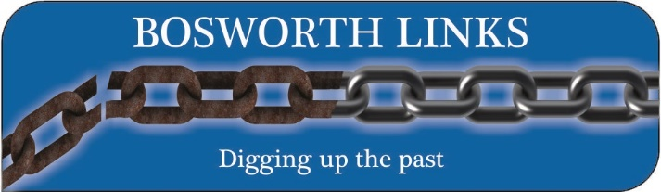
You will be seeing this logo around and about in increasing abundance. It is the name given to a very exciting archaeological project, the brainchild of our previous chairman, Peter Loseby. That is all for now but Bosworth Links is very much a part of the Market Bosworth Society. I expect to provide more information next month
Finally, our next lecture is on the 20th October, 2016 to commence at an earlier time of 7:10pm. We actually have two lectures that evening. John Pope, Parish Councillor and chairman of the Local Development Plan is undertaking a complete survey of trees and hedgerows in and around Bosworth, with the intention of protecting them as appropriate. He has asked for 10 minutes to inform you what he is about with a 10-minute slot to answer any questions. Following John, we will have our lecture proper which is the exciting sounding “Layman’s Guide to Ancient Roman Medicine and Surgery”, to be delivered by John Waite. I don’t think I would have enjoyed Roman surgery but you never know. Perhaps after John’s lecture all will be revealed.
Apologies for the length of the News Letter but I hope you have enjoyed reading it. I know Eric will be ticking me off as I have exceeded two pages! Sorry Eric.
I hope to see you at our next lecture, but for now my very best wishes to you.
Nigel Palmer
Chairman, Market Bosworth Society

