Dear Member
Welcome to this, the August News Letter. I hope that the News Letter finds you well and that you have been enjoying the fine weather. Although the fine weather seems to find me jobs to do in the garden it is nice to be out in the sunshine.
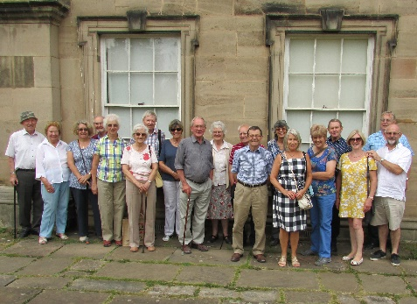
It was also a lovely day for the second of our Summer Visits, this time to Calke Abbey. Not too far away and well worth a visit. To the left is a photograph of the members taking part, just before we commenced our tour, many of whom said how much they enjoyed looking around the house and gardens. Not to mention the rather fine cream teas. On arriving at the house entrance, we were met by one of the guides who gave us an interesting and thorough introduction to the house. Whilst a guided tour was not available each room had a room guide who were more than happy to engage in conversation and answer a myriad of questions. We were informed, during the introduction, that the display consisted of about half of the items The National Trust had discovered when taking over the house. The rest was in storage. Take it from me, there was plenty to see. Many fascinating items from home and abroad, the four poster bed has to be seen to be believed. The introduction also explained the philosophy of the National Trust and its approach to the properties in its care. The objective is to preserve and not to improve. This policy meant that we could appreciate the house as it was and not how it could be. In one room part of the ceiling had fallen. This exposed the lath and lap process of plastering of the time which was very interesting to see. It was an art form to plaster in those days, no plaster board and a quick skim. The plasterer had to apply the plaster in such a way that it looped over the lath and remained thus until it had dried. The mixture would have to be exactly right or it simply would not work. A lot of skill in the old days. As I made my way around the house I noticed that as I ventured further into the older part the temperature dropped quite considerably, no doubt the thick stone walls and that part of the old section was nearly below ground. On average, over the years there were some 25 servants of all descriptions required to look after the house and its inhabitants, how times have changed. Given the chance to have one servant I think I would choose a gardener whilst Lynne would certainly choose a parlour maid. It was an excellent visit, Robert Leake has suggested that we return when the Christmas lights are switched on. Let me know if you are interested. No promises at this stage but if enough want to go I am sure we can arrange something. Thank you to those members who attended I thoroughly enjoyed your company as we explored the house together.
At our last committee meeting Martyn (Andrews) alerted us to an article in a country magazine, relating to the creation of rural diesel electricity generating sites. My research has suggested that whilst the Government plans to invest £110M in wind energy they are concerned that in the meantime a temporary source of electricity needs to be found as does a source when the wind does not blow. It was originally envisioned that owners of standby diesel electricity generators, in rural locations would receive payments for supplying the National Grid, much the same as householders with solar panels do now. The article suggested (and this appeared to be counter intuitive when the cost of diesel is considered) that sites are beginning to spring up in rural locations with the purpose of profiting from selling diesel generated electricity. Clearly there are a number of issues quite apart from the air quality issue and noise pollution. Should any member hear of plans for one of these sites please alert me or any member of your committee.
Please do not forget to let the Market Bosworth Parish Council (MBPC) know if you have had any difficulties with the Back Lane Surgery doors. At the last meeting the chairman of MBPC, John Wasteny asked me to pass on his thanks to those members who had contacted MBPC with their experiences and comments. John went on to say that this type of feedback from our members was very valuable in helping to secure a solution.
Incidentally, if you hear of anyone not receiving their copy of the News Letters please do let me know (nigel_palmer.MBS@btinternet.com or 07930149408) as I am in the process of trying to track down two members whose contact details are not accurate or up to date. There may of course be more. Do tell.
Now on to more welcome (much more welcome) and somewhat exciting news. The Market Bosworth Society website was set up over six years ago. A great job was done in setting it up and it has stood the test of time. Since then it has served us very well but in terms of the internet six years is a long time. The website was in need of some updating, not to mention some TLC and George Lees (who you know monitors our website and was instrumental in setting up our very popular Facebook page) and I, found the whole process very daunting. Until, that is, we were introduced to Steve Barrett. Steve has turned out to be nothing short of a godsend to us. Not only has he been able to update our website to the latest software (ensuring strong protection from viruses, malware, hackers and other nasties) he has been able to facilitate additional pages for our Photographic Competition. I will be sending out full details of the competition nearer to the launch (likely to be the 15th of September. 2016). Your committee have agreed to a sizeable prize fund. We are all hoping for a positive response with an avalanche of entries. But as I said more of that later. The finishing touches are, as I type this being put into place.
After our Summer Visits in July and August we are back indoors. Our lecture on the 15th September, in The Free Church, Barton Road, 7:30pm is entitled “Memories of Bosworth Panel”. It has been carefully researched by Glynis and her team and will once again be narrated by our own Robert Leake. Many have complemented Robert on his narration of the lecture in May. If you were present on that evening you will know what a fantastic job the researchers and narrator did, bringing the history alive. I was struck by the number of members and guests who remained after the lecture sharing and swapping anecdotes and stories. A lot of memories were rekindled that evening, that is certain. You will not want to miss this lecture. If you know of someone who although not a member who would like to attend, please remember that subject to availability they will be warmly welcomed. We usually charge a small fee of £3.00 to help cover costs.
I look forward to welcoming you at our September meeting and remember to keep a look out for news of the competition.

Best wishes.

Nigel Palmer
Chairman
Market Bosworth Society.

