July 2017

Dear Member
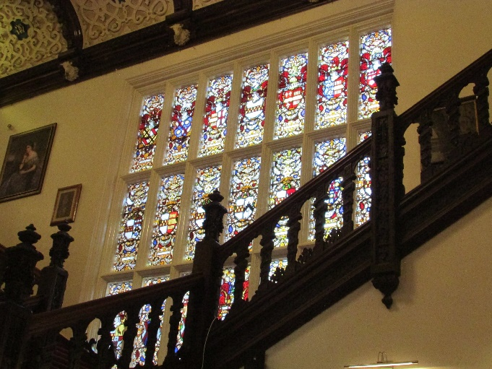
I would like to apologise that this month’s News Letter is later than usual, normal service will be resumed in August. I hope that this, our July newsletter finds you well and enjoying the summer, or at least dodging the spots. I am still getting my breath back from last weekend when we held the first of our digs under the Bosworth Links banner. Despite some dodgy weather it was a rip-roaring success enjoyed by a few hundred people. I will come back to that later but for the moment I want to mention our field trip to Beaumanor Hall. I was joined by 18 fellow members and after assembling in the vestibule of the Hall we were greeted by Margaret out guide for the afternoon. Margaret explained the genesis of the house and the Herrick family who had lived there for over 300 years until in 1915 the last family member died and as there were no heirs the association ended.
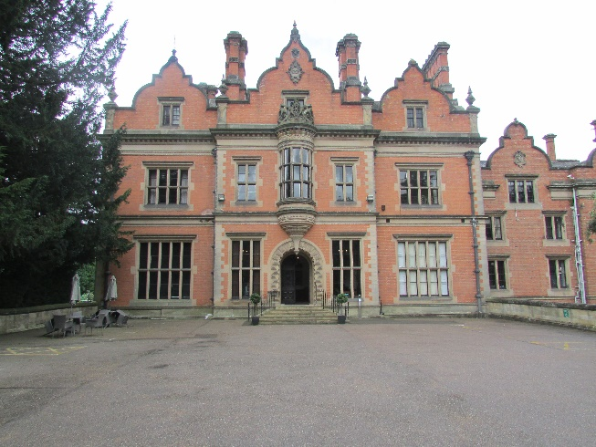
I was struck by the beautiful wood carvings on the ceilings and the oak panelling, for anyone who appreciates the beauty of wood it is a real treasure. One of the highlights for me was the fantastic stained glass window (see above) which depicted the arms of the various Herrick families together with those with whom marriage united them. Unusually the window faced North and so the light was subtle, a factor which had helped to preserve the brilliance of the colours. It could be that the North facing wall was the only one available for the window, personally I prefer to think that it was deliberately done to preserve the colours and to be able to enjoy the glass in a gentle light. As usual the servant’s quarters and even the middle-class guest bedrooms were not a patch on those of the owners. Halfway through our tour we were provided with soft drinks, coffee, tea and biscuits. We then ventured into the cellars to look at the Salting Room, where meat was preserved before being kept in an ice house, the laundry and the kitchen. In one of the rooms Margaret’s husband had created a display of early electrical appliances, Hoover vacuum cleaners, a Hoovermatic washing machine a twin tub and many others. Well worth a visit for that alone. We then enjoyed a walk through the grounds (the rain being remarkably well behaved and falling only when we were indoors) past the various war-time huts to the Morse room where we could imagine all of those engaged on listening to the enemy concentrating hard during their 6 hours shifts.
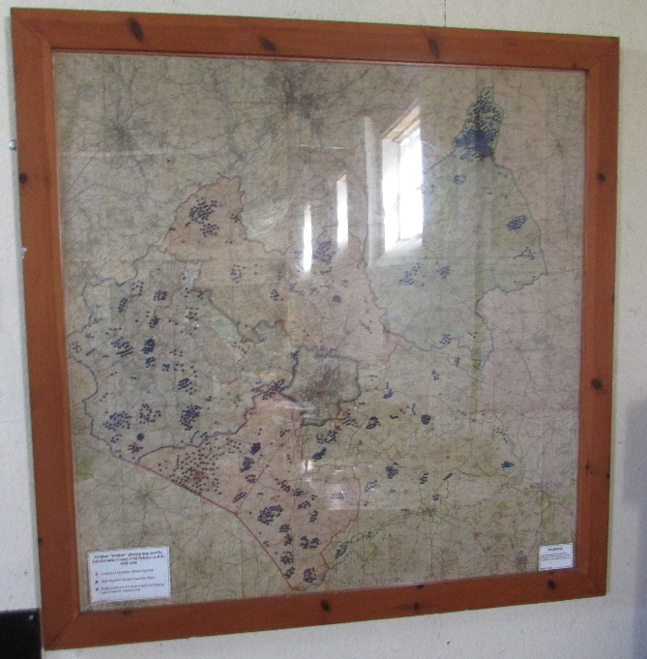
Not a great picture, but this is a map, showing a plot of all the bombs which fell in Leicestershire over the course of World War 2
It shows general bombs, high explosive bombs and also incendiary bombs. You may notice an anomaly and keep that in mind as the answer will become clear in November. No cheating now! I would like to thank all of the members who joined in with me and Lynne and made it a lovely afternoon.
Don’t forget that the Bosworth Battlefield visit is on the 17th August and the list is filling fast, don’t miss out!

Bosworth Street and the Tommies
We have been researching the answers to the questions posed by The Tommies and I have to say the archive has turned up some excellent information which I am sure they will make full use of when they return from their summer break. We have also been contacted by a number of people from and around Bosworth. We are very grateful to those who have taken the time and trouble to look out their memories and mementoes. We will be publishing a proper thank you next month but for now please know that we are very grateful for your help.
Archive Update and Gap Closure
I have been to see Paul Grundy, Borough Conservation Officer who gave me over an hour of his time to help research some of the Borough Councils files (it was Market Bosworth Council in those days) and have some interesting plans to add to those lent by Mrs Farmer of Warwick Lane. I have been contacted by a number of people who suggested I contact those who once worked for Billy Beck. I am in the process of researching a list but if you happen to be one of Billy’s employees or you know someone who was please get in touch 07930149408/01455290160 or info@marketbosworthsociety.com. Harcourt Spinney remains something of a mystery despite some excellent photographs lent by Peter and Marilyn Hooker. Come on, whilst it’s raining get into that old trunk in the attic and have a good sort out. There will shortly be some very exciting news about a brand new archive facility in the centre of Market Bosworth. That is all for now, but on this occasion at least the word exciting has been appropriately used. Watch this space as they say.

It is a job to know where to start. We had a fantastically successful weekend, thanks to over 150 volunteers and personnel from University of Leicester Archaeology Services. The weather did almost behave but any rain did not dampen our spirits, even though I feared we would wake up Sunday morning to 23 swimming pools! Every pit offered up finds of relevance, being pottery or flint or both. We had people digging, people riddling, people recording, people collecting, people washing (some trying to do all of these at once) it was brilliant. A real community effort. We had some volunteers from outside Bosworth and without exception commented on how well they had been welcomed and made to feel at home. What made it worthwhile was not just the enormous amount of valuable data but the smiles on the faces of people at the feedback meeting and Barbeque. It was a fantastic community event with people of all ages and abilities working and chatting together. Gemma and the team did a brilliant job.
We held a Bosworth Links committee meeting yesterday evening to review the weekend and the early results. Mathew Morris, our Project Manager, was delighted with the level of finds which are much greater than previous digs at Charnwood and Rothley. Early indications are, and this is obviously subject to verification, that Roman pottery was found together with pottery sherds from the first century all the way to the 20th century. Add to that the flint debitage (the waste flint from flint tool making) found in a number of pits especially at St. Peter’s Junior Academy (where we also discovered a sherd of prehistoric pottery) and we have evidence that Bosworth has been a centre of habitation for thousands of years. We have also made some progress in our aim to establish the centre of the Medieval settlement but will need to dig more pits next year to confirm our analysis.
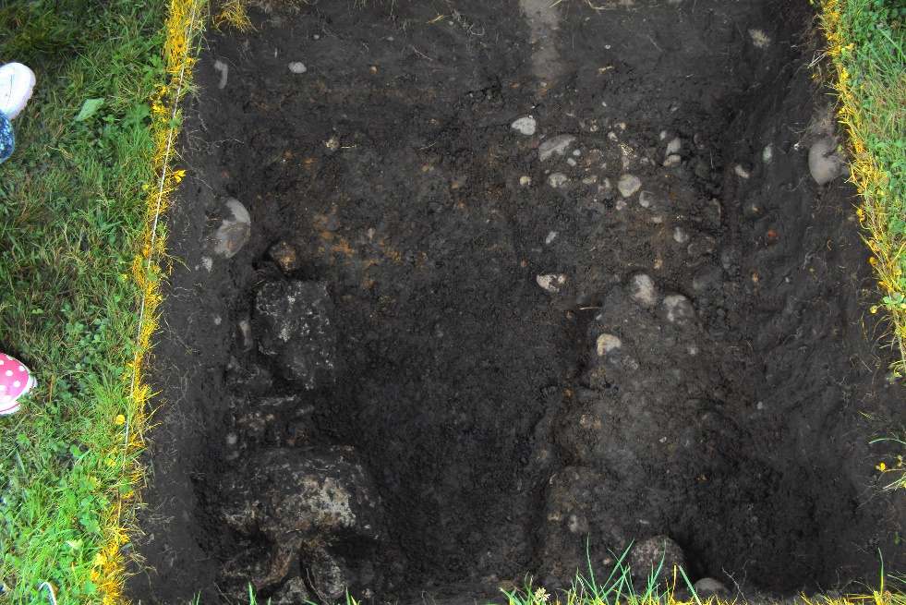
Seen here is the pit on the Parish Field. Bottom left is a structure made we believe of Carlton stone (the same as bounds the bottom of Rainbow Cottage and The Alms Houses) a small strip bearing charcoal and burnt material along the centre line and on the right an area which appears to have been cobbled with small round stones. More work needed here to establish exactly what it is. Reference to old maps on the website has not been conclusive and so it will either need further excavation or perhaps a Geophysical Survey to see where it leads. Anyone living on the East side of Cedar Drive may want to stand by!
The Parish Field was a focal point for visitors and we were very grateful to Malcolm Lockett, Chairman of the Hinckley Archaeological Society who brought a splendid selection of artefacts to show our visitors. Malcolm enjoyed explaining the artefacts and even got his hands dirty as he helped us to excavate the structure we found. Thank you very much Malcolm, you were fantastic.
A good and typical example of the willingness of the community to support the dig was the neighbours of the Parish Field generously allowing the dig team to use their outside facilities. A lady nearby allowed us to use her garage to boil a kettle and make tea. So much goodwill and willingness to help was truly humbling.
We had a Metal detecting exhibition taking place at the same time on the Parish Field. Carlo Camposano worked with David Neave and Ed Robinson to give a demonstration of responsible metal detecting. Many items were found but two that stand out for me were a flattened musket ball (it must have hit something) and a silver penny dated 1645 in the same clod of earth. The exhibition was very popular, with children ignoring the sand pit and colouring sheets to watch the detectors at work. At one point David resembled the Pied Piper as he was surrounded by excited and interested children. Some people even had a go at detecting. Much more work will be needed to complete the detection of the field as it has to be done in layers with later deposits hiding earlier ones. Hopefully the exhibition will have shown that metal detecting has a rightful place in archaeological discoveries and more opportunities will result. See our website and Facebook page for updates and photos.
Phase one is almost complete, with the results feedback taking place on the 19th November 2017. At the meeting the finds will be on display and Mathew Morris will give a presentation encompassing all of the data gathered so far. That will certainly not be a meeting to miss. Planning for 2018 has already started and we have left open the volunteer form on the website (www.marketbosworthsociety.com/bosworth-links). We would love to hear from anyone who would like to host a test pit. You do not have to be an expert, you do not have to provide your own dig team all you have to do is offer a small, one metre square, bit of your garden for examination. We already have quite a number of offers for next year but do please contact us on 07930149408 or info@marketbosworthsociety.com if you are interested. I am always happy to have a chat with anyone wanting to find out more about the Society or any of its projects.
The list of people I need to thank is enormous and you will be relieved that I am not going to do that here. Eric would be very annoyed at having to print umpteen pages! We will be contacting everyone separately but a big thank you to all who took part, making the weekend very special. You were magnificent.
Nigel Palmer
Chairman

