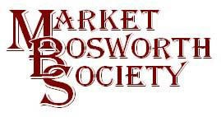 June 2017

Dear Member
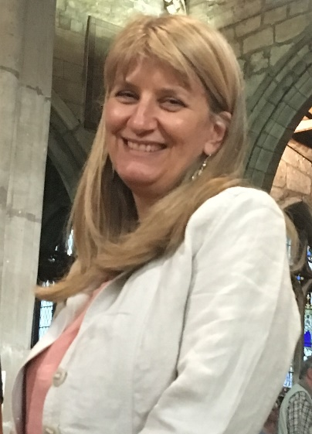
I hope you are well and able to cope in this unaccustomed heat, although as I type this we are back to warm rain. I hope you were able to attend last Thursday and had a good time at St, Peter’s Parish Church Thank you to those who came and helped to make a great atmosphere. We were made very welcome at church by Robert Leake, who did all he could to make sure we had tables and chairs as needed. Thank you Robert, much appreciated. We had decided a temporary move from the Free Church would give us more capacity, which we needed. There were over 80 people at the Community Meeting (more about that later), many of whom remained for the MBS lecture being joined, of course by members.. We had been looking forward to hearing Professor Carenza Lewis talk for some time and we were not disappointed. Before her lecture Carenza was happy to talk to those present, sign auto graphs and pose for pictures. Her lecture was humorous, factual, inciteful and motivational. Carenza chose for her title Power of Pits and it became clear it was an apt title. Carenza started her series of pits in 2000. She deliberately chose populated areas (not areas of know previous occupation such as deserted villages). This enabled a picture to be established of historic occupation of a site and any shifts in its centre. Exactly what we are aiming to achieve via Bosworth Links. Carenza went on to show how by carefully examining finds, no matter how small, a time map could be drawn up. By finding, identifying and dating the things thrown away or lost by our ancestors Carenza was able to show the development of settlements from pre-historic times right up to the present day. In a series of map overlays she charted the different groups who used the site of the settlement. We were shown where the main habitation of Iron Age groups, then changed to Roman occupation and then Anglo Saxon. We hope to do the same and be able to see how Bosworth has changed. It will be very interesting to see if the 15th Century had a similarly spectacular effect upon Bosworth as was seen elsewhere. I think Carenza’s method could be subtitled “So much from so little” as the smallest shard of pottery, correctly identified and dated can tell a big, big story.
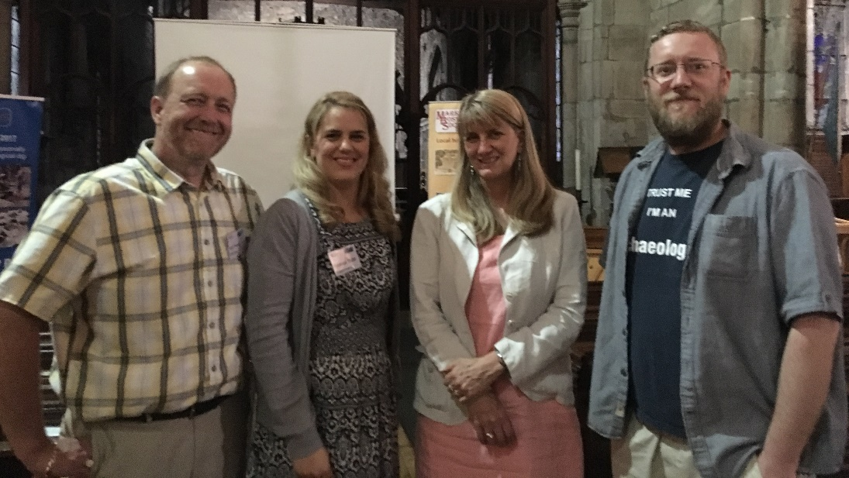
Carenza was happy to pose for pictures and sign autographs. She was very friendly and loved answering our questions. Seen here is Yours truly (clearly relieved that the evening had been a great success) Gemma, our Project Officer who is making significant progress in finalising the details of our dig, Carenza who has been very supportive and helpful and Mathew our Project Leader and Chief Archaeologist.

Immediately prior to the Society’s lecture meeting we held a Community Meeting. This was open to everyone who was interested in Bosworth Links, whether they had volunteered to take part, agreed to host a pit or simply curious about the project. As previously mentioned over 80 people came to the meeting to be greeted with a glass of wine or orange juice. We were joined by Mathew who had brought a selection of finds to show what may be found in our pits. Carlo and Marie Camposano brought a wide selection of their finds, discovered over many years of field walking and digging. The finds tables were popular all evening with many interested parties taking the opportunity to see for themselves the sort of items that could be unearthed. Thank you to all who donated to Bosworth Links, you were all very kind!
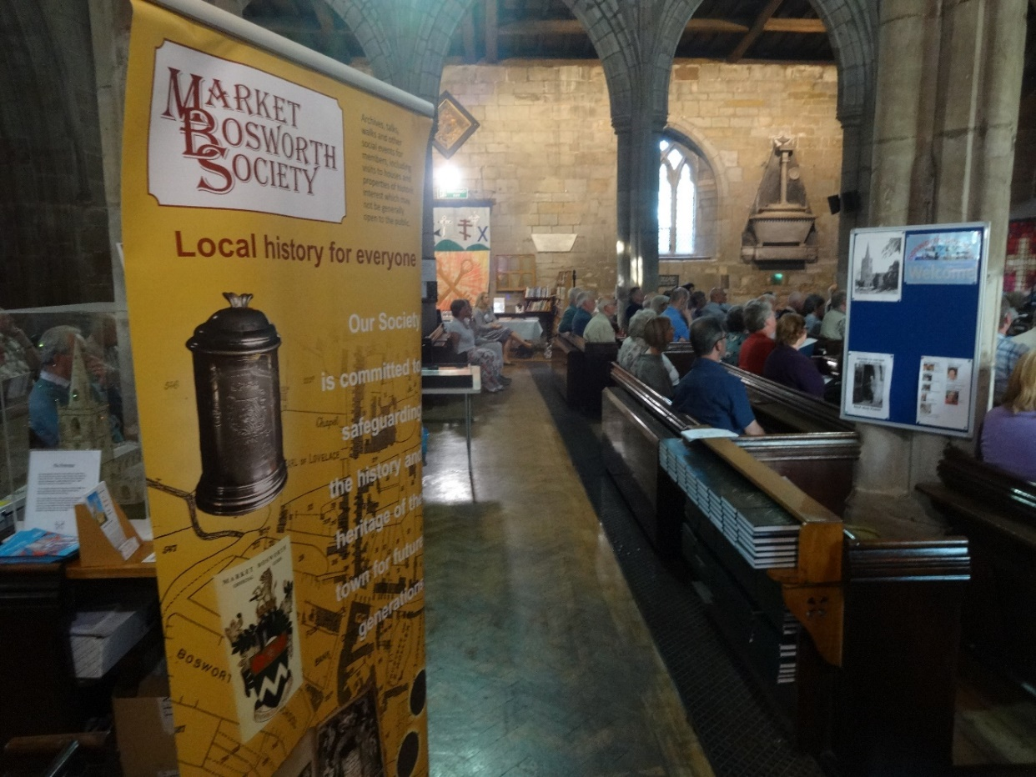
As you can see, St. Peter’s Parish Church was quite full in anticipation of Mathews lecture and later Carenza.
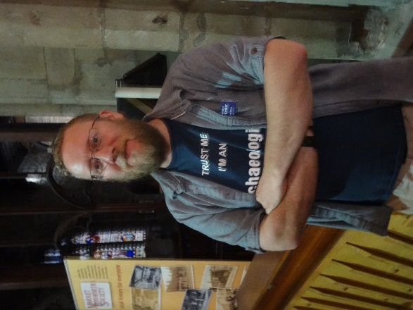
Mathew (seen her just before his lecture) is an old hand at public speaking following many engagements where he reports how the remains of King Richard III were discovered. Mathew explained why we wanted to excavate parts of Bosworth, how we were to go about it and what we may discover. Of course we will not know the answer to the last point until after the digs. We will be looking to open some of the sites to visitors and will be putting up notices when visitors will be welcome to visit the pit sites, with owner’s prior permission.
It all happens on the 22nd & 23rd July. You still have time to register (if you are quick) by visiting www.marketbosworthsociety.com/bosworth-links. Come and be part of a fantastic project to learn more about our history.
Thank you to all of our Test Pit Hosts and Volunteers!
Bosworth Links Master Class
May I remind all of our volunteers that the Masterclass, led by Peter Liddle MBE will take place on the 1st July in the Dixie Hall. The event will start at 1:00 pm and will be completed by 4:00 pm. Peter will use his expertise to explain the process of test pitting and what to look for. He will explain how to identify something of interest and what to do if unsure. It will be an invaluable meeting for all taking part. Light refreshments (tea, coffee and biscuits) will be provided.
Beaumanor Hall Summer Field Trip Visit
The list is open for our visit to Beaumanor Hall. The numbers are limited to 25 and the list is filling fast. If you would like to go please let me or Robert Leake know ( nigel_palmer.mbs@btinternet.com 01455 290160 or 07930 149408, or Robert Leake, robert@robertleake.com or 01455 290020) as soon as possible.
We have had offers of lifts from some members. If you would like to travel with them then please contact them directly. Lifts have been offered by:
Name Seats Available
Rick & Chris Jones 2
Beth Dawes 2
Richard Liddington 2
Phil Tebbutt 2

Thank you to those offering lifts. It should be an interesting trip (flier attached in case you missed it earlier).
Subscriptions
Please note that subscriptions fall due at the Annual General Meeting in March. Thank you to the many who have already renewed. We do have a few members who have yet to renew. I hope you will continue to be members. You can renew by cheque to me, 29 Warwick Lane, Market Bosworth CV13 0JU or drop off your renewal at The Forge, Park street. Any member of the committee will be pleased to help with renewal questions,
Bosworth Street and The Tommies
Recently the Market Bosworth Society was invited to visit the Bosworth Battlefield Centre and meet with a group who call themselves The Tommies. They are all adults facing one or more challenges. They have created a project they are calling Bosworth Street. They have constructed miniature houses, pubs, shops even a hall. Each member has written a story about a character they have created. These track experiences during the First World War. The finished project will be displayed at the centre (probably next to the souvenir shop) from next February.
We were invited as the Tommies were trying to make their stories as realistic and accurate as possible. They had a number of questions and we took them away to start researching answers. We had a wonderful offer from Maurice Harris who has agreed to share all of his research about the War Memorial with the Tommies. This was a very generous and kind offer. We have also received help from Robin Jenkins (a previous lecturer on Leicestershire Hospitals in the First World War) and also David Humbertson (who will be our lecturer in October 2018).But we still need some help. Here are the questions that we have been asked to help with:
- How many people from Market Bosworth went to the war? How many survived? What divisions where they in? Where there any fighter pilots?
- Do we know of any young men from Market Bosworth who lied about their age in order to sign up?
- What was the population of Market Bosworth? How did people leaving for war affect the town?
- Are there any records of people from Market Bosworth going to war as Nurses/Medics?
- Are there any records of miners in Market Bosworth? Is so where did they go to mine?
- Did anyone from Market Bosworth receive a medal? If so which one?
- Was Market Bosworth Subject to the requisitioning of horses?
- Who was the vicar during the war period? Did he have a family?
- Were there any conscientious objectors?
- Do we know anything about the police presence in Market Bosworth over the war? E.g. was there an official police officer or where they away at war with a special constable in the town and more specifically do we have any information about the life of this person?
- Who lived at Bosworth Hall? What was it used for during the war?
- How many farms are recorded for the Market Bosworth area during WW1? Are there records of what they were producing and if this was linked to the war effort?
- Was there a pub in Market Bosworth? What was it called? Do we know anything about the proprietor?
- Are there any diary's/documents left that can tell us more about the people who lived in Market Bosworth at the time...either those who fought or those who stayed at home?
- Do we know of any relatives still living in Market Bosworth of people whose stories might link up to ours?
We are currently working through the Archive but would love to hear from anyone who can answer (even in part) the questions posed. Please contact me nigel_palmer.MBS@btinternet.com or 07930149408/01455290160 if you can help. They are a wonderfully positive and energetic group and very deserving of our support.

Next Field Visit

Will be a return trip to the Battlefield Centre with an interesting extra (if I can arrange it all) so please mark your diaries and calendars for the 17th August, 2017. Times to be advised but cream teas are available! It should prove to be an interesting and fun afternoon. Can’t wait!

Archive Update and Gap Closure

Last month I asked for help with photos, maps and plans. Specifically to fill gaps in the archive for Harcourt Spinney, Shenton Lane and Warwick Close (specifically W.Beck’s builders yard and the farm which preceded it). Thank you to those who have supplied details, especially Mrs Farmer and Chris and Marilyn Hooker, who kindly lent documents and photographs respectively. Please have a look around and see if you too can help to fill in some gaps in our archive. Old deeds (especially if replaced by land certificates) are often an invaluable source of information. Any builders out there may well have some long forgotten plans of the areas we are interested in. Any documents and photographs, can be lent or donated or copies permitted. the Society will be grateful to you for your help, as will, we expect, future generations. My contact details appear above or any committee member will be happy to discuss this with you.

Nigel Palmer
Chairman.

Society visit to historic
Beaumanor Hall
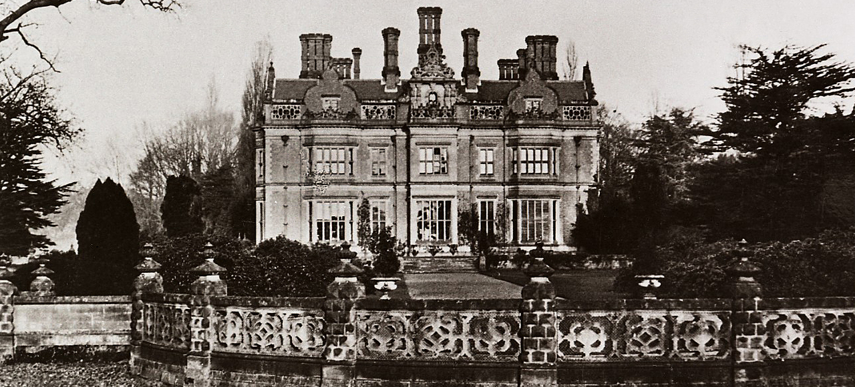
Please note a change of date to that advertised. The visit will take place on:
Thursday, 27th July, 2017
commencing at 2:00 pm (to 4:30 pm approximately).

In an almost direct line between Leicester and Loughborough, Beaumanor Hall has nestled between the villages of Woodhouse Eaves and Quorn, at Woodhouse, since it was built between 1842 and 1854 by architect William Railton for the Herrick family. In 1940 it was requisitioned by the War Office as a Y Station, a secret listening station with links to the Government Code and Cypher School at Bletchley Park. It was later purchased in 1974 by Leicestershire County Council, as an education and conference centre.
The hall is about 15 miles from Market Bosworth (around 30 minutes by car) and for Sat Navs the postal code is LE12 8TX. The cost is £8.00 per person including refreshments.
More information on the Hall is available from https://www.beaumanorhall.co.uk/
Please indicate your intention to attend by contacting Nigel Palmer, nigel_palmer.mbs@btinternet.com 01455 290160 or 07930 149408, or Robert Leake, robert@robertleake.com or 01455 290020
Please note that we are restricted to a maximum of 25 members. First come first served! Please say if you have any spare seats in your car when registering your interest. Many thanks.

