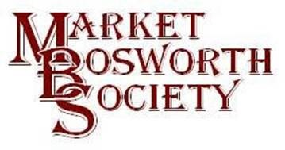
Dear Member
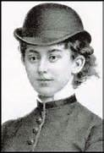
Welcome to the belated issue of our June News Letter. I do apologise for being later than normal but I do have a very good (and quite exciting) excuse. We have just been informed by the Leicestershire County Council’s Green Plaque Awards Scheme (LCCGPAS) that Lady Florence Dixie has been awarded a Green Plaque! That is excellent news indeed and I would like to thank everyone who voted and supported this application. There has been a lot of information exchanged on the Societies Facebook page together with more than one reminder to vote. When you consider that Lady Florence was almost unknown until Peter Loseby recommended her to the LCCGPAS and also that she was up against some very distinguished competition (Sir Frank Whittle to mention one such) to secure a plaque is a brilliant achievement. Well done and thank you to everyone who voted for her. I will make sure that you are kept apprised of developments particularly where and when the Green Plaque is to be displayed.
Very well done indeed and thank you again.
The long anticipated Peter Foss Lecture “The History of Bosworth – How it began” was well received by over 70 member and guests. Peter gave an excellent account as he talked us through some very interesting aspects of his work. His research into how Market Bosworth came into being and developed (as there is no river and not standing on a natural thoroughfare) was very interesting. Peter had identified a chapel known as St. Anne’s (please do forgive me if it should be St. Ann) which pre-dated St. Peters Church by quite a margin. St. Anne’s stood just about where the entrance to Harcourt Spinney is now, on what was at that time a small hill. He went on to display photographs of some of the Roman artefacts, one a complete (but reconstruction) Roman urn, found just across the road from that site, where 48 Barton Road now stands. Peter however, considered that Market Bosworth was not originally a Roman settlement. We will have to explore further, by Test Pitting for example to find the truth (more of that next month). Peter also read out a letter dated in 1727 from one of the Dixie family to his brother, the Baronet. The author of the letter was in London attending a family funeral and had written to the Baronet asking for some of his fine Liquor. Upon researching the use of the word Liquor Peter found that the Shorter Oxford Dictionary pronounced the earliest use of that word as 1747 yet it was in a letter dated 1727, an example of the fascinating historical facts Peter shared with us. A very interesting and enjoyable lecture from a knowledgeable and modest man. I had quite a chat with him before the lecture and must add that I found him a really nice man to talk to with a lively wit and intellect. It is my hope that he will come back again before too long. Perhaps he can be persuaded to come back and tell us about Joseph Moxon? We must wait and see. I for one enjoyed the evening immensely.
Immediately prior to the lecture, Peter and Sheila Loseby were invited onto the stage where they were presented with an engraved cut glass fruit bowl representing a thank you from the committee and members of The Market Bosworth Society for all their hard work as chairman and secretary, respectively. Peter Foss kindly made the presentation on behalf of Market Bosworth Society, which made it all the more special for Peter who, like many present holds Peter Foss in high esteem. That has been one of the very few occasions I have seen Peter Loseby stuck for words! Peter and Sheila were particularly touched by the generosity of the Society and its members, having already received some garden vouchers and a handmade card, presented at the A.G.M. earlier in March. Thanks also to Robert Leake for taking these photographs.
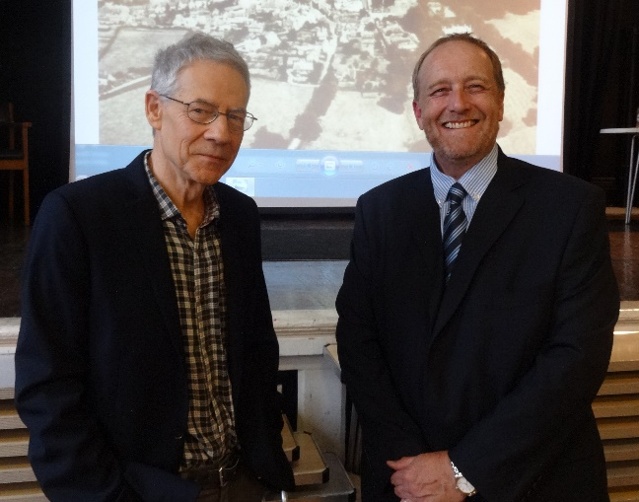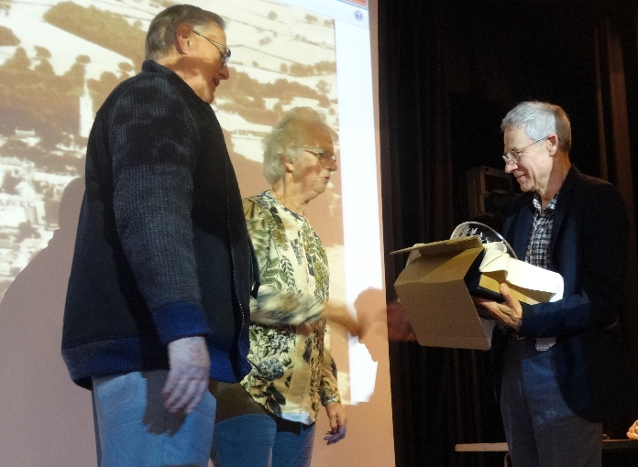
Peter Foss & Nigel Palmer Peter & Sheila Loseby with Peter Foss
At this point in the News Letter I would normally tell you about next month’s lecture but as it is summer (the Open Gardens event was very lucky yesterday) and we are about to say goodbye to Flaming June, we have our first of two Summer Trips coming up. Market Bosworth Society members will be making a summer visit to the Ashby Canal on the 21st July 2016. Geoff Pursglove has kindly offered to lead a Leisure Walk along the banks of the Ashby Canal. Geoff will point out and explain points of interest along the way, which will take us around two hours to complete the two miles. There Is one style to cross (with a detour if required) and Geoff suggests sensible footwear and weather suitable clothing. Members are asked to meet opposite the Globe Inn at Snarestone at 7.00 pm. As car parking is limited it would be most helpful if members could car share wherever possible (I will issue a list of attendees a little nearer to the date). This outing promises to be a lovely walk along a beautiful stretch of the Ashby Canal. There is a limit on the numbers we can accommodate (so far we have 21 places booked and confirmed) so please do not delay. Should you want to attend then please contact nigel_palmer.MBS@btinternet.com, or by calling 07930149408 or if I am unavailable please contact Robert Leake, r.leake@btinternet.com or by telephone on 01455 290020.
Also coming up shortly is the Leicestershire and Rutland Festival of Archaeology which runs from July 16th to the 31st with the launch event on the 10th July, 2016 at the Jewry Wall Museum (156-160 St. Nicholas Circle Leicester, Leicester LE1 4LB, England Phone Number: 0116 225 4971). Sheila & Peter Loseby and I will be at that event and hope that you will be able to come along and see us. We are also supporting the event with two planned activities:
TOUR OF St. PETER’S MARKET BOSWORTH AND ITS CHURCHYARD 18th July 2016: 2.30pm – 4:00 pm Come and join a guided tour around the C14th parish church in historic Market Bosworth, to be followed by a guided walk around the ancient churchyard where some interesting burials will be discovered. Approx. 90 minutes (part indoor/outdoor) Meeting at 2.30 inside the church. To secure a place please contact Robert Leake on 01455 290020 or r.leake@btinternet.com Numbers are limited to just 15 persons. Donations welcomed for St. Peter’s Church.
And also a GUIDED WALK AROUND HISTORIC MARKET BOSWORTH Tuesday 26th July: 7:00pm Peter Loseby will lead a walk around Historic Market Bosworth, pointing out its many architecturally important and unique buildings. Taking approximately 90 minutes. Price £3.00 (which includes souvenir Market Bosworth Town Trail guide booklet, free to Market Bosworth Society members) Meet at the car park off Rectory Lane (parking free) To secure a place please contact Peter Loseby on 01455 293659 or sml53@hotmail.com Numbers are limited to just 20 persons. If you would like to join either, then please contact Robert or Peter as appropriate. I must just add that I have been associated with Market Bosworth for over 54 years and have lived here for more than 30 years all told. I thought I knew most of the history but I have to admit I learned a great deal whilst preparing to conduct a group of visitors on, for me my first Guided Tour, as tour guide. There is so much to learn about Market Bosworth, come along you will be surprised (remember to ask about Dr. Pull).
I hope you will be able to come on the trip to the Ashby Canal but if not then maybe you will be able to join us for our next visit which will be to Calke Abbey in August. That trip will include a guided tour of the house and a walk through the beautiful gardens which should; by August, be at their most fragrant and beautiful, surely a visit not to be missed?
As always if you wish to comment upon this New Letter or suggest places of interest to visit or the name of a Guest Speaker do please contact me or indeed any committee member.
I hope to see you at Snarestone on the 21st July.
Nigel Palmer
Chairman, Market Bosworth Society.

