Dear Member
Over forty members of the Society were delighted to hear Jürgen’s story which he shared with us at our May Meeting. A year last February we were fortunate enough to hear Ruth’s story and whilst talking to Jurgen it was obvious he had an equally interesting story to tell. It was certainly worth the wait and Jurgen is a very engaging communicator and speaker. The story began with Jurgen starting school in 1942. At that time, his mother and father were working and it was decided that he should live with his maternal grandparents and his elder sister with their paternal grandparents. Jurgen described these times as the happiest of his life and he dearly loved his grandparents who loved him. They lived in a working-class area of Hanover and the streets and waste ground where his playgrounds. Upon starting school, his grandfather walked him to school but the other boys noticed and so grandfather was retired from this duty. Even so, Jurgen found out later that his grandfather followed him at a safe distance to ensure his safety, after all Germany was at war and bombing raids could occur any time, night, or day. Jurgen found that his grandparents were less strict than his parents and like all boys got into scrapes and enjoyed catapults and games. Jurgen recalls that all the streets bar one were cobbled. There was just one street which was tarmacked over and it is there he went with his friends to learn how to roller skate. Until the residents cleared him and his friends off, that is. Jurgen believes strongly that grandparents should play a part in a child’s development based on his own experiences and observations.
Jurgen and his family were bombed out twice, on the second occasion they were in the cellar of their house and whilst the usual worry was incendiary bombs this time a landmine was dropped close enough to topple the house upon them. They were trapped in the cellar for some time until they were rescued by a team of Italian Prisoners of War who worked to rescue those trapped beneath fallen houses. Most houses at that time had a cellar, which was often strengthened and used as an air raid shelter.
Jurgen told us many stories and events and has a document detailing exactly what his grandparents had in their home, Following the bombing they could claim for replacements for the items they had lost, which included his grandmother’s cooker. Jurgen did not recall hunger until after the war had ended and they were very fearful at the end of the war that the Russians would come. Fortunately, it was the Americans army that turned up and they, together with the British and the French were much gentler and kinder to the German citizens. Before the war, Jürgen’s father had been a volunteer with the Air Raid Protection Service. Later becoming an instructor and winning a medal for his work in February 1942. Not everyone escaped the Russians, Jürgen’s father was captured by them and sent to a prison camp. He was not released until 1949 when he fell ill and was repatriated home. Sadly, many Russian prisoners were held long after the war, many returning home to find they had been presumed lost and their wives having re-married.
Throughout his story Jurgen explained that as a child he had all he needed, love and affection from parents and grandparents, education from the schools, and camaraderie from his many friends. Despite the horrors of war Jurgen considered himself fortunate to have such a loving protecting family.
There were many questions posed at the end of his talk which Jurgen happily answered. It was a moving and thought-provoking lecture with many strands and factors, which I cannot bring together here. If you missed Jurgen or Ruth and you that they are to speak somewhere do try to attend as their stories are certainly valuable as social history and a reminder of the importance of family. I also found the story quite uplifting as the spirit of childhood rose above the horrors of an adult war.
oO-Oo
Our next lecture meeting will be held at St. Peter’s Parish Church on the 15th June 2017. Please note the change of venue.
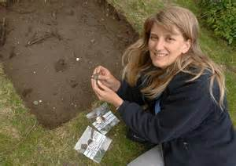
Professor Carenza Lewis will be our guest lecturer and she will be telling us all about her work so far. Work that has reshaped our understanding of the late Medieval period and the effects of the Black Death. We moved to the Parish Church as we hope for a large audience. I hope everyone will have an interesting evening. Members of the Market Bosworth Society will be admitted free of charge for non-members we charge £3.00 to defray some of our costs. All are welcome so come and have a listen.
Before the lecture meeting on the 15 June, there will be a Community Meeting starting at 6:30 PM. The meeting is for anyone and everyone who would like to know more about Bosworth Links. We shall have a presentation from Mathew Morris, our Team Manager and there will also be an opportunity to pose questions and to examine some examples of finds that may very well turn up during our digs. The meeting will end immediately before Professor Carenza Lewis begins her talk and we expect many people will stay on for this lecture. At least we hope for a large audience for Carenza.
Can I mention that membership renewals are due? You may post cheques to me at 29 Warwick Lane, Market Bosworth, Leicestershire CV13 0JU or hand them to any committee member, or drop off an envelope at The Forge. Thank you to those who have renewed already. Just a reminder that single membership is £9.00 with a joint membership costing just £14.00.
I recently went over to Leicester to have a look at the finds from the excavation at the old Stibble factory, (behind the Showcase cinema.) If anyone had any doubts about how popular archaeology is in Leicester consider this. We queued for 2 hours and forty minutes to gain access to the viewing gantry. Some queued a lot longer than that! It was worth every second. To look upon mosaics laid down over 1500 years ago by Roman artisans was very moving. The patterns, the different sizes of tile, the layout was fascinating. If you missed the opportunity to be there the website is https://ulasnews.com/2017/04/25/largest-archaeological-excavation-in-leicester-in-over-a-decade-to-open-to-public/.

Here are just a couple of pics I took on the day.
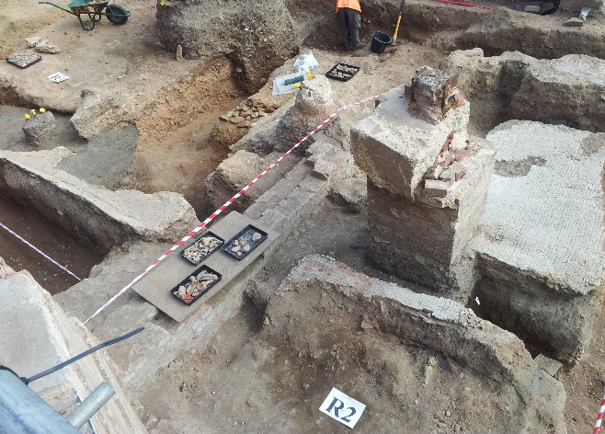
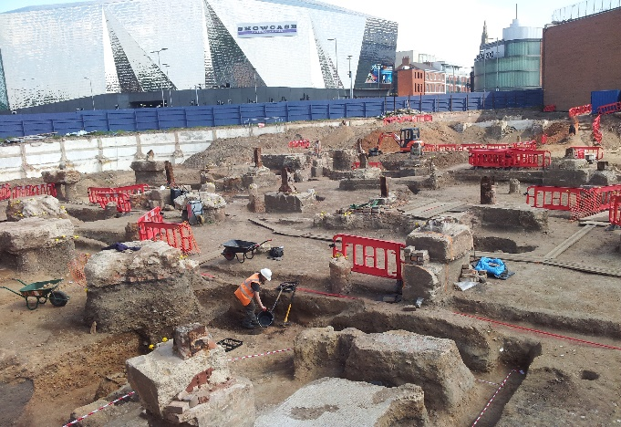
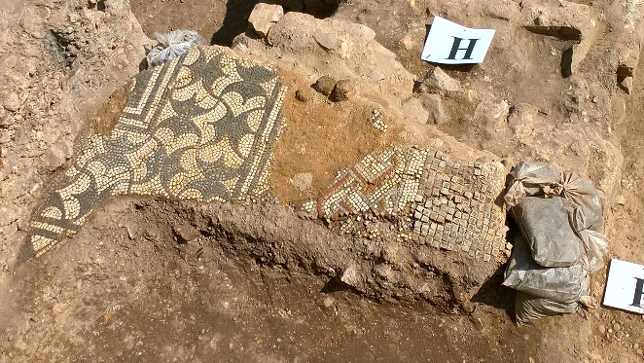
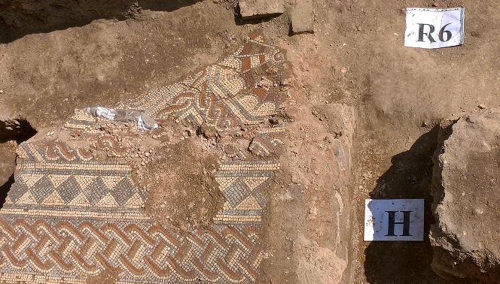

There were several children queuing, some in Roman dress and despite the wait they all behaved impeccably.
And finally, (well finally,) an appeal. I have been looking at the archives lately and we have some gaps which I am hoping we can fill. I am looking for photographs, maps, plans, or sketches of the following locations. Barton Road/Harcourt Spinney, preferably before or immediately after work started on Harcourt Spinney. Shenton lane, the cottages next to the allotments and Bill Becks builders yard which is now Warwick Close. You may donate the items to the archive or allow us to take a copy, either would be fantastic. Plans and sketches often turn up within old deeds and conveyancing contracts. Not to mention draws, suitcases and tea chests. Time to clear out the loft for summer? If you are not sure them do please get in touch, 01455 290160 or 07930149408 alternatively info@marketbosworthsociety.com.
Please do not forget that Bosworth Links digs will take place on the 22nd and 23rd of July.
The event is part of the Festival of Archaeology (http://www.archaeologyfestival.org.uk/ and is the largest event in the Leicestershire and Rutland Region. All the information is available here www.archaeologyfestival.org.uk we really want it to be a success and would love everyone to take part and enjoy the day. As I type we are seeking permission to run an event locally so that if you are not lucky enough to have a pit in your garden you will still be able to take part and see what is going on. We have a few places in mind the Parish Field being one of them. Do volunteer and do come along and join in all the fun. www.marketbosworthsocity.com/bosworth-links.

Yippeeeeee! I am delighted to announce that after an enormous amount of hard work we are now really forging ahead with Bosworth Links. We have secured enough funding (from The Richard III Legacy Fund, Market Bosworth Parish Council, The Dixie Educational Foundation, and the Heritage Lottery Fund) to make this year’s dig a certainty with a brilliant start on next year’s funding too! Thank you to everyone who has helped, volunteered to take part, and invited us to have a pit in their garden. We still need more volunteers (experience is not needed as full training, including how to drive a spade, or shake a riddle will be provided) so do not be shy. All ages and abilities welcome.
We now have 25 pit sites found around Bosworth and will shortly be visiting the owners again to top and tail the arrangements, decide upon where best to dig and answer any questions. We are also, via our Schools Liaison Officer Judy Buckell making progress towards the three pits, one at each of our schools. All the schools signed up to take part back in October and Judy is finalising the details. If your son, daughter, granddaughter, grandson, niece nephew…. comes home and tells you that they did not get a chance to have a go. Do not despair. Ask around and you will find that it is highly likely that someone you know will be hosting a pit. I am sure an extra pair of hands will be most welcome. We are very keen for as many children to learn about the process and the discoveries that can be made about the development of their town. Not only is it a shared experience and an opportunity to work with people of all ages it will also build a sense of pride in their home town. Plus, there is always 2018, so get your hosting offers in now!
We can also announce that we have secured a Project Officer, Gemma Tallis who is a perfect fit for our needs. Gemma has archaeological experience and is an excellent administrator (which is what we need to whip us into shape as we near phase one). Gemma is a regular visitor to Bosworth and will be known by many of you.
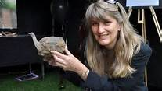
I may have mentioned before that Professor Carenza Lewis is coming to talk to us in June (15th at St. Peter’s Parish Church, 7:30) Prior to that we are holding at the same venue a Community Meeting from 6:30 pm. We will be joined by Mathew Morris (who discovered the body of Richard III) who will be giving a short presentation about the Bosworth Links dig. We will all be on hand to answer questions and show some of the finds you might discover in a pit. Do come along and see what we are about. To become a volunteer, please visit www.marketbosworthsociety.com/bosworth-links.

Nigel Palmer

