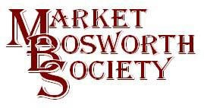March 2017

Dear Member
March has been another busy month for the Society. We held our AGM on the 16th, followed by a hugely enjoyable lecture from David Clarke, Leicestershire Hand Made Cheese Company. We also attended the Richard III artwork dedication event on the 19th.
I was quite nervous when it came to chair my first AGM but I think it went well. We had 37 members present, thank you, to those who attended, for your support. At the meeting we confirmed that Eric Colley, committee member and former Secretary had decided to stand down as had Diane Coleman another long serving committee member. I was able to thank them for their work on behalf of the Society and present them both with a small token of our appreciation. I shall miss them in committee as they were always willing to contribute in a positive and helpful manner. I hope to be able to keep in touch when I see them at our monthly meetings and field trips. 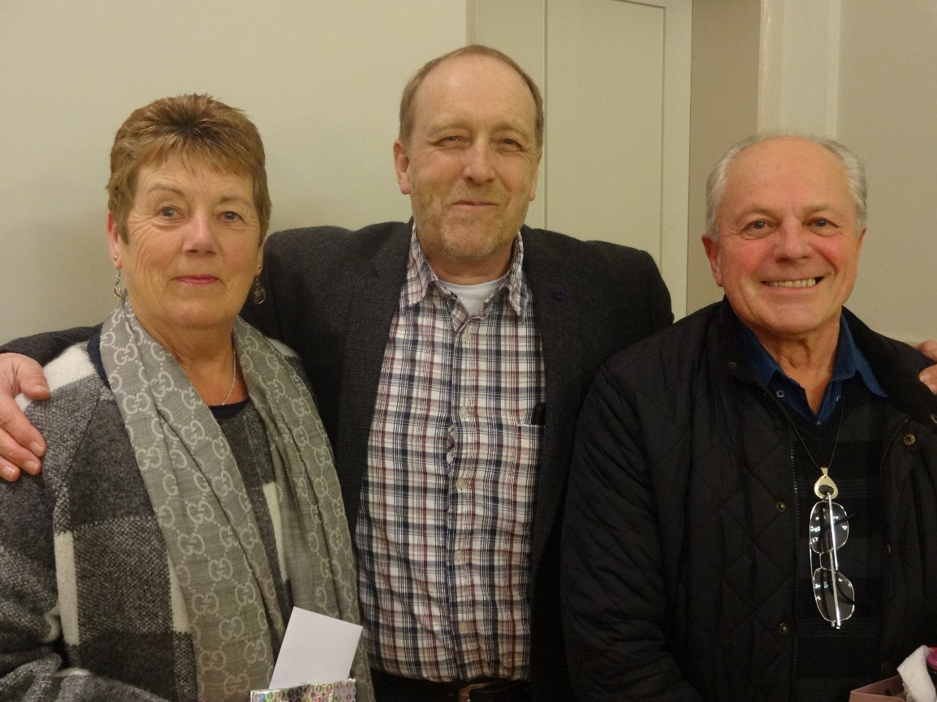
Here is a photograph courtesy, of Robert Leake, shortly after presenting Diane and Eric with their parting gifts. Robert assures me this is the best of the pics but I still look as if I am about to take part in a gurning competition. I am sure you will all join with me in wishing Eric and Diane a long and happy retirement from committee duties. In their stead the members present elected two new committee members. Ingrid Davison who you will recall started off our May lecture meeting with memories of her grandparents in Bosworth and Lynne Palmer (yes my better half) who you may have seen working in Lloyd’s Pharmacy. I look forward to working with them both as committee members.
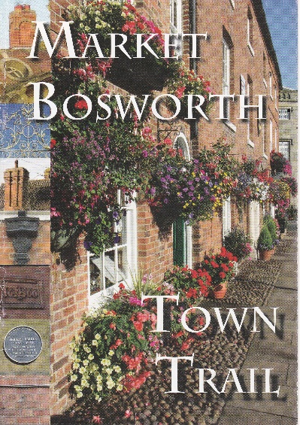
I have attached a copy of the AGM minutes with this News Letter for your information, but would just like to mention that having examined the accounts and taken advise from our Honorary Treasurer your committee recommended that yet again the membership fee be maintained at £9.00 for a single membership and £14.00 for a joint membership. A number of members commented that this was excellent value and when you consider the lectures planned it does indeed demonstrate great value. Our projections indicate that we should still be afloat at the time of the next AGM but we do have a major expense looming, that to re-write and reprint our very successful and popular Town Trail Guide. If anyone has any suggestions for inclusion, I will be very happy to hear them. One of the factors which has helped to maintain the membership fee, is the growth in our membership numbers, there are currently ninety two members. Which reminds me that membership renewals are now due for the 2017/2018 year and you can pay by cheque or cash at any of the meetings or by dropping your membership fee off at The Forge or 29 Warwick Lane. I have updated the list of committee members on the website (together with contact details) www.marketbosworthsociety.com and any committee member will be more than happy to help with your renewal.
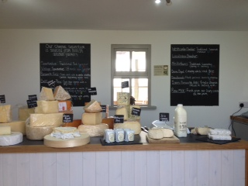
Following the AGM David Clarke from Leicestershire Hand Made Cheese Company gave us a most interesting and enjoyable lecture. Like many farmers David and Jo, who farm at Upton, needed to diversify in order to build and sustain their business. They considered several options and finally decided to add value to their existing operation by turning a proportion of their milk production into cheese. That was 11 years ago and David admitted that he and Jo had learned a great deal in that time. Originally they were going to call one of their cheeses Champions Choice, but someone pointed out that sounded more like dog food and so Sparkenhoe Red Leicester was born One of their first pieces of equipment was a stainless steel mixing table incorporating a cooling table. It was bought from a farm in Cornwall where it had stood amongst some nettles in a field. David explained that his bargain cost only £750 and then several thousands of pounds to bring it up to a working condition! One of the early lessons. The breed of cows they use are pedigree Holsteins and David still has cows that are direct descendants from the herd managed by his grandfather. The herd is well looked after and bulls with desirable attributes are used, one such was for good feet, bred into the herd. An average cow delivers 50 tonnes of milk in her lifetime. One of David’s herd gave over 90 tonnes of milk. David takes great care of his land he explained that good soil gives rise to good grass and pasture, which in turn gives good milk from good well cared for cows.
David took us through the cheese making process which is a lot of hard work and a great deal of cleaning. They never stop working on their cheeses and cleaning the dairy. Many members took advantage of the opportunity to purchase cheeses after the lecture but if you want to buy some excellent cheese then the shop is open on Fridays and Saturdays 9.00 to 2.30. There is also a tea shop. I have to admit that I am smitten by the Sparkenhoe Red Leicester, it takes me back many years to my boyhood when cheese tasted of cheese. I cannot really do justice here to what was a fantastic evening. Do go along to the shop and have a look for yourself. David announced that they are about to embark on the creation of a Stilton cheese. I cannot wait to taste that. The website is http://www.leicestershirecheese.co.uk/index.php. Sparkenhoe Farm, home to David and Jo will be taking part in the national Open Farm Sunday on the 11th of June, 2017. This will be well worth a visit and I will be recommending to your committee that we make a field trip there next summer, with hopefully a Holstein Cream Tea in the Tea Room afterwards. Or Cheese and crackers, whichever you prefer!
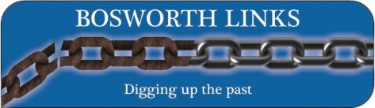
Almost two years to the day when the mortal remains of King Richard III were taken via Bosworth to rest in Leicester Cathedral we were in The Market Place as guests of the Parish Council at the dedication of the Richard III artwork. We set up at 11:15 helped by Peters Bailiss and Starkey (thanks for your help guys) of Bosworth In Bloom and happily the extra sand bags provided meant that we retained our gazebo and did not go hang gliding. We were very busy and signed up a great number of volunteers to Bosworth Links (if you have yet to sign up, pop over to www.marketbosworthsociety.com/bosworth-links and fill in a registration form).
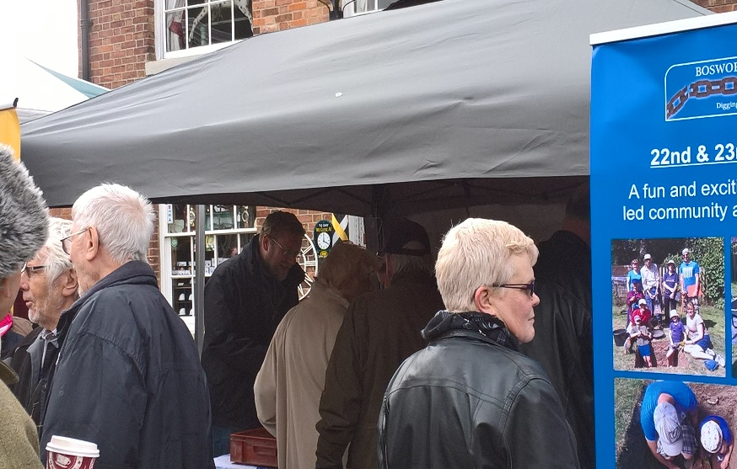
It was fitting that Mathew Morris (seen here centre, rear ) the Archaeologist who discovered the king’s remains was present on the day. We invited Mathew to help support Bosworth links. Mathew brought along a selection of finds as did our member Carlo. We are very grateful to both as seeing the finds and having them explained proved immensely popular.
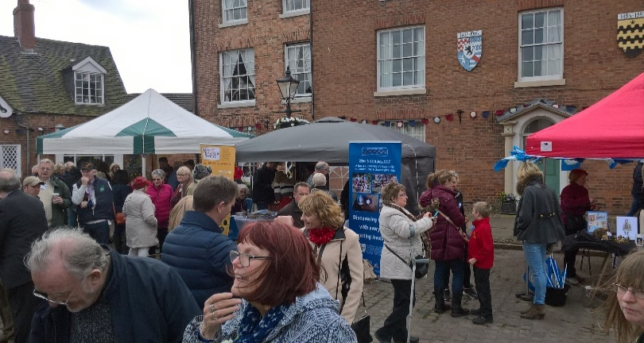
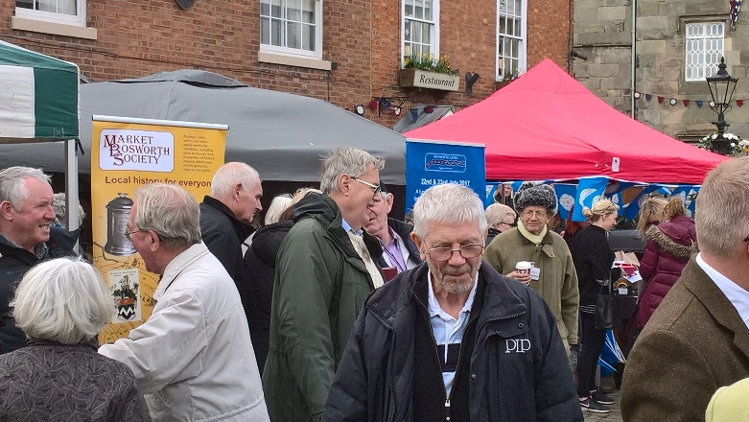
Mathew, Peter & Sheila Loseby, Martyn Andrews, Glynis Oakley Carlo & Marie Camposano, together with yours truly were kept pretty busy all afternoon. Which was very encouraging. Thanks to all who popped in for a chat and a go at ageing the finds.
A couple of scenes of our stall within a very good crowd enjoying the festivities..
I do hope you enjoy reading these News Letters, but as usual I am always open to suggestions and ideas. Last month, you will recall that I included a picture of the Market Bosworth Free School from June 1795. Thank you to those of you who responded and told me where the school was located. I can also reveal that the set of steps apparently leading nowhere were to facilitate the mounting of horses and ponies at the end of the school day (presumably getting off the things is far easier). Interestingly I looked into the Archive and the map of 1592 (available on the website) shows a free school exactly where the one in the image was positioned two hundred years later. The archive also has a map dating 1903 which shows that the Free School was no more but instead shows the school in Park Street.
Our lecture next month will take place on the 20th and will as usual be held in The Free Church, Barton Road. The lecture will commence at 7:30 pm and is entitled Bob and Bill. Derek Chattington, our lecturer is a local man (Carlton) and explains the story as a very human account of interesting social history which should be most interesting and enjoyable. Don’t forget all are welcome (subject to availability) non-members pay £3.00 on entry.
Nigel Palmer

