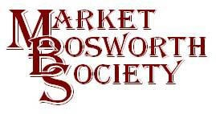 December 2017

Dear Member

Welcome to the last News Letter of 2017. You will have to wait until next year for the next edition, I hope that on balance the reaction is one of disappointment…. It has been another busy year for the Society and I will get to that later, but first, there was no lecture meeting in December, but I do have an event to review.

Forge Open Evening
In support of the Christmas Lights Switch on Brian and Glynis Oakley kindly opened The Forge, visitors were welcomed with mince pies and Mulled Wine. The visitors to the forge were very kind and gave their donations generously, Thank you. Thanks as well go to everyone who came and supported the Society. Ed Robinson, Farrier did a brilliant job of handling the forge and showing how to make items, not just horse shoes from hot metal, heated in the traditional way. Ed showed off his skill, as did his colleagues to an appreciative audience who all enjoyed watching. Not, as one wag suggested, that visitors were present only to stand by a warm fire! Here is Ed hard at work with Brian taking a break from pumping the bellows and doing his own metalwork.
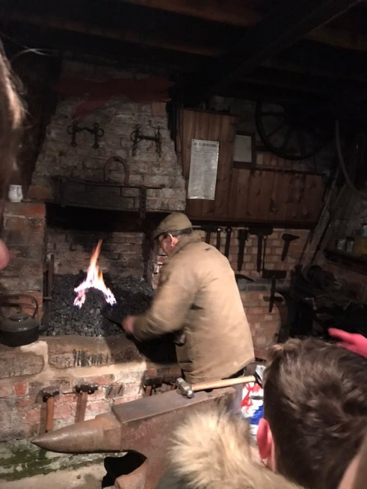
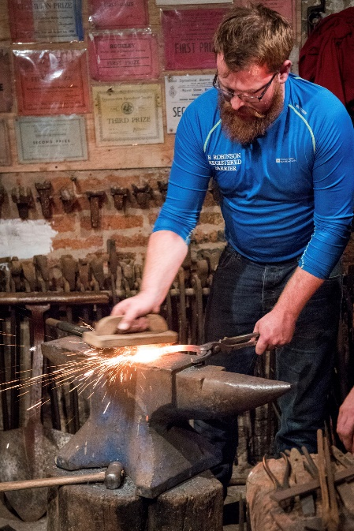
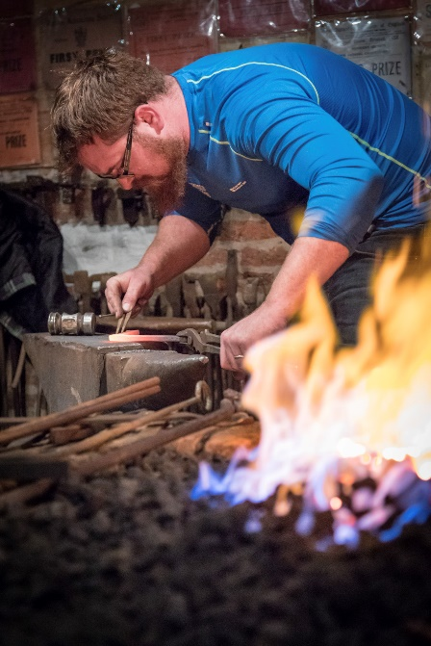

Thank you to all those who helped, you were brilliant. Photograph credits go to David Neave and Martyn Andrews for kindly sharing their photographs and allowing me to share them here. Many displays were set up in the studio, mainly from the dig in July. A lot of people were interested in the story the displays told of the growth and distribution of the settlement of Bosworth. We also had photographs from the dig displayed on the wall and visitors to The Forge enjoyed seeing themselves together with their friends and neighbours. The most popular item on display was the DVD” Pits, Pots and Pipes”. Dozens of people sat and watched the DVD of the dig weekend and a number of new volunteers signed up for next year. The dig weekend really was worthwhile, interesting and fun. Plus, the masterclass beforehand giving us all an opportunity to identify the pottery we turn up in our gardens not just during the dig weekend. Thank you to everyone who came to see us, you made it a fantastic evening, chatting away and enjoying the DVD and photographs. A lovely evening thanks to visitors, helpers but especially Brian and Glynis.
Committee Highlights
I asked your committee to share their highlights of 2017 and here are some I received.
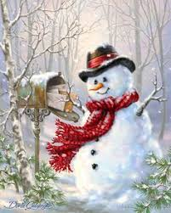
Some reflections of the year from Glynis, Ingrid and Beth (Archivists and researchers)
. We have been kept busy with two main projects this year. After archiving the story of the late Reverend Teddy Boston on behalf of Audrey, his wife, we were delighted with the news that the 'Boston Collection' would be housed in our newly acquired Archive Room. An essential purchase for the latter, was a map drawer and we were entertained watching Nigel and Robert shifting it to its new home. Touch of the Laurel and Hardy? (more Chuckle Brothers-Nigel)
Our task, in conjunction with the 'Bosworth Tommies', was to find out about the real 'Bosworth Street' during the time of the Great War. This time-consuming work of searching and sifting through the archives rewarded us with relevant and new information
And a final word from Glynis....
I was very pleased with the amount of material that has been given to the Bosworth Society, especially record books from the Market Bosworth Fire Service.
And from Ingrid.... I had the exciting opportunity to work on Test Pit 10 on the Allotments and now can't help wondering what lurks beneath my veggies, other than grubs.
And from Beth.... The 'Tommies' project gave me the opportunity to spend time with one of my sons, a Colonel in the Army, whose knowledge of the structure of the Army and conditions in World War 1, amazed me.
Lots of love from Bath, Glenys and IG (sic)
The sign off (which I should really have removed) is a comment upon my typing skills, I have spelt Glynis in a variety of different ways, as I have with Beth. For some reason I call Ingrid (Davison) IG not ID as it should be. Fortunately, Glynis Beth and Ingrid are very forgiving, and I don’t mind a little teasing.
Then from Robert, your Vice Chairman.
Highlights of the Bosworth Society Year

It has been another exciting and varied year for the Society. The involvement of so many people in the Bosworth Links project was amazing and it was good to wander around over that special weekend looking down, so many holes usually surrounded by the smiling faces of the diggers and searchers. The sight of all the discoveries being cleaned and labelled in the Dixie Grammar School Hall will long be remembered.
The gradual creation of an Archive Room at the Parish Hall to contain the archives of St. Peter's Church, the Bosworth Society and the life of Teddy Boston has been an exciting development since the summer. Special thanks must go to Andrew Jackson for adapting and refurbishing the room at the rear of the Hall with the full support of St. Peter's Church Council.
As for a memorable meeting I always like to hear local people reminiscing about life in Market Bosworth, often from the years before I arrived in the town. It was a real treat therefore to be the panel chairman for our Memories of Bosworth in September with three well-known local personalities, Audrey Boston (wife of Rector Teddy Boston at Cadeby), John Smith (formerly of Bamford's Main Street grocery store) and David Fitt (formerly Head of Community at the High School and responsible for organising many memorable events).
Finally, thinking about the year, I would pay tribute to our Chairman, Nigel, who works so hard for the Society, spending considerable time attending various council and planning meetings. Well done Nigel!
Thank you, Robert, you are making me blush!

Lynne, who joined your committee last March, wanted to recall the dig, seeing all the volunteers chatting excitedly over their bar-be-que was a real community social event but she also wanted to say
“I was very pleased to be invited along with some fellow committee members to meet the Tommies at the Bosworth Battlefield Centre. They are a group of adults with learning difficulties. I was very impressed by the hard work they had put in to creating Bosworth Street, a fictional place existing in 1914-18. What I found to be most moving was when each of the Tommies stood and told the story of the imaginary character they had created, who lived in one of the houses, pubs or hall they had built. The enthusiasm was contagious, and the energy was fizzing in the room. The Society was delighted to help them with some historically accurate information. It is expected that their work will be placed on display at the Bosworth Battlefield Centre. I shall ask Nigel to let you know when and where”.

Finally, for my recollections, nothing can really beat the dig weekend. It was the culmination of a massive amount of work by a lot of people. From an idea of Peter Losesby, a great acorn really did grow. Seeing the excitement on the faces of the Schoolchildren taking part was brilliant. Over 200 got involved at the St. Peter’s Primary Academy and the Dixie Grammar School. We also had over 120 adult volunteers over the weekend and none were put off by the weather (which did behave reasonably well). Seeing all the finds and discovering the feature in the Parish Field, all very exciting. I enjoyed chatting with diggers, riddlers, washers, sorters and collectors. Everyone was enthusiastic and made it a wonderful experience. Volunteers helping were made very welcome by the owning hosts. A typical Bosworth welcome, as someone said to me at the time. I consider myself very lucky to chair two committees made up of dedicated and capable people, determined to make things happen. I also count myself fortunate to have shared in so many experiences over the last year. I am looking forward to 2018. None of this would have been possible without our supporters but more importantly, you. Market Bosworth Society members make these things possible and I am immensely grateful to you. Thank you.

Next Meeting

January the 18th at 7:30 pm will see us back in The Free Church, Barton Road. We have not one but two lectures that evening, a buy one gets one free in celebration of the Sale season. We have persuaded David Woolerton to return. You may recall that David gave us a lecture about bowling and demonstrated what an entertaining speaker he is. His first lecture this time is “Disaster at Desford 1888” and “Shackerstone, a day in 1908”. I can guarantee that not only will historians and rail enthusiasts enjoy these lectures, but everyone will as David weaves his stories for us. Tell your friends, especially any rail enthusiasts. All are welcome. Society members enjoy free entry of course, guests are asked to pay £3.00 to defray costs. Or guests may want to become members. Anyone wishing to become a member can do so by filling in an on-line form, or by contacting me and I will post one out or simply come to a meeting and join then. Everyone is welcome at our meetings, guests are subject to availability of seats.

A reminder

Last month I explained the Hinckley & Bosworth Borough Councils Local Heritage Asset List plans and asked you all to put forward suggestions for new additions to that Heritage Asset List. I hear that it is going well but I do not, at this stage know how many suggestions have been made for Bosworth. Do please go to https://www.hinckleybosworth.gov.uk/downloads/file/3570/nomination_form_for_the_local_heritage_list.
The nomination process is detailed there, and it is also in last months News Letter. Copies are available if required. Do please remember that we have a wonderful community resources available to us in the shape of the Community Library. You can go on-line there and fill in your forms. Any of the Community Library Volunteers will be happy to assist you. Whilst there why not watch the DVD “Pits, Pots and Pipes”? I shall put the link below for you. Just make sure that the volume is turned up.

And Finally

All that remains is for me to wish you a Very Merry Christmas and a Happy New Year. Thank you for reading the News Letters (at least I hope you do) and don’t forget, any comments, suggestions or ideas can be communicated via any committee member or by email the contact details are below, as promised.

Telephone: 01455290160 or 07930149408
Email: nigel_palmer.MBS@btinternet.com or info@marketbosworthsociety.com

The Society website can be found at www.marketbosworthsociety.com and Bosworth Links is www.marketbosworthsociety.com/bosworth-links
There are links there for the DVD, All the Pit Reports (together with the main report) and galleries of photographs on the Market Bosworth Society website

The link to “Pits, Pots and Pipes” https://vimeo.com/241023767

.
Merry Christmas and Happy New Year.
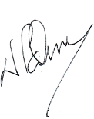
Nigel Palmer Chairman

Oh, one more thing. Some time ago Charles Frisby gave me permission to share his memories of Christmas 1947. I recall my father telling me that it was indeed a very bad winter. Here are Charles memories, get snug and enjoy this very special Christmas story.
Lindley and Higham Airfield — 1946/47 Winter
I have a lot to say about before the airfield was started and the work I did there. But I'm going to talk about the squatters, the footpath and the bad winter of 1946/47 first.
It was in the winter of 1946/47, while working for L & A Freeman, we had the job of making the huts that were used by the Air Force to live in during the war, fit for families to have as homes. They were squatters, which are people who had lost their homes to the bombs in Coventry and other places, also men coming back from the war with nowhere to live and people who simply just moved in.
At this stage Bosworth Council took control and stopped people moving in any old how. From then on anyone wanting to get a place to live in had to go on a waiting list.
There was one stove in the centre of the hut, some had a WC for others the WC was outside in blocks. A lot of toilets did not work so the squatters had to use buckets and get rid of soiling the best way they could. Water and electricity was another problem all therefore the council had to take over and enforce a duty to make things good enough for a family to live in.
Just after Xmas 1946 the weather took a turn for the worst, worst known for years, blizzards and deep snow drifts and hard frosts set in. The huts and roads leading to Lindley were completely cut off, the people up there were in an awful state, no water or heat. It was then that my father, Tom Frisby, with I think Jack Freeman were asked to muster as many men as possible no matter what the cost to get help to the squatters these orders given by Bosworth Council and paid for by them. The men who were willing to come forward all worked for
L & A Freeman. I will give as many names as I can remember they were Les Varley, Herbert Varley, Arthur Swingler, Don Coxon, Charles Frisby, John Frisby, R Harper, Bill Eason and others. Jack Clarke wanted to come but was deemed too old as it needed fit young men. Jack Clarke did not work for Freemans though. Everyman was given a shovel, they all knew how to use one. We went by lorry as far as possible, Tom Frisby driving with Jack Freeman in the front, all the rest of us on the back. We did manage to get to the drive in the lane, plenty of men to push and dig out when we got stuck. The drive up to the huts I would say was about 2ft or more deep and the snow still coming fast and blinding us as we worked. We moved the lorry up as we dug out the snow. When we finally got up to the huts the snow behind us was back to 2ft again.
It was late in the afternoon all of us worn out, we had fuel and food on the lorry to be given to the ones most in need. We never stopped till we had the water running and stoves working to get the people and children warm. Ourselves we were sweating through the hard work. Some huts had no stoves, so we had to go and find some from other buildings up there also take stoves off people who had two or more and they weren't pleased about it.
At last we stopped, job done for now, got a good fire going in one of the huts and had plenty of tea and egg on toast, the eggs we got from I think Mr George Hall, the farm near the huts. Mr and Mrs Farmer live there now. We got out clothes dried and ready to go home after a good day’s work.
It was at night, but you could see because the snow made it lighter. There was no way we could go by lorry as the drifts were now deep so some of the men who lived at Hinckley said they would bed down in the hut for the night the rest of us made our way back to Higham over the airfield, and what a job we had. As a young teenager it started as a bit of fun in the morning but now I knew things were bad, in fact very bad. Arthur Swingler and Les Varley had to pull me along the cold had got me. My father Tom Frisby with another man had to carry Herbert Varley I'm sure without them we would have died. None of us were dressed for that sort of weather at last we were home. Before we all went our ways, my father asked the men if they could be ready for a 9am start the next morning, bearing in mind it was now about 11 pm, yes, they all said, dam thought I.
Back in home I slept like a log, morning soon came but strangely I was up early I fed all my livestock, had a bite to eat, a cup of tea, and was ready for the walk back to Lindley. It had stopped snowing but a cruel frost. Together we set off taking us about 2hrs, going over Mr Billings field then down Wood Lane, over the railway line, and made for Lindley Wood between the two ponds past the old church ruin and then to Mr Halls farm, where Mrs Farmer now lives, to arrive at the first lot of huts that were near the farm.
We always called Herbert Varley Joey because as a child he was small I don't know how it happened but we somehow lost Joey Varley and hadn't missed him till we got back to the huts, panic set in and Arthur Swingler, Les Varley and myself were sent back to find him. It was easy to follow our tracks in the snow. It was near the two woods that we heard a faint shout of help, there was Joey stuck in a deep ditch and could not get out. The cold had got him again, really, he wasn't fit from what happened the day before, I felt the same so did the others, we had to carry him back to the huts to get warmed up, he did no work that day only making tea for the men and squatters. We did find out later why we lost him it seems he wanted to badly go to the toilet and thought he could catch us up in due course. When it came time for him to get out he was too weak to move he had caught a nasty tummy bug, we all had the same thing a day or two later.
I think the huts were about 20ft x 60ft. We made these into a kitchen, WC, dining room and three bedrooms, some two bedrooms. The people had to be moved to other huts while we did the work and then moved back after.
As all the sand was frozen solid that had to be cut out of the heaps that were tipped outside the huts with a pickaxe and crowbar, brought into the huts to thaw out with the fires going night and day to stop the mortar from freezing. I was busy making door frames, hanging the doors and other woodwork.
All was going along very nice considering what the weather was like when all of a sudden one of Mr Hall's bullocks, that had got out from the farm stock shed came running through the hut knocking all the walls we had just put up down. They were only built that morning not a good start for the first hut. The good thing was Mr Hall gave us eggs and milk to compensate he was then called a very good man, a big change from what he was called one hour earlier, a gift works wonders.

We soon got back into swing with another six huts ready to move into. There was no hunting, so I never went off with the hounds.
One of the huts was away on its own from the others with the windows bagged up with sacks on the inside. We never saw anyone go in or out till one-day Arthur Swingler saw a child moving the sacks to one side looking out, he said her hair looked matted up and her face was
dirty, she was drinking out of a jam jar. He told my father about it and said something must be wrong in that hut so Tom Frisby, Les Varley, Arthur Swingler and myself went to check it out. Tom Frisby knocked on the door many times, shouted to ask if they were ok or needed help, no answer or noise could be heard from the inside. I remember Les Varley saying he thought he heard a child crying and Tom Frisby carefully got the door opened with a crowbar and told us all not to frighten any children that might be in there. The place was dark and cold, no heat and it smelt awful. We pulled the sacking from the windows and what a shock, four children, blue with cold and little on to keep them warm. No table, no chairs, not even a box, they bedded down on straw and they did the toilet where they slept. One child about nine months old was sleeping with no clothes on in the straw with her own mess. The only food we found was bread, some buns and just water. How they lived through that cold I just don't know, but worse still how did we not find them when we first went up we had checked every hut but that one, my father said shame on us.
I still know the name of that little girl and her parents after all these years, I will tell no one their names. It became a police job and I think the man went to prison.
When we saw the state of the children my father had a job to stop Arthur and Les knocking hell out of the man and his wife for being so cruel. We took out coats off and put them round the children and rushed out with them to one of the huts with a good fire. The people living in the other huts came with food and milk we also fed and looked after the mother and father.
Tom Frisby then got Bosworth Council out it was up to them then. When the council came out we told them that we were using the footpath or had been till the roads were cleared, they said it was alright as the footpath would soon open again, I have the names of the men who told us.
I will never forget those poor children, God bless them, and I hope they all did well in life. I must state here that other men in Higham did their share of clearing the snow and looking after people, well done men and women of Higham. I could say lots and lots about the squatters, but it would take too long, it remains locked in my memory.
A few years later when I was about to get married I applied for one of the huts to live in and enough ground to start a smallholding, that was wishful thinking on my part, no proper plan. I was told to get married first and my name could be put on the waiting list, I still have these letters from Market Bosworth Rural District Council. One dated 27th May 1948, the other 8th July 194
By kind permission of Charles Frisby, Historian and Author.

.

