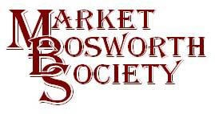

Dear Member
Welcome to the December Newsletter which I hope you will find both informative and entertaining. The newsletter promises to be a little shorter this month as I have no lecture to report. We do however, have an event to tell you about, if you don’t already know that is. December the 1st saw the Christmas Lights Switch-On (or rather a switch off and switch on thanks to a human error) and The Market Bosworth Society took advantage of the kindness and generosity of Brian and Glynis Oakley who graciously allowed us to host an open night at The Forge. A lot of the preparation work was already done by Brian and Glynis before our team of setter-uppers arrived and I think we all did a decent job. It is always fantastic to see vintage and antique equipment being used as it should be. I have to admit that I do prefer to see the vintage tractors working as they were designed to do in ploughing matches (even if I can remember driving most of the types as a boy) rather than chugging around a show ring. By early evening The Forge rang to the sound of Peter Loseby narrating the slide show and the clang of hammer on metal as the smiths and farriers set about making shoes. Something which has been done that way for centuries. The bellows were a very popular challenge to many visitors who helped Brian keep the furnace hot. It was a great evening enjoyed by many happy people who gave generously for their glasses of Mulled Wine and Mince Pies. Thank you to everyone who came and made the evening such a success. Thank you to all who helped especially Brian and Glynis.
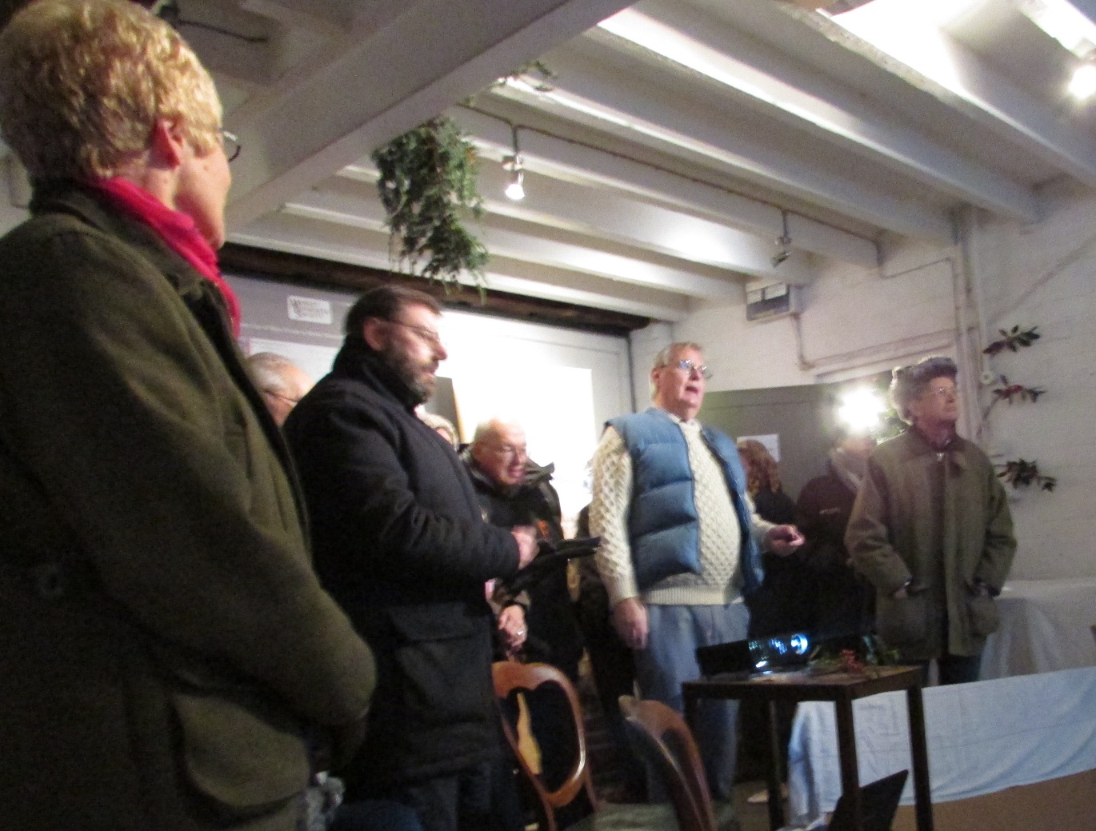
Peter Narrating to a growing crowd

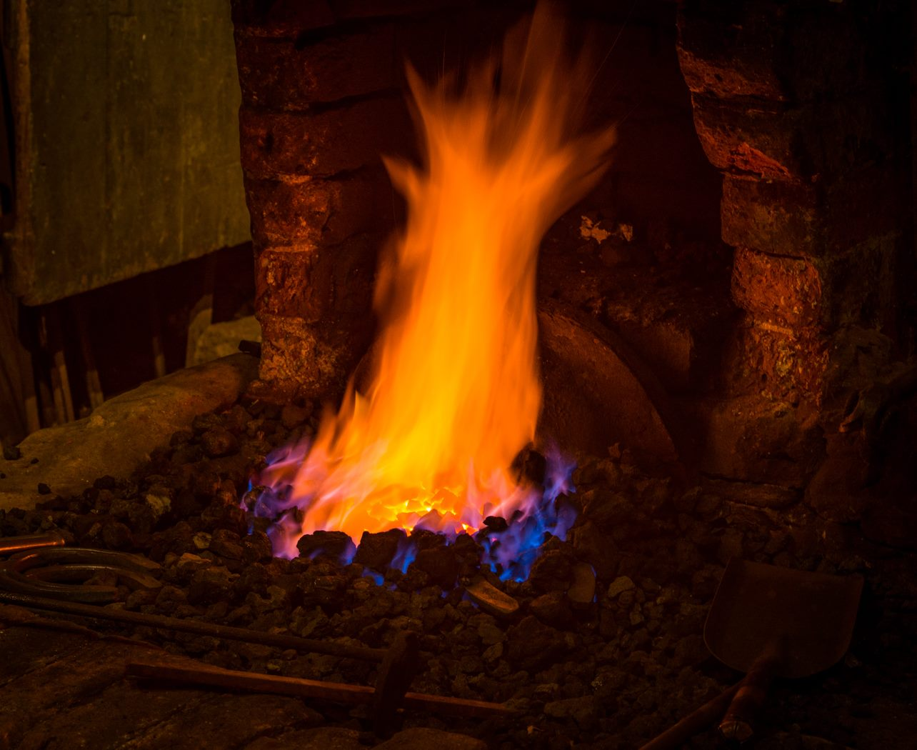
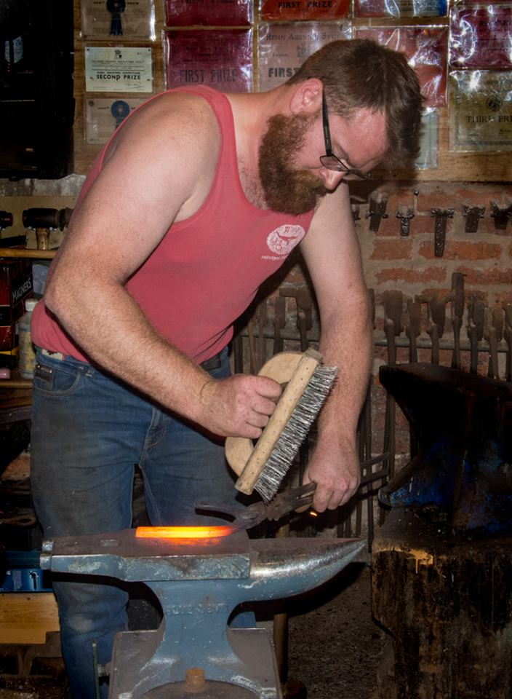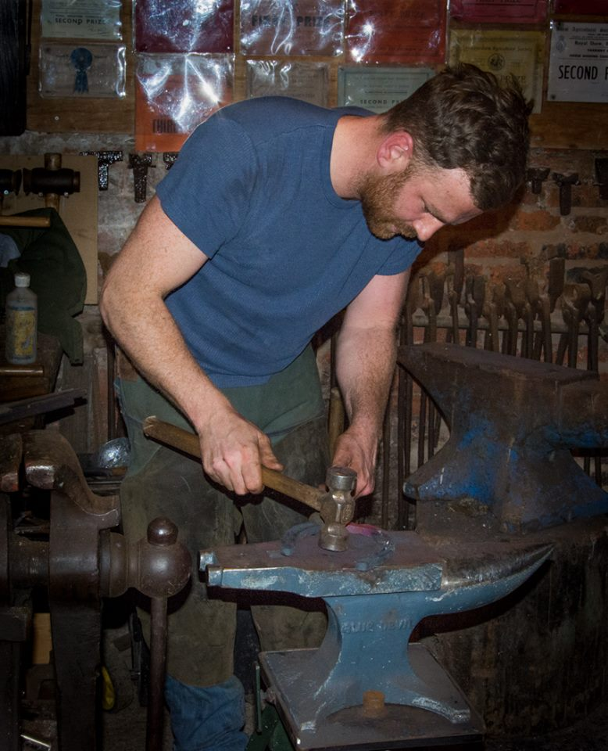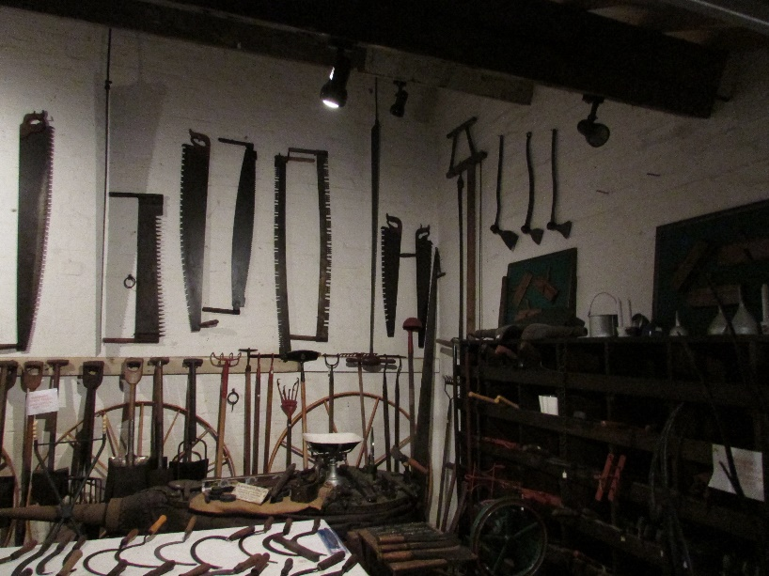
The furnace, kept very hot by all the volunteer bellowers ensured our two visiting smiths were busy. Both of the smiths are regulars at The Forge and love working with the furnaces, as would have done their forefathers. The last picture shows the wealth of tools of all sorts on show. I can still remember using many of them. It does not seem that long ago that portable drills relied upon manual power with a small rotating handle converted to a spinning motion to drive the bit. Or was it?
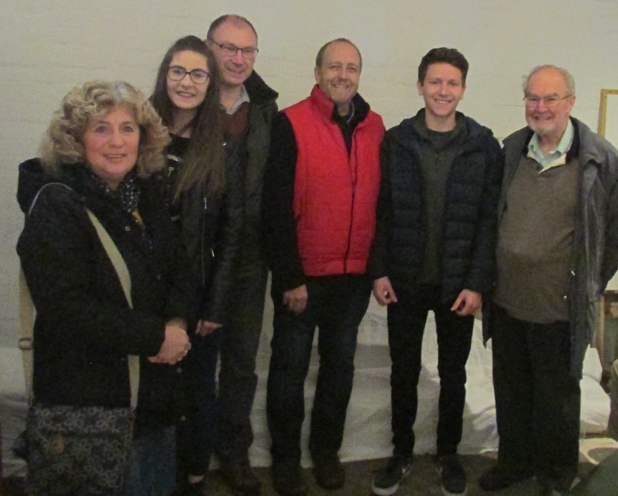
We were visited on the evening by the Photographic Competition Winners, shown here, left to right we have Helen Burrows, Natalie Burrows, Paul Burrows, Me, Toren Storer and Dick Bates.
I took the opportunity to award the prizes (see www.marketbosworthsociety.com for full details) and congratulate the winners on some very fine photography. Thank you to all who took part, there were some excellent photographs. I wish we could have awarded prizes to everyone but then, that is not how a competition works. A number of people have suggested that we make it an annual event and your committee will consider that. You never know.
Watch this space, as they say.

Turning to next year (not long now) our Lecture in January is entitled Dam and Blast and will be given by Derek Jerram. The lecture will take place at The Free Church, Barton Road on the 19th January, 2017. As usual the meeting will commence at 7:30 pm. This lecture promises to be very interesting indeed. I have been in touch with Derek, who forgave me for miss-spelling his name in Aspect, and explained the outline of his lecture. What he actually said was “There are bodies lying all over the place”. He was worried that this may upset some of our members but I was able to re-assure him that our members are made of sterner stuff. Anyone who can sit through a lecture covering Roman surgery techniques with needles bigger than the ones my gran used to knit with, will not be deterred at all. Derek sounds to me to be an excellent communicator and I am really looking forward to this lecture. As ever, you are more than welcome to bring a friend with you to the lecture, a small fee of £3.00 to help cover costs will apply, to non-members.
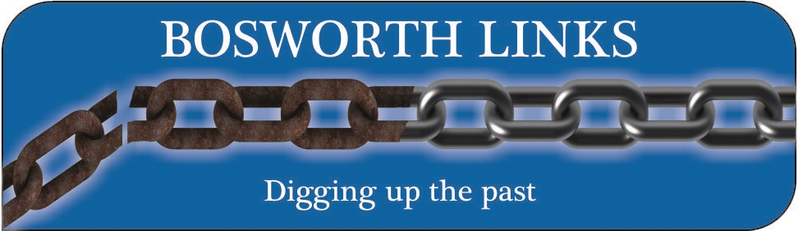 We have now almost completed our application to the Heritage Lottery Fund and the Parish and Community Initiative Fund. We have received all the quotations, letters of support, and numerous other documents necessary to support a community wide project costing many thousands of pounds. The Bosworth Links Committee have received some very kind and helpful support from a number of people. We hope to be able to thank them all shortly, for the time being you know who you are and that we are very grateful to you. We hope to have the first positive news in The Spring so we will be biting our nails to the quick in the mean-time. We will be adding a webpage to our normal offering in the New Year and I hope to be able to keep you all up to date via the web page, Face Book and our Newsletters.
That just about wraps up 2016. As ever, please do let me know if you enjoyed the Newsletter or otherwise. I am also happy to hear if you have something you would like me to include or if you, or someone you know has a good story to tell. As I type this our lecture programme and visits programme is nigh completed for 2017. I will be able to share with you shortly. I will say that I think a lot of members will be very pleased with our field trip in July.
But for now, I would like to thank you for coming to the meetings and field trips and supporting me as your chairman. 2016 has been a very mixed year for me with some incredible highs and sadly some incredible lows. I hope, and wish that for you 2017 is a great year, so for now….
Nigel Palmer
Chairman

