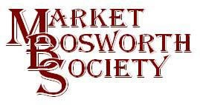 November 2017

Dear Member
November Lecture Meeting. Terry Shepherd, “Battling the Beams”
We were delighted to welcome Terry as our Guest Speaker in November. We have been looking forward to hearing Terry for some time. You will recall, if you went on the field trip to Beaumanor Hall we saw in one of the huts a map. The map showed the fall of all bombs in Leicestershire during World War 2. It had an obvious anomaly which was spotted by everyone. There was a large cluster of bombs in an unpopulated part of the county where there was nothing for the bombs to damage but grass, hedges and fences. I had been promising to reveal all and last Thursday Terry did that for me. He also explained that the counter measures were so successful it was not uncommon for enemy aircraft to land in England realising their mistake too late to travel elsewhere due to lack of fuel.
Terry gave a very full and interesting account of how the Luftwaffe had developed a system of transmitting beams, based on the Lorenz landing beam system, from two sources in occupied territory and Germany Occupied territory was literally on our doorstep which gave the Luftwaffe a great reach into the United Kingdom. By transmitting two pulsing radio waves, which converged over a target great accuracy could be achieved by navigators even in nil visibility. One beam transmitted only dots and the other dashes. If too far to the left, only dots could be heard and vice versa. Once perfectly aligned the pilot heard a constant tone. By simply tuning their Lorenz receivers and radios to the correct frequency they could tell if they were on track, left or right of the track and when to release the bombs. This enabled the Luftwaffe to operate in almost any conditions as a visual reference was not necessary. They were also able to concentrate a bombing raid upon a small area with devastating effect. It is not difficult to imagine how dangerous this could be to the Allies. The devastation of Coventry is a good example of the danger of the Luftwaffe system. Later they even developed a sophisticated system using highly accurate clocks to tell the bomb aimer when they were directly over their target. Very dangerous indeed, they had to be countered.
Fortunately, we had our own experts or Boffins, who were equally as clever as the German scientists. Avery interesting cat and mouse game began with measure and countermeasure taking place right her in Leicestershire. Naturally it was very secret or hush, hush to use a phrase from those times, Terry expanded his talk to include some human aspects of the soldiers and airmen involved which made it a roundly interesting evening. After the lecture Terry was happy to field questions and a great evening was enjoyed by us all. It is interesting, to me at least that there have been examples of technological warfare throughout history and the latest of course being the alleged Russian involvement with Facebook posts to influence major decisions in their own favour. It is a job these days to believe almost anything, but is that really any different? What goes around comes around, I guess. You can of course rely on anything you read here, ahem.

Hinckley and Bosworth Borough Council Local Heritage Asset Plan
I had a meeting with Paul Grundy recently, Paul is the Borough Conservation Officer and he had previously told me that the New Heritage Definition Lists he had recommended, following the public consultation meetings had been accepted by the Planning Department of Hinckley and Bosworth Borough Council and he could now move to the next stage.
Market Bosworth Of course has its own Local Heritage Asset List. The document was prepared by Market Bosworth Society, Market Bosworth Parish Council and Market Bosworth Neighbourhood Forum (specifically credited were, Ian Farquharson, Peter Loseby, Cathy Monkman and Chris Peat). The document was drawn up between October 2013 and March 2014, the document is a source of reference, but confidential material will not be published. Whilst the document is only three and a half years old it is worth looking at the new criteria which may include some items not previously eligible for consideration under the older criteria.
The new criteria are as follows:
Any of the following can now be included. Examples include, a building or group of buildings, a monument or site (an area of archaeological remains or a structure other than a building), a place (e.g. a street, park, garden or natural space), an area or landscape (an area defined by visual features or character, e.g. a town centre, village, suburb or field system).
Consideration should be given to:
Historic: It is important to understanding an association with a person, event, episode of history, local industry, or social, economic, cultural or religious development of the area. This might be an illustrative interest (it illustrates an aspect of the area’s past that makes an important contribution to its identity or character), and/or an associative interest (it connects us to people and events that shaped the identity or character of the area).
Evidence: It is an important resource for understanding and learning about the area’s history, enhanced by a significant contemporary or historic record (written, drawn or oral). This might include archaeological interest (it will be the primary source of evidence about the substance and evolution of the area and the people and culture that made it).
Aesthetic: It makes an important contribution to the area because of its design (planned or fortuitous), construction, craftsmanship or decoration. This might be architectural interest (it is a high-quality representation of an architectural style, a building of use, a technique of building, the use of materials, or be the works of a particularly important architect or company), and/or artistic interest (it includes artistic endeavour to communicate meaning or use of design (including quality landscape design) to enhance appearance).
Community: It is perceived as a source of identity, distinctiveness, social interaction and cohesion, contributing to the ‘collective memory’ of a place. This might include commemorative or symbolic interest, that reflect meanings of a place for the people who relate to it. It is important to all or part of the community. It has a social value and may be a source of civic pride.
The actual nomination form is available via: https://www.hinckley-bosworth.gov.uk/downloads/file/3570/nomination_form_for_the_local_heritage_list
together with instructions for submission.
I have some ideas in mind (the Churchill Memorial for example) but that apart do not wish to mention anything else as I would not want to influence anyone.
Please only include items outside of the Conservation Area (but within the Parish Boundary) plus there is no need to include Listed building as they are already protected. Listed building information can be found here http://www.hinckley-bosworth.gov.uk/downloads/file/1101/listed_buildings_register (you may use control+f to search the document once downloaded)

Market Bosworth Conservation Area
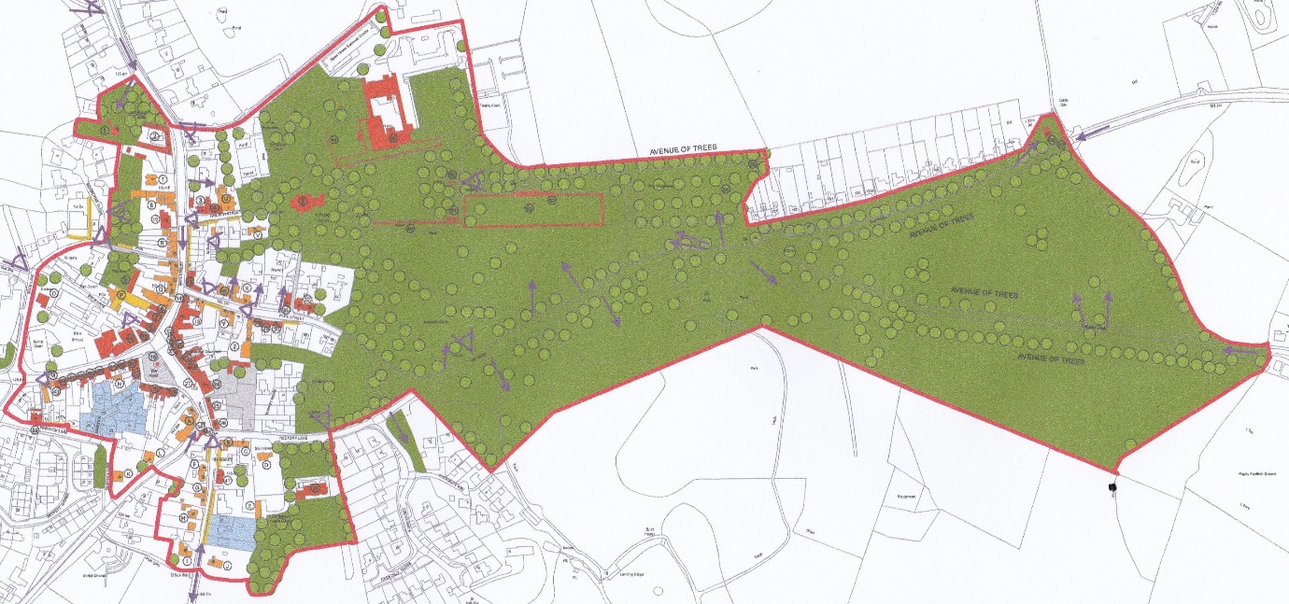
A full-sized Conservation Area map is available on-line here: http://www.hinckley-bosworth.gov.uk/downloads/file/4095/appraisal_map_-_adopted_27_may_2014.
If you have any questions Paul has asked me to pass on this email address conservation@hinckley-bosworth.gov.uk or you may of course telephone on 01455 238141. Or you can always contact me, details at the end of this article, but I am no expert. Do please make sure you submit your ideas, it would be a shame to miss out on an important piece of our heritage.
I do realise that there will be some out there who do not have access to the internet. I apologise that the forms are only available there. If you would like a form and do not have access to the internet, you could ask a someone to print one for you. Better still you can visit the Community Library where access to the internet is available and you will be able to fill in the form and send it without printing and therefore do your bit for the environment. Plus, there are people on hand to help show you how to do it! We do have some very useful resources available in Bosworth.

The Tommies and Bosworth street
You will recall that the Market Bosworth Society had been asked by a group working at the Bosworth Battlefield Centre to help with their research into World War One. We were delighted to help such an enthusiastic and friendly group. We have been very pleased by the number of people who have stepped forward to help. Special thanks to Maurice Harris who has spent hundreds of hours researching the names on the War Memorial. Maurice very kindly shared this information with the Tommies and with The Society. We are very grateful. Glenys, Ingrid and Beth have done a first-class job of researching Bosworth during The Great War, to such an extent that they have the basis for a Lecture at one of our meetings in 2018. Incidentally future meeting dates will be announced shortly as we have been working hard on securing lectures and arranging field visits. If you have any anniversaries coming up, want to get help with any historical local research then do please get in touch. Our archive is quite extensive, and we are always happy to help.

VHS Video
We are always looking out for local video and DVDs. We have recently had some VHS tapes converted to DVD, principally for addition to the archive but also for a planned local history night next year. If you have any tapes or come across any whilst having a sort out, do think of us. They must of course be of Bosworth (Carnivals, celebrations or simply walks in our beautiful countryside). We would be delighted to add them to the archive for future generations to enjoy. The VHS tapes were converted by Peter Bourke (info@tapeconverter.co.uk.) telephone 07875571008 or https://www.facebook.com/tapeconverter/ ) who did an excellent job for us. Don’t let these fascinating and unique glimpses of history get lost, do please think of adding them to the archive.
Next Month’s Meeting (18th January 2018 7:30 pm)
As usual there is no meeting in December. We have a special treat for our January meeting, however. Disaster at Desford (1881) & Shackerstone; a day in 1908. David Woolerton makes a very welcome return to us (Free Church, Barton Road). Last time David talked about Bowling in Market Bosworth. Those present found David to be knowledgeable, amusing and a very good communicator. As you can see David will be giving not one but two lectures! What better way to start the New Year

Christmas Lights Switch On
To help the celebrations, The Forge, Park Street, will be fully operational. You may also enjoy a mince pie and a glass of mulled wine. Ed Robinson will be making shoes and other items as they have been made for hundreds of years. The museum will also be open, and we hope as well to have on display photographs from the recent Community Led Archaeological Dig together with the Video, “Pits, Pots and Pits” which will have had its very first screening at the feedback meeting on the 19th November. Many thanks to Brian and Glynis Oakley for making this possible. We have already supported Bosworth In Bloom by selling calendars at the lecture meeting and at the Bosworth Links Feedback Session. Well done Peter and Sheila. There will also be some available to buy at The Forge, subject to sticks lasting. I hear they are selling fast. They are a lovely reminder of how beautiful Bosworth is and make great Christmas gifts, lasting a whole year.

Market Bosworth Post Office
I have been asked to remind you that there is a fully functioning Post Office in Bosworth twice per week. The Post Office is based in St. Peter’s Parish Hall and is open on Tuesday 1:00pm to 3:00pm and again on Thursday between 2:30 and 4:30. It is especially useful for many who don’t have their own transport, it would be very nice if everyone could show support by making use of the Post Office.
Newbold Church
Alf Pallett has tracked down someone who knew the man on the scaffolding on the picture I published last month. It was Don Mattock. Thanks Alf! That was a good piece of detective work and the person who knew was a near neighbour of where my father grew up. It is a small world, I would still like to hear if anyone remembers the works and can collaborate Dad’s story. I bet it was very cold up there with little to keep the wind and rain at bay.

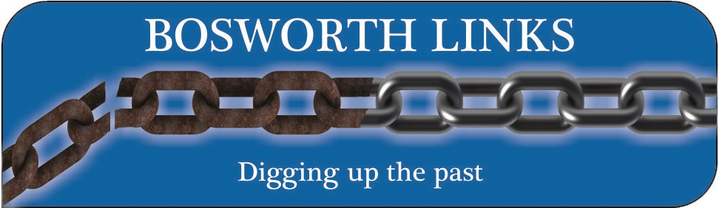

Sunday the 19th November saw yet another milestone in the journey of Bosworth Links, following a hugely successful Community Led Archaeological Dig in July MBS hosted the Feedback Meeting in the Hall of the Dixie Grammar School. I can say that the dig was successful because of several reasons; around 200 children took part from two schools, The Dixie Grammar School and the Market Bosworth St. Peter’s CE Primary Academy. We also had a team from the Young Archaeologists Club (YACs) which is run by Mathew Morris (if you or anyone you know is interested them contact me and I will be happy to pass on the details). The finds numbered 8,534 weighing in at over 76 Kilogrammes (a weighty 12 stone in Imperial measurement) from just 25 pits. Over 150 volunteers took part, digging, sieving, collecting and washing. A great community weekend
Whilst not every pit produced a volume of finds, what was found was of significance and every single pit contributed to our knowledge of Bosworth’s past and how our Town developed. Mathew has produced a report for each pit host and an overall report. If you were unable to attend the meeting and have not received your report as a host, it is our intention to get the report to you. Any concerns please contact Gemma using the bosworthlinka@marketbosworthsociety.com address. I have included a link at the end which will enable you to view all the reports produced by Mathew and the University of Leicester Archaeology Services.
The video, Pits, Pots and Pipes, as it has been titled was a huge success. It really captures the activity of the dig weekend, the weather and the finds. But most of all it celebrates community and working together across the generations and abilities. And the fun we all had. Every volunteer and host were given a DVD of Pits, Pots and Pipes to share with their friends and families. If you did not get a DVD then again let us know. To watch the DVD on-line here is a link https://vimeo.com/241023767
I will also publish the links on our Facebook pages and our Website, www.marketbosworthsociety.com.
You will see from the report that a significant amount of information about the settlement of Market Bosworth was discovered which bodes well for next year. What was also heartening was that just about every one of our volunteers resigned for next year, together with several new recruits.
I have received this short extract from Mathew and post it here to whet your appetite for the full report.
“In total, 25 test-pits were excavated in July 2017 by homeowners, volunteers, and local school pupils. On average, test-pits were excavated to a depth of c.0.6m through topsoil and subsoil. Natural substratum was reached in 16 of the 25 test-pits. For the most part, it was clear that the ground at most sites was extensively reworked in the past, either through agricultural disturbance (i.e. ploughing), building work or gardening. However, two test-pits did contain archaeological features, a possible wall and pebble surface in one and a possible pebble surface in another. Altogether, 8,534 individual finds (76.43kg) were recovered. Archaeological material ranged in date from the early Bronze Age to the present day and could be broken down into the following categories for analysis: flint, pottery, clay tobacco pipe, glass, metalwork, coins, building material, industrial residues, bone and shell, and other finds.
Analysis of the data has potentially identified an extensive early Bronze Age landscape beneath the town. Flint debitage, cores, a concave scrapper and calcined bone focus in one area east of the market place, between Park Street and Rectory Lane, suggesting domestic and funerary activity was probably taking place nearby. A second activity site was identified west of the village at the primary school, where one test-pit produced an assemblage of flint debitage and a piece of prehistoric pot. This new evidence, coupled with a known but currently undated ring-ditch and earth mound recorded around the town increasingly suggest that it is sited over an early Bronze Age barrow cemetery. No new Iron Age or Roman sites were identified beneath the town, with the few finds of these periods found in proximity to known Iron Age and Roman activity east of the market place, and next to a Roman villa to the north of the town. Significantly, however, one test-pit close to the villa also produced a piece of Anglo-Saxon pottery, as did two other test-pits on a neighbouring hill. This is the first recorded evidence of Anglo-Saxon activity in the parish and the three test-pits have potentially identified two new activity sites north of the town.
Evidence suggests that Market Bosworth did not develop in its present location until the 10th century. This early activity appears to concentrate along Park Street, south of St Peter’s parish church, and north of the market place. By the 12th century the town appears to be well established, the bulk of the activity again focused along the southern side of Park Street. During the 13th century, activity had spread westwards around the market place and northwards along Main Street but by the 15th century it had contracted back to the eastern side of the market place and along Park Street. This constituted a 44% drop in activity from the preceding centuries and can perhaps be taken as an indication of population decline following the Black Death in the mid-14th century. By the end of the 16th century, occupation across Market Bosworth appears to have re-occupied areas which had seemingly depopulated in the later medieval period, particularly around the market place and along Main Street and Park Street, but had not spread much beyond its for medieval limits, keeping a compact, nucleated plan. This remained the case until the late 20th century when modern housing estates started to expand the town away from its historic core.”
It was Professor Carenza Lewis who developed this technique of discovering our past and this was the basis of the very successful TV series, Time Team, with amongst others Tony Robinson. We were determined, with the support of the University of Leicester Archaeological Service (ULAS) to do a thoroughly professional job and ensure the voracity of the data making it useful to researchers in the UK and across the world. Mathew shared his report with Carenza and you can imagine how excited we were to receive an email from Carenza in which she said “. The similarities in the way it’s illuminated the town’s (and ‘pre-town’s) development with the work we’ve done is very gratifying, as it provides additional confirmation that this method can work anywhere (and isn’t reliant on me doing it!). The Bronze Age material interests me as we found very little of it (<2% of pits produced anything of this date), but when we did find it in places like Meldreth and Shillington we did find quite a lot (well, relatively, you know what I mean!), as you evidently did. It’s also interesting also that you found no significant amount of Roman material – likewise in East Anglia we had very little of this (9% of pits producing more than a single sherd, and almost never from the centre of later settlements). Some of the direct parallels are almost too good to be true! – e.g. your post-Black Death decline is almost exactly on our regional average (about 44%), while the ‘recovery’ (when it eventually happened) readopting the high medieval footprint is also something we see often.
Well done to everyone taking part, I cannot say how pleased I and the committee are at such a fabulously positive outcome. All the links and photographs are available from www.marketbosworthsociety.com Mathew has promised some additional photographs taken by the pit supervision team and I will also place them in a gallery on the website with a link on the Bosworth Links page.
The video and many of the photographs will be on display on the evening of the 30th November at The Forge, Park Street, as part of the Christmas Lights Switch on Celebration. Do come along and have a chat over a mulled wine and mince pie. Ed Robinson will be demonstrating the Farriers art as he forges horseshoes in the time-honoured fashion.
Thank you to everyone who took part in Bosworth Links, our wonderful volunteers and our generous and supportive sponsors and supporters who made all this possible, The Heritage Lottery Fund, The Dixie Educational Foundation, The Richard III Legacy, The Market Bosworth Parish Council, The Hinckley and Bosworth Borough Council and the Heart of England Co-op who made this all possible.
I look forward to next year! The 21st and 22nd of July 2018
That link I promised is:
https://www2.le.ac.uk/services/ulas/discoveries/projects/community-archaeology-1/bosworth-links-dig-1-2017
Finally
I do try to keep these Newsletters interesting and informative. I recognise that I am no journalist, but I do try. I am open to any suggestions regarding content. If you have an interesting story to tell, need help with a historical or conservation question then contact me, I will be happy to share with your fellow members.
My contact details are nigel_palmer.MBS@btinternet.com or 01455290160 or 07930149408.
I look forward to seeing you at The Forge on the 30th November.

Nigel Palmer
Chairman.

