Dear Member
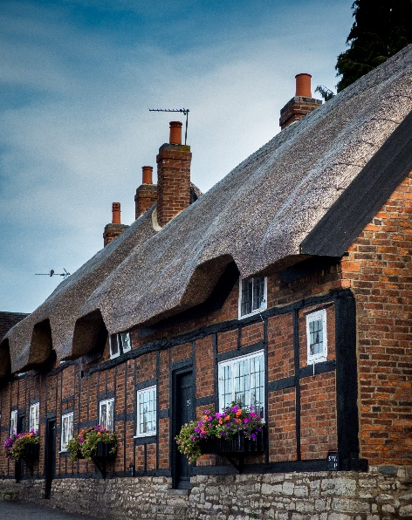
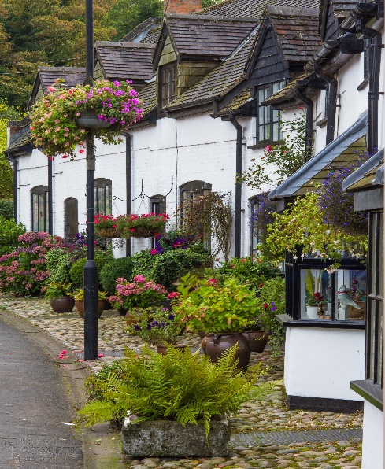
I am delighted to be able to share with you our Photographic competition winners! There were some really excellent photographs entered and the judges had a difficult time in making the final decisions. Sadly we did have some very good pictures, ruled out of the competition, because they did not meet the standards set out in the rules. I would like to say a big thank you to everyone who took part and congratulations to all the prize winners.
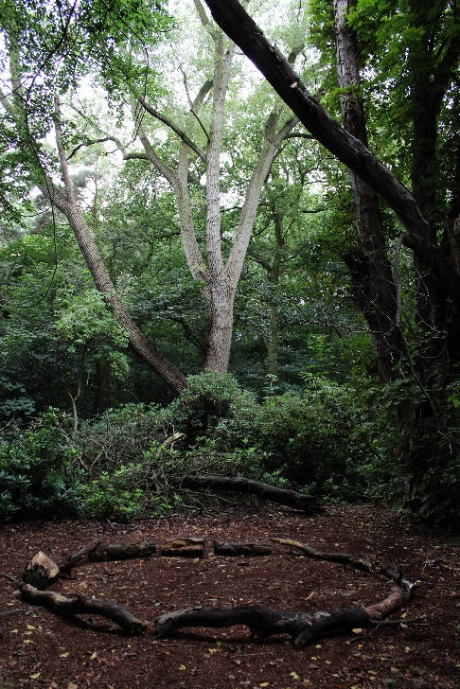
Winner “Cottages in Bloom” P Burrows. 1st Runner up “Thatched Cottages” H Burrows.
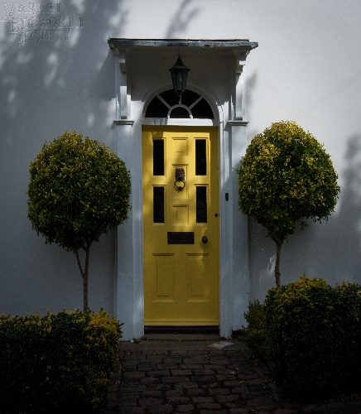
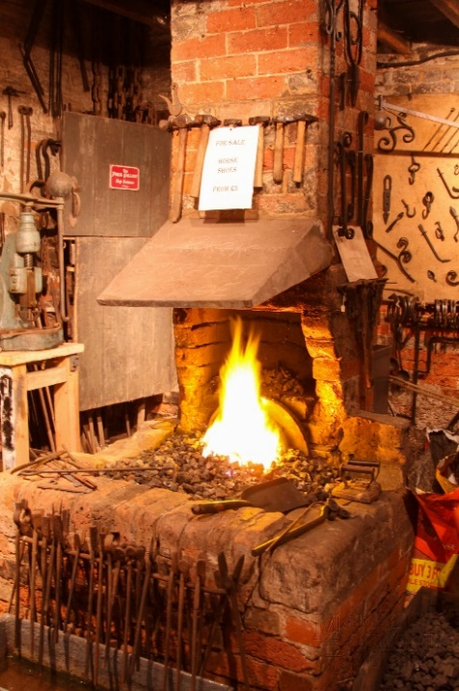
Under 19 Winner “Yellow Door” N. Burrows.

2nd Runner up Dick Bates.” Warmth of Bosworth” and 3rd Runner up T Storer. “Community”
The winning photographs can be seen on our website www.marketbosworthsociety.com/competition. All of the entries are available to view and there were some stunning photographs.
Thank you! To all who supported the entries by voting or liking.
First World War Casualties in Leicestershire Hospitals our entertainment for our lecture meeting on the 17th November, the fascinating story of The Base Hospital set up, with several other hospitals, during the First World War to treat wounded and sick soldiers. Robin Jenkins Senior Archivist for Leicestershire shared the story with us. We enjoyed many photographs and actual personal reports written at that time. Two things struck me and will stay with me. Firstly the enormous acceleration of resources needed to treat our soldiers and some soldiers from other countries, even Austrians and Germans were treated there. For example, in 1914 there was one hospital ship and three cross channel ferries in use. By 1916 there were one hundred hospital ships transporting 130,000 officers and over two million men. The Base Hospital itself was extended numerous times (tripling in size) and surprisingly the open fronted ward (facing south) was very popular. It had canvas blinds to keep out the worst of the weather. Contrast this with hospitals today where often the heat is stifling. The other factor was the kindness and generosity of the people of Leicestershire. When the first train arrived carrying the wounded it was not only met by stretcher bearers and ambulances but also 38 private cars to ferry the wounded to hospital. The newspaper report included the fact that all of the cars were owner, drivers including a lady driver. This continued throughout the war with each train being met by private drivers freely giving their time to help the soldiers. The wounded troop trains were in fact met by crowds of locals, with many showering the soldiers with cigarettes, tobacco, chocolate and other gifts. The locals were so generous that it had to be decided to receive the trains after midnight to reduce the volume of the crowds, as they were unwittingly causing delays. The hospital also asked for local visitors, to boost the morale of the patients and were overwhelmed by the response, to the extent that they had to police the numbers of visitors to prevent overcrowding. Again the level of visitors remined consistent throughout the war with a visit to the hospital becoming a regular item on a family’s itinerary. Add to that gifts of billiard tables and a myriad of other life enhancing items and I saw a picture that out of violence and war such humanity could also be found in quantity. For me, the lecture was both interesting from a factual point of view but also very moving. An excellent follow up to the crowds seen in the Square for Remembrance Sunday.
I hope I have done justice to Robin who delivered the lecture in a clear, professional and humorous way. As usual the end of the lecture was marked by questions and answers together with loud and long applause,
As I am sure you recall, we do not have a lecture meeting in December. But we do have an event, Glynis and Brian Oakley have kindly agreed to open The Forge on the 1st December in celebration of the Christmas lights Switch On. I, together with others, will be dispensing Mulled Wine (or lemonade if preferred) and Mince Pies, first come first served and subject to stocks lasting! We will also have some items for sale, so you can get on with your Christmas Shopping whilst enjoying the warmth of The Forge. We will also be visited by the Photographic Competition winners who will be collecting their prizes. It would be very nice to see you there.
I have been asked by Marion to remind you of the Dixie Grammar School Community Lecture on Wednesday the 7th December. Entitled Forensic Linguistics; Analysing Language in Criminal Investigations. The lecture is given by Tim Grant, Professor of Forensic Linguistics at Aston University. The lecture commences at 4;30 pm and is expected to last for one hour. It sounds to me to be a very interesting subject, someone jokingly (at least I thought they were joking) said they would attend as it would help them to understand my Newsletters! The very nerve.
Our next Society lecture meeting will be on the 19th January with Derek Jarrom treating us to his lecture “Dam and Blast” This will be in the Free Church (which does look very smart following the re-decorating) Barton Road, commencing at 7:30 PM. All welcome, subject to seating availability, non-members will be asked to pay the usual nominal £3.00.
I look forward to seeing you at The Forge.
Nigel

