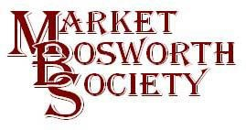 October 2017
Dear Member,
Although not as mobile as usual I have managed to get out and see the beautiful colours the trees are displaying at the moment. Some of the reds are breath-taking and it almost seems like a celebration of summer before the trees shed their leaves and slumber over the winter. We are very lucky in Market Bosworth to be surrounded by so many trees and long may this continue. Hopefully the recently completed Tree and Hedgerow Survey will ensure that we will enjoy these scenes for many years to come. As indeed will the Hinckley and Bosworth Borough Councils Heritage Strategy, which has now reached the draft consultation stage.
Bosworth in Bloom
I would like to wish everyone involved with Bosworth in Bloom congratulations on becoming joint winners of the large village category of Britain in Bloom. What a fantastic achievement and the rightful reward for all of the hard work and dedication shown by the volunteers. I take my hat off to you. Residents and visitors to Bosworth can see the results of your hard work everywhere and whilst I can’t speak for anyone else, I think your work is superb. The judge’s decision simply endorses what we can all see. Thank you for making Market Bosworth even more beautiful. Very well done your accolade is richly deserved.
Getting to know the Gurkhas
In what I believe to be Margaret’s second visit to Bosworth she shared with us a fascinating insight into the Gurkhas. Starting in 1716, before Nepal actually existed Margaret began to tell her the story of how the various different villages and tribes became settled in the Kathmandu Valley. They are a resilient and intelligent people making a life and living in some of the most difficult terrain on earth. We heard how the association with the British Army and the Indian Army started, an association which is still very strong today. For example, in 2008 there were 17,000 Gurkha applicants (between the ages of 18 and 22) for just 235 vacancies. Sadly, a large number of applicant are not successful. As many young men grow up in their village, they would regularly receive extra food and tuition to help them enlist with more success. For some the shame of failure is too much choosing to leap off a bridge rather than to return to the village in failure. Life is indeed tough. It was not all doom and gloom and statistics. Margaret told a number of very amusing anecdote, one about the drink Buck Fizz and one about a pair of size 12 boots, neither of which I can report here. I can, however tell you one amusing story, allegedly true, but who knows. New recruits were soon used on guard duty and after reporting to the Guard Room the officer in charge would check out the recruits understanding. “What would you do if you saw someone crawling on their belly toward you?” asked the officer “I would say Holt, who goes there and aim my weapon”. “Very good” said the officer, “but what would you do next” After a pause the recruit replied “Sir, I would pick him up and return him to the officer’s mess”
.
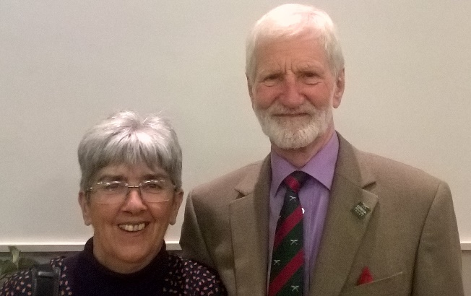
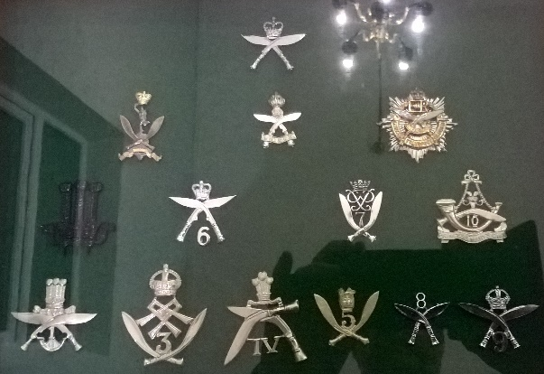
Margaret & Robert Cross Some examples of Gurkha cap badges
Margaret went on to explain the work of the Gurkha Welfare Trust (https://www.gwt.org.uk email: info@gwt.org.uk or telephone 01722323955)) who care for retired soldiers and their widows. It is most definitely a worthy cause. They provide many things from clean water to bridges to rest homes. Many villages have no running water, electricity or toilets, things we take for granted. Everyone present enjoyed the talk; over ninety minutes without notes or slides, by giving a long and loud round of applause in recognition. It really only seemed like a few minutes.
Local Research
In previous issues of Aspect, I have asked for help in researching what was once W (Billy) Beck’s builders yard. I have been delighted by the number of people who have come forward with information and a good deal of facts are being gathered. To those who have contributed I thank you and ask anyone else to get in touch. I have been told off for sprinkling my contact details across previous articles and, so I have, this time added them to the end. I recently contacted Peter Harrison via a good deed from my good friend Robert Leake. Peter, who lives in America, now has been more than generous in sharing recollections, photographs and documents. One story close to my heart involves Newbold Verdon Church. My father originally started out as a carpenter but after National Service had to switch to become a plumber. He worked for Bill and told a story about Newbold Church Tower. I am not entirely sure of the date, (perhaps someone could help?) but the tower was renovated by W Beck and Co. My father was tasked with fitting a lead collar at the top to make it waterproof which was then covered by a sheet of copper. After beating the lead to shape and fitting it he carried on and fit the copper. Once done he chased his name and the date into the copper. I am not sure if this was permitted but I think it safe to make the revelation now. Does anyone else know of this story? It came back to me following some pictures sent by Peter.
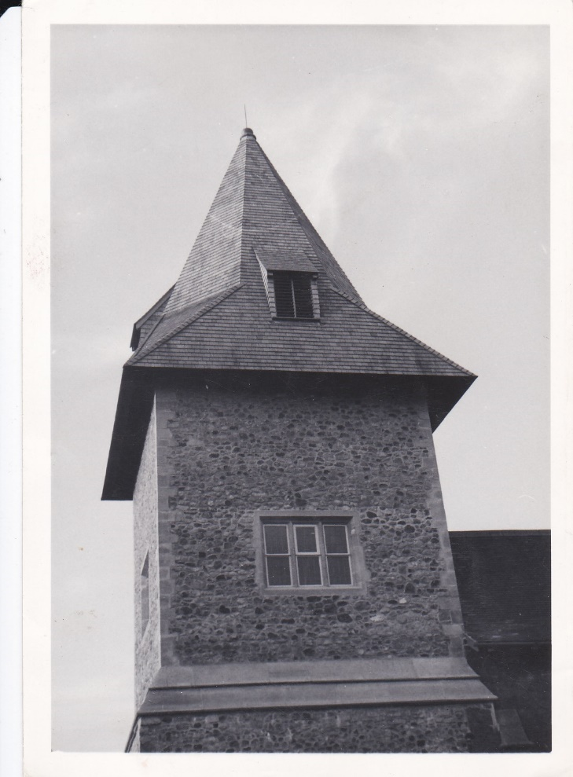
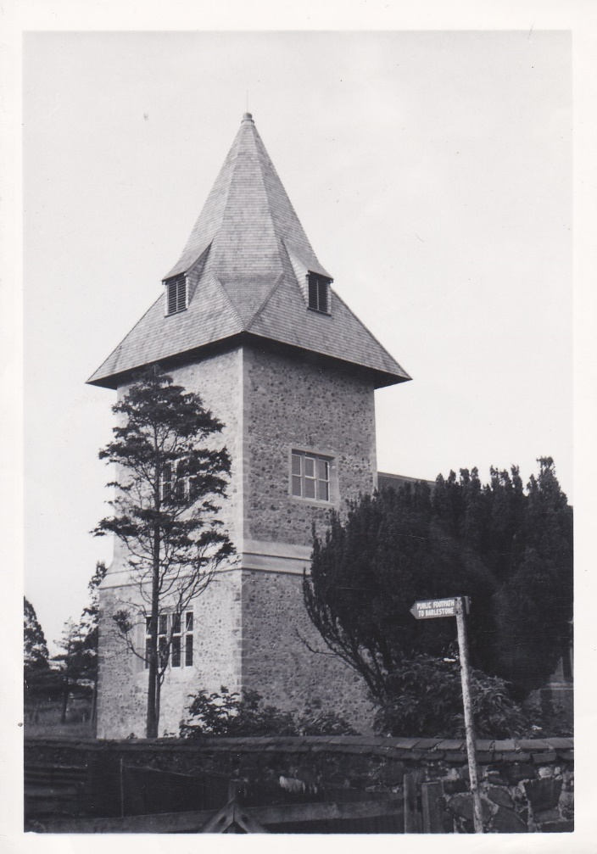

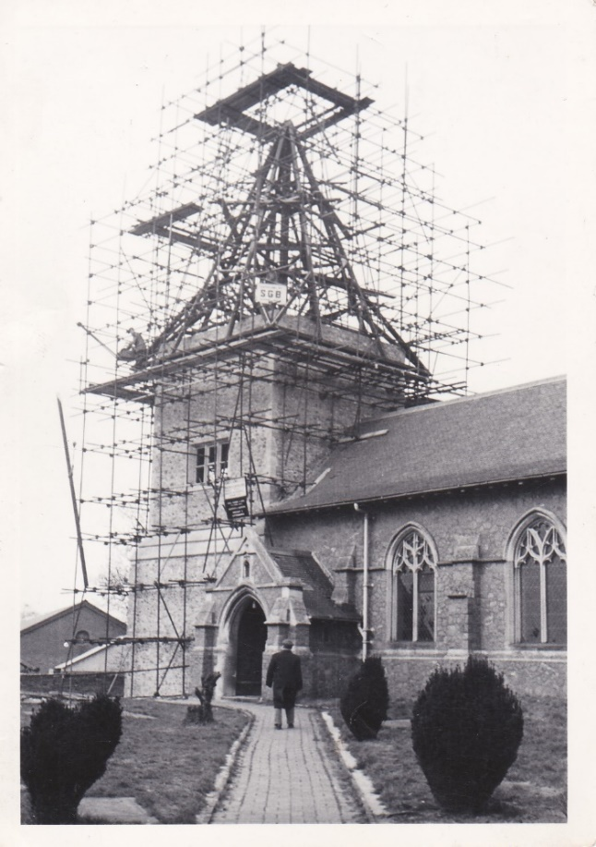
These photographs show the tower as it looks now, and a good job was done at the time. The picture to the left shows the tower in a state of readiness for the new covering.
The character on the path is William “Billy” Beck. As he is wearing a thick coat it would appear to be winter. One can only imagine how cold it must have been up there with no shelter from wind or rain.
You will see that there is a man standing on the scaffolding. So far, I have been unable to identify the man with any certainty. Names put forward are Don Mattocks, Ron Towers and several others. Do you know who it might be?
I would love to find out and I would also love to know if anyone else had heard of dad’s bit of signage. It is a family story and dad always joked that he had to behave because God could clearly see his name.

Next Month: Bending the Beams Terry Shepherd 16th November 7:30
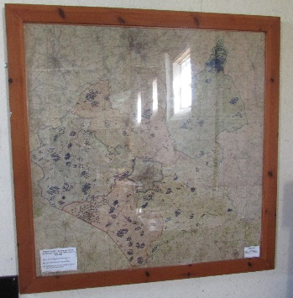
After our lecture this month we are once again in for a treat next month. This is a local story, Whitwick actually, of some very necessary and highly skilled work carried out by a small unit. Hugely hush, hush hardly anyone knew of the work. Those who visited Beaumanor House in the summer on our field trip will recall a map on display in the final hut we visited. The map depicted the fall of every bomb (high explosive, land mine or incendiary) dropped on Leicestershire during the second world war. A number were puzzled by the map, come to the lecture and be puzzled no more! Terry Shephard will explain all to us. I heard this lecture several years ago and am delighted to bring Terry to our meeting.in The Free Church, Barton Road, Market Bosworth. The meeting will commence as usual at 7:30. If you are not a member you may still come along, subject to availability. You can join the society or simply pay a nominal £3.00 to help defray costs. I expect a big crowd for this one so do get there early.

Guided Walks
Last Spring, Peter Loseby was contacted by The Leicester Association of National Trust Supporters. They had heard about our guided walks around Bosworth and asked if we could accommodate them. Peter, Robert and I agreed that we certainly could and arranged for two separate visits to Bosworth of around 45 members per time. This enabled the three of us to split the visitors into manageable groups. Any more than 15 is almost impossible as the pavements are narrow in some places and the visitors cannot hear the narrative. Twelve is probably ideal, any less than that and they can ask too many questions! The walks as designed to be a “light touch” as we don’t focus upon too much data or dates. We do explain about the naming of the Bow Pool and Delius Cornet (who knows where that is?) to generate an interest in Bosworth which will hopefully encourage visitors to return and carry out their own research. Local businesses benefit from the tourist pound and the Society is pleased to offer support. I have repeated here the report of the visits from their newsletter.
Summer 2017 Reports
Local Outings
Walking Tour of Market Bosworth
Friday 16th June 2017
It was a lovely, sunny morning when we went on a guided walking tour of the historical town of Market Bosworth. The influence of the three key families that dominated the surrounding area is clear to see. There is little let of the Harcourt's moated manor house, but you can see the shields of the families who participated in the Battle of Bosworth high up on the walls in the Market Place.
The second family bought the estate in 1589 and the influence of Wolstan Dixie's family is clear to see. The Dixie Grammar School stands on Station Road and can trace its origins back to 1320. It was re-founded by the Dixie family in 1601. It is the present school building that we viewed, which was built between 1827 and 1829. The Latin dedication translates as "Education once received is a possession of which mortal man cannot be deprived". The distinctive windows with their cast iron glazing pattern have been copied around the town. From the car park, you may see the west entrance to Bosworth Hall, now a hotel. The present hall replaced the moated manor house in 1682 and has been altered and added to by the Dixie and later the Tollemache Scott family.
St Peter's Church, with its tall spire, was built in the 14th century and was a well-known landmark which would have been clearly seen by the soldiers on the Bosworth battlefield. In the churchyard is the gravestone of Doctor Robert Pull and our guide shared the gruesome story of how the poor man was buried alive
Our guide shared several interesting photographs with us that showed how little the buildings had changed around the Market Place and how the centre had been updated, the cobbles have been replaced and the focus is a War Memorial that is well cared for. As we walked, we admired the many floral displays and the quirky scarecrows, our visit was completed with a meal at the Red Lion. There was so much to see that it would be well worth another visit.
Sheila Sterynowicz.
If you belong to a club or society who you think may like to have a guided tour around Bosworth, then do get in touch. If you have a family gathering and would like to show them around, then again, we would be happy to assist. We normally charge £3.00 per person, which includes a Town Trail Tour Guide. You may also recall that in support of the Leicestershire Festival of Archaeology Robert Leake provided a guided tour of St, Peter’s church and churchyard which was thoroughly enjoyed by those taking part. Robert has kindly offered to act as a guide should anyone wish to organise a group tour. Again, numbers are limited to a maximum of 15. For the brave of heart, Robert does a ghost walk which as we approach Halloween is very topical. If you are interested in any walks or tours, then do please get in touch. Contact details are at the end of this newsletter.
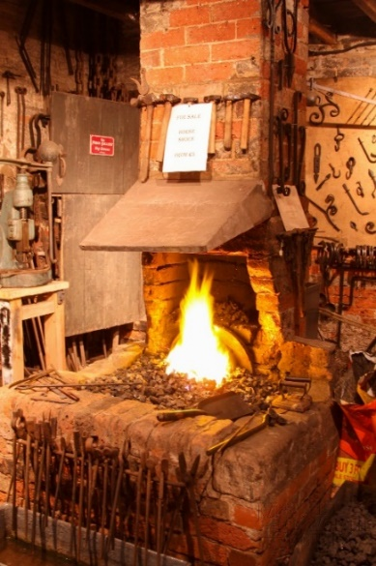
An Extra Date for Your Diary! 30th November 2017.
You will know by now that the Christmas Lights Switch On will be on the 30th November. I am delighted to report that Brian and Glynis Oakley have kindly agreed to open The Forge on that evening. There will be displays of tools and equipment from over the years collected by Brian, there will also be films and pictures from the Bosworth Links Summer dig. Perhaps the most popular display will be Farrier and Blacksmith Ed Robinson demonstrating how The Forge would have worked over many years. Ed and his team are extremely skilful craftsmen who seem to be capable of making metal do their bidding with ease. Please call in and enjoy a mince pie and glass of mulled wine, and take a turn on the forge bellows! A huge thank you to Brian and Glynis for allowing us into their home and making this possible. What better place to be on a cold winters evening than by a real live fire?
Over to you!
If you have any comments, questions, suggestions, enquiries or simply wish to get in touch please do so. Telephone 07930149408 or 01455290160 or you may wish to email nigel_palmer.MBS@btinternet.com. You may also post on our Facebook pages, Market Bosworth Society or Bosworth Links.
Nigel Palmer, Chairman

