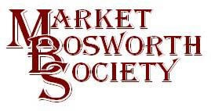October 2016
Dear Member
October is here already with its mists and fruitfulness, some beautiful and spectacular colours to be seen and a turning up of the heating thermostat. I do admit that Autumn is not my favourite season, Spring promises warm sunshine and balmy summer walks in our beautiful countryside, whilst Autumn reminds me that winter is closing hard. That apart, October has been a busy month for the Society. We had two lectures! Both on the same evening and both in a way commensurate with the aims of your Society, the preservation of our village and the sharing of historical fact and information.
Firstly, we were hosts to John Pope, Chairman of the Neighbourhood Forum. Our Parish and Borough Councils are very keen to protect and preserve our trees and hedgerows. We are certainly very fortunate in market Bosworth that we are separated from other villages by some of the most beautiful countryside in Leicestershire, if not the country. Whichever direction you travel into Market Bosworth you pass hundreds of trees and hedges, many of them ancient. Some trees in The Country Park, for example are estimated to be over 350 years old. It is quite within reason that some trees in some of our spinneys and woods may have been saplings in 1485. It is imperative that we protect these trees and hedgerows in order that they may be enjoyed by generations to come. I must admit that John made a compelling argument and I for one will be volunteering to take part. I don’t have the room here to give all the details of John’s talk or objectives but I would urge you to contact him and volunteer your services. John can be contacted: by telephone, 01455 290724, Mobile 07519 074522 or by email j.pope@marketbosworth-pc.gov.uk
I know John will be delighted to hear from anyone who can spend a little time to support this project.

After John came another John, this time John Waite. John is a Roman Re-Enactor, Author and Roman Historian and a very interesting and knowledgeable man. John’s lecture was entitled “A Layman’s Guide to Ancient Roman Medicine and Surgery”. We heard how the Romans had taken on a lot of what the Greeks had discovered and that Humourism, the basis for the Roman medical philosophy was a major influencer of the treatment of ailments from 450BC to 1858AD! It is based upon a balance of the essential elements, where a perceived imbalance can cause illness and disease.
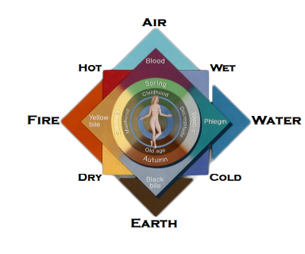
We heard how a lot of surgical techniques evolved from the battlefield and that it was from there that surgery became available to citizens. I was amazed that two thousand years ago Roman doctors could diagnose and treat gall stones. What was even more remarkable was that the Ancient Romans could also treat eye cataracts. John had brought several accurate replica scalpels and tools with him and demonstrated the method employed to remove a cataract. The probe used to enter the patients eyeball was quite small about the size of a pencil lead. It still looked big and horrific to me. Any surgery had to be conducted without anaesthetic as the Roman’s had none. They would have given the patience some Opium based drugs to take the edge off, but it still seemed to me to be a very unpleasant experience. John encouraged his audience to take part, ensuring that everyone had a good look at the various pieces of equipment he had with him. Judging by the applause after his lecture those present had thoroughly enjoyed his efforts.

Toward the end of the meeting, I invited Peter Loseby to update us on the progress of Bosworth links. Peter confirmed that progress is being made to secure funding for the project, which will cost around £40,000 to deliver successfully. Funding is being sought from several sources and that the list of supporters was ever growing. All the local schools, Parish Council and several other bodies have already given letters of support. Once we have secured the requisite funding; we have no reason to suppose we will not be successful, we will publish more details of the project. Suffice to say we are getting quite excited,
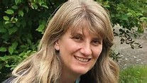
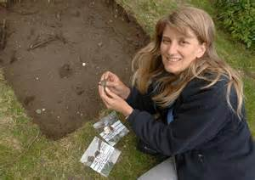
especially as Professor Corenza Lewis (pictured above) has agreed to be our guest lecturer in June next year.
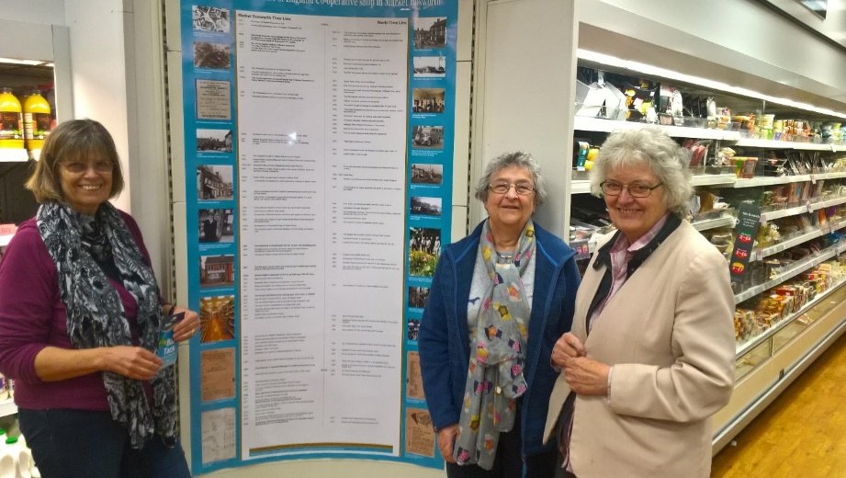
Your Society has also been very busy helping to celebrate an important birthday. The Heart of England Co-op in Market Bosworth celebrated one hundred years, this month. The Co-op opened its doors for the first time in October 1916, in the middle of the First World War and has been serving the people of Bosworth and surrounding villages ever since. Growing up in Market Bosworth I have fond memories of the Co-op, I still remember my mum’s dividend number and the excitement mounting as I anticipated the arrival of Derek Pallett with mum’s weekly order of goodies (plus soap, washing powder, bleach and other boring items). You may recall that our May Lecture Meeting focussed upon the Co-op and other shops in Bosworth in the 1950’s and 1960’s. I was delighted when the Society was asked to help to celebrate the centenary which we have done so with a time-line. Glenys Oakley, Beth Dawes and Ingrid Davison have, once again made a marvellous job of researching local and worldwide events that took place over those hundred years. I will also add that Dean at The Graphic has done a great job of designing and printing the timeline. Please do go and visit the Co-op and have a look at the timeline it makes interesting reading. Thanks to all concerned for an excellent job.

Your Archivist, Glenis Oakley with her team of researchers, (left) Ingrid Davison and Beth Dawes. If you know of any anniversaries coming up please contact me, 07930149408 or nigel_palmer.mbs@btinternet.com

I would like to say a big thank you for those who took part in the photographic competition. Despite a few website related issues, which were overcome with the expert help of Steve Barrett. Thank you, Steve, we could not have done it without your skill, knowledge and kindness. Do please visit www.marketbosworthsociety.com/competition and have a look at the entries. Some members have suggested we make this an annual event which will be considered. We have had nearly fifty entries and whilst the competition is closed to new entries we do need your votes, your committee will be choosing the winners from a top ten, decided by a public vote. So please get voting (or liking on the photographers Facebook page). It is hoped that the winners will be announced in early December. We aim to publish the winners on the website and on our Facebook page.

Coming up next is our next lecture meeting, at the normal start time of 7:30pm and be held at the newly refurbished (well done to Maurice and all involved, the new décor is very nice indeed) Free Church, Barton Road. Our lecturer on the 17th November will be delivered by Robin Jenkins and is entitled “1st World War casualties in Leicester Hospitals” I think you will agree a very apt lecture for the month in which we observe Reembrace Sunday (the Societies wreath will be laid this year by Martyn Andrews). Everyone is welcome to attend the lecture, (subject as ever to seating capacity). If you are not a member of the Society a nominal fee of £3.00 is charged to defray some of our costs, but do come along you will be warmly welcomed.
The last event of the year will take place on the 1st December, 2016, Brian and Glynis Oakley have kindly agreed to open The Forge, which has proven to be very popular in previous years. There will be some of the Societies publications on sale which provides an excellent opportunity to secure some Christmas Presents whilst supporting your Society, remember to bring your purse and wallet!
Finally, a reminder that there is a meeting to be held by the Bosworth Legacy subgroup, which is part of the Boroughs tourism group, in Market Bosworth community library on Saturday 29 October at 1.30 pm. The meeting will be led by Fred Brookes and will last no longer than an hour. I have attached a document from Fred together with a document advertising a lecture by Father Philip of Polesworth Abbey on behalf of the Hinckley Archaeological Society.
I hope you are enjoying the beautiful Autumn colours? On what better note is there to end this Newssheet?
Kind regards
Nigel Palmer
Chairman

