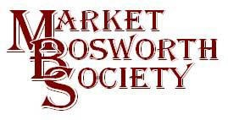 April 2017
Dear Member ,
Those members who attended the April meeting found it a little different from our usual. We were hosts to Derek Chattington who told us the fascinating story of his family history. Derek is a firm believer that our choices shape our future and his lecture illustrated this. Derek set the scene by explaining how he came to live in Carlton nearly 30 years ago. Driving towards bosworth he decided to call and have a break. Whilst in Bosworth he saw his current house in an Estate Agent’s window and a few short weeks later that house became their home. Several decisions and their subsequent consequences were woven into the impressive story. Derek’s story was built around two Brothers, Bob, and his younger brother by two years Bill. Whilst Derek’s story could go back further he started it with the journey of William and Elizabeth Chattington (nee Banks) Bill and Bobs grandparents who travelled by foot from Hales Owen to the Rhonda Valley in search of work and a better life. The journey took them several days and on arriving they found a hovel, in which they made their home. They had 9 children, one of which William was the father of Bob and Bill. Sadly, William died aged just 42 of pneumosilicosis killed by the anthracite dust in the mine he was working in. The focus turned to Bob and Bill and illustrated how, despite very similar backgrounds and in some respects similar experiences, they both served in the Army during the Second World War for example, it was their choices which had the greatest impact upon their fate and future. Bob and Bill moved to Coventry, again seeking work, and were expected to contribute to their family income. Bill started a job at the Dunlop factory which he retired from 42 years later. Bob had a series of different jobs, even a spell in Australia before he too eventually retired. Bill died almost penniless. It turned out that his son had not paid the rent with the money Bill had given him, whilst Bob retired in reasonable comfort. I cannot do real justice to the story here but I would recommend anyone with an interest in family history to invite Derek to tell his story. I for one, certainly enjoyed the telling of this life story.
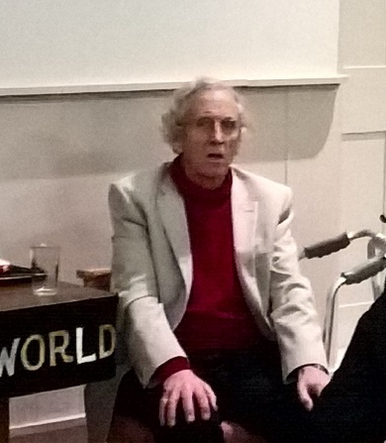
I would like to add that recently Derek had suffered a broken hip but he still turned up, with his walking frame to deliver his talk, something that the audience truly appreciated. A real trooper. Thank you, Derek
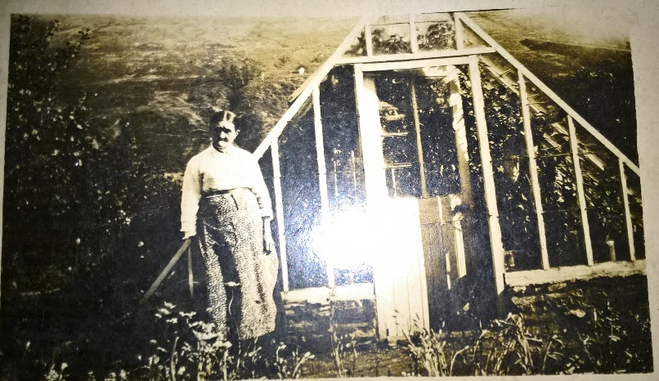
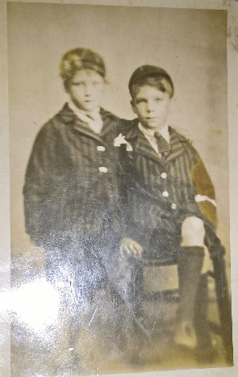

Seen here are Bob and Bill as boys, Elizabet Chattington who made that journey to the Rhonda Valley and Derek, answering questions after his lecture.

Next month the life story theme continues. Some will recall that Ruth Schwiening entertained Society members back in February 2016 with her very person “Ruth’s Story”. In conversation with Ruth and Jurgen (Ruth’s husband) later that evening it soon became clear that Jürgen’s story was equally worth sharing and I am delighted to confirm that Jurgen will be our guest lecturer at our next meeting. The meeting will be held on Thursday 18th May, 2017 and will commence at 7:30 pm. The venue will be, as usual, The Free Church, Barton lane. Whilst the meeting is for Market Bosworth Society Members it will be open to anyone wanting to come along and hear Jurgen. We simply ask for a small contribution (currently £3.00) towards costs. As always admission is subject to availability. If you like the look of our lectures and Field Visits (available at www.marketbosworthsocity.com) then you may wish to join. Membership is just £9.00 for a single membership and £14.00 for a joint membership. Everyone is welcome.
On that very subject, thank you to those members who have renewed their membership, this year’s membership fees are due. You may renew at our next meeting or alternatively by cheque or cash to me at 29 Warwick Lane, Market Bosworth, CV13 0JU or to Glynis at The Forge, Park Street or of course Marion at the Dixie Grammar School. If you renewed a joint membership last Thursday (and you surname is not Owen or Jerram) could you let me know please? We have a fee but not the members! 07930149408 or 01455290160, thank you.
We held our AGM in March and we elected two new committee members to replace those standing down. Ingrid Davison, who some of you will know as she has taken part in some of our lectures and has worked behind the scenes as a researcher many times. Ingrid has very many interests and will be a real asset to the Society committee. Lynne Palmer, my dear wife, you may also know as she works part time for The Bosworth Pharmacy (formerly Lloyd’s Chemist) and has done so for five years now. Lynne is new to committee work but I expect her ability to engage with people will be a real help to us.
Here are Lynne and Ingrid reacting to me reminding them that I am in charge……
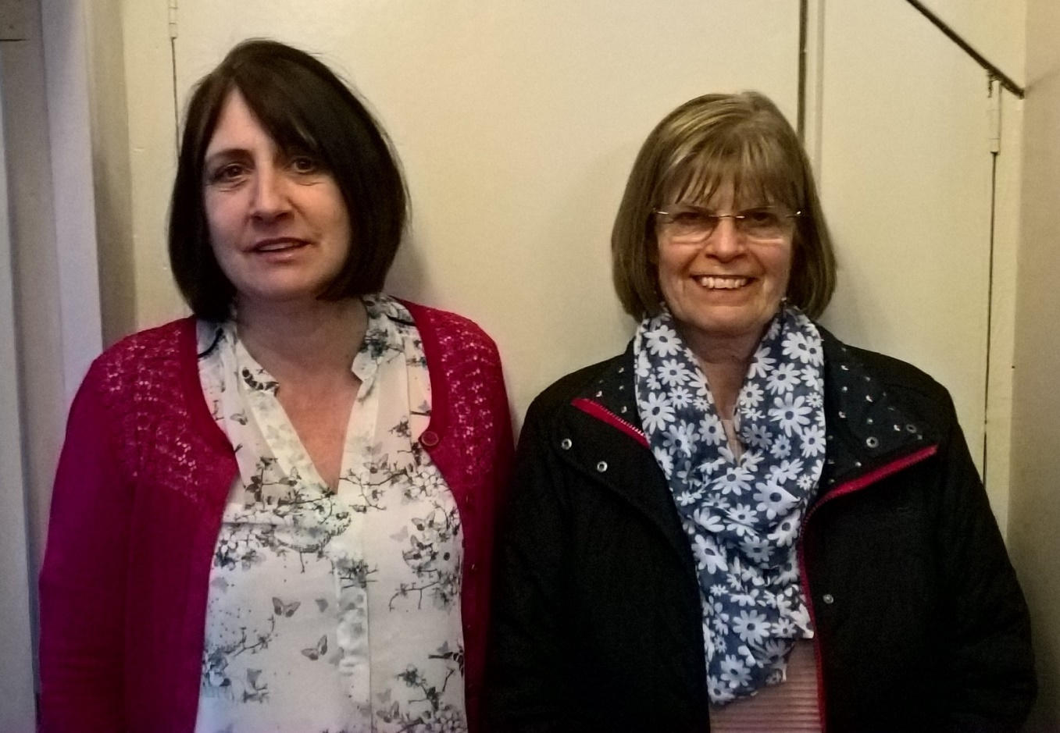

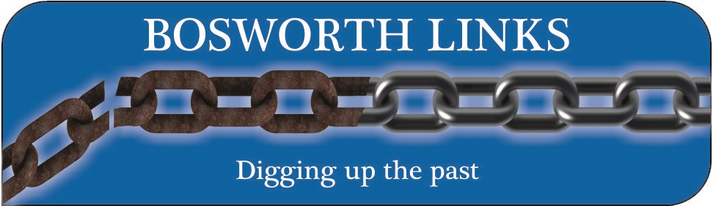
I have some exciting news, in fact the project is moving forward at a very commendable pace, thanks to the Bosworth community. To explain further, we have been successful in our main funding request and am delighted to say that the Heritage Lottery Fund have given their approval to our request and have confirmed that we may begin the project. We still have two further applications pending for finance with other bodies and we will hear from them in late April and mid-May. I would also like to give a massive thank you to all the people who have volunteered to take part in Bosworth Links especially those who have agreed to host pits on their property. I did fear for Peter’s (Loseby) safety when he told me he intended to knock on doors and ask if we can dig holes in the owner’s lawn or garden. As it turns out the warmness of the welcomes, he received overwhelmed Peter and thanks to him, we have now identified all the dig sites for this year’s dig. Do not worry if you are not hosting a pit this time around. Remember, it is a two-year project and if you want to take part just let me or Peter know. You can email me, telephone me or preferably complete a volunteer form available at http://marketbosworthsociety.com/Bosworth-links and follow the link to that form. I predict that next year’s list will fill very quickly and so delay may prove disappointing. Peter, me, and the rest of the Bosworth Links committee offer our heartfelt thanks for the very positive response we have received.
We have begun our search for a Project Leader (a temporary self-employed post spanning the two years of our project)
If you are interested or you know anyone who might be then please share this advertisement with them:
Bosworth Links Project Officer Advertisement: Market Bosworth Society has been successful in securing Heritage Lottery Funding for Bosworth Links, a community archaeology project to take place in Market Bosworth, Leicestershire, as part of the national Archaeology Festival in 2017 and 2018, in partnership with University of Leicester Archaeological Services (ULAS).
The Society is now seeking a project officer, reporting to the Bosworth Links Committee, who will be responsible for establishing the programme of archaeological events, encouraging, and supporting volunteer participation, communication, consultation, and financial management.
We expect you to have proven experience of supporting similar externally funded community projects and to demonstrate successful outcomes of your work with communities and volunteers. You will be required to spend significant time around Market Bosworth, with evening and weekend working during the archaeological activities. You will be self-employed, and your contract will be for two allocations of time in the Springs and Summers of 2017 and 2018 although precise details will be discussed in due course.
Much of the project will involve people of all ages, including potentially vulnerable groups, for example from pre-school age children, school children up to and including senior citizens. You will be required to provide details of previous experience in working with such groups and be willing to undertake a Disclosure and Barring Service Check (DBS), if required. You will also be required to provide confirmation that you are entitled to work in the UK throughout the term of the project (up to November 2018). Two references will also be needed, preferably from existing/previous employers.
When submitting your application kindly ensure that you attach a copy of your Curriculum Vitae and copies of the above-mentioned documents (you will be required to present the original document at a subsequent interview). Please indicate your payment expectations.
To apply for this role please email your application to: info@marketbosworthsociety.com.
For further information and a job description see: www.marketbosworthsociety.com/bosworth-links
Closing date for applications: 10th May 2017
Interviews will be held in Market Bosworth (Bosworth Hall Hotel) on: 16th May 2017.
David Kent General Manager of the Bosworth Hall Hotel) has very kindly offered the use of a suitable interview room free of charge to us. Thank you, David, much appreciated.
I have also been in contact with Professor Corenza Lewis (who you may know from here work with the Time Team TV programme) and she has confirmed that she will be our guestst speaker at our June meeting. We are also plan to hold a community meeting immediately before that lecture to answer questions, share expectations and hoped for outcomes of Bosworth Links. Mathew Morris (Bosworth Links Project Leader) will be there to answer archaeological questions about the digs. I will publish more about the meeting in due course. Keep an eye on our Facebook page for up to date developments and of course your News Letters. Do please let me know if there are items you would like to see included or to make any comments, positive or otherwise on the contents.
In the meantime, I hope members remember to renew their membership, then sit back in the lovely May sunshine.
Nigel Palmer
Chairman

